Style Guidelines for Final Year Project ReportsARtisan
Final Year Project – Mid Report
Session 2023-2027
A 4th Year Student

A project submitted in partial fulfillment of the requirements for the Degree
of
BSc. (Hons.)BS in Computer Science / Software Engineering / Artificial Intelligence



Department of Computer Science
COMSATS University Islamabad (CUI), Lahore Campus

Project Registration
Project ID (for office use)
Type of project |  |  | [✔] Traditional [ ] Industrial [ ] Continuing
Nature of project |  |  | [✔] Development [ ] Research & Development
Sustainable Development Goals(SDGs) |  |  | [ ] Good Health and Well-Being [ ] Quality Education  [✔] Industry, Innovation, and Infrastructure [ ] Gender Equality  [ ] Decent Work and Economic Growth [ ] Climate Action
Area of specialization |  |  | [✔] Artificial Intelligence (AI) [ ] Blockchain [ ] Cybersecurity  [ ] Data Science and Analytics [ ] Game Development  [ ] Internet of Things (IoT) [✔] Natural Language Processing (NLP)  [ ] Mobile App Development [✔] Web Development
Project Group Members
Sr.# | Reg. # | Student Name |  | Email ID | Phone # | Signature
(i) | SP23-BSE-172 | Warda Saeed |  | sp23-bse-172@cuilahore.edu.pk | 03215927607
(ii) | SP23-BSE-145 | Saim Jamil |  | sp23-bse-145@cuilahore.edu.pk | 03008143667
(iii) | SP23-BSE-152 | Syed Muaarij Nadeem |  | sp23-bse-152@cuilahore.edu.pk | 03231021387
Declaration: FYP group members have cleared all prerequisite courses For FYP-I as per their degree requirements.
For BS(Computer Science) and BS(Software Engineering)
(CSC241 Object Oriented Programming, CSC291 Software Engineering Concepts, CSC270 Database Systems, HUM102 Report Writing Skills)
For BS(Artficial Intelligence)
(CSC291 Software Engineering Concepts, HUM102 Report Writing Skills)
Plagiarism Free Certificate
This is to certify that I am Warda Saeed S/D/o Saeed Ahmad, group leader of FYP under registration no CUI /SP23-BSE-172/LHR at the Computer Science Department, COMSATS University Islamabad, Lahore Campus. I declare that my FYP proposal is checked by my supervisor and the similarity index is ________% that is less than 20%, an acceptable limit by HEC. The report is attached herewith as Appendix A.
Date: 16-09-2025 Name of Group Leader: Warda Saeed Signature: __________
Name of Supervisor: __________________ Co-Supervisor (if any):_________________
Designation: _____________________ Designation: _____________________
Signature: _____________________ Signature: _____________________
HoD: _____________________
Signature: _____________________
ABSTRACT
E-commerce has grounded deep into society and led it towards online shopping to great extent. The increase in online shopping offers great convenience in shopping but it has given rise to certain important challenges, mainly in product visualization. Customers struggle with envisioning products in 3D space, especially in domains such as home furnishing and decor items. Because customers are greatly concerned about how these items will be adjusted in their personal space. This psychological disengagement or, which we term the “spatial imagination deficit” frequently leads to uncertainty in purchases thus increasing the return rate of products. Our project, “ARtisan”, resolves this issue by proposing a modernistic web-based platform that emphasizes the power of Generative Artificial Intelligence in combination with Web-based Augmented Reality (WebAR). Users will gain exceptional capability to articulate desired product features via text prompts, generating unique 3D models. These extraordinary creations can be then immediately visualized within the customers’ real-world space. These models are easily accessible through a standard or even a low-end web browser on a mobile device. By combining AI-driven personalization with AR technology, ARtisan focuses to enhance confidence, minimize uncertainty and decline the graph product returns. The expected final form might provide a more modernistic, interactive and reliable online shopping experience that not only enhances customer satisfaction rate but also revolutionizes the way online retail platforms showcase products. Moreover, the reduction in product returns will engage and encourage the sellers to contribute more to e-commerce, leading to economic growth.
Table of Contents
Chapter 1. Introduction 10
1.1 Introduction 10
1.2 Problem Statement 11
1.3 Proposed Solution 11
1.4 Main Objectives 11
1.5 Assumptions & Constraints 12
1.6 Project scope 12
1.7 Software Development Lifecycle Model 13
Chapter 2. Requirement Analysis 14
2.1 Literature Review 14
2.2 Stakeholders List 16
2.3 Requirements Elicitation 17
2.3.1 Functional Requirements 17
2.3.2 Non-functional Requirements 24
2.3.3 Requirements Traceability Matrix 27
2.4 Use Case Description 31
Chapter 3. System Design 52
3.1 Use Case Design 52
3.1.1 UC-01 Generative AI 52
3.1.2 UC-02 Preview and Interact with 3D Model 52
3.1.3 UC-03 Detect Real-World Surface for AR 53
3.1.4 UC-04 Authenticate User 53
3.1.5 Manage Profile 54
3.1.6 UC-06 Create and Compose Multi Object Scene 54
3.1.7 UC-07 Manage Personal Asset Library 55
3.1.8 UC-08 Export and Share Model 55
3.1.9 UC-09 Receive AI Recommendations 56
3.2 Activity Diagram 57
3.2.1 AD-01 GENERATIVE AI (TEXT/IMAGE-TO-3D) 57
3.2.2 AD-02 3D MODEL MANAGEMENT 58
3.2.3 AD-03 WEB-BASED AUGMENTED REALITY (WEBAR) 59
3.2.4 AD-04 USER AUTHENTICATION & ROLE MANAGEMENT 60
3.2.5 AD-05 USER PROFILE MANAGEMENT 61
3.2.6 AD-06 SCENE & MULTI-OBJECT COMPOSITION (DESIGNER MODE) 62
3.2.7 AD-07 ASSET MANAGEMENT 63
3.2.8 AD-08 MODEL EXPORT & SHARING 64
3.2.9 AD-09 AI RECOMMENDATION SYSTEM 65
3.3 Sequence Diagram 66
3.3.1 SD-01 GENERATIVE AI (TEXT/IMAGE-TO-3D) 66
3.3.2 SD-02 3D MODEL MANAGEMENT 67
3.3.3 SD-03 WEB-BASED AUGMENTED REALITY (WEBAR) 68
3.3.4 SD-04 USER AUTHENTICATION & ROLE MANAGEMENT 69
3.3.5 SD-05 USER PROFILE MANAGEMENT 70
3.3.6 SD-06 SCENE & MULTI-OBJECT COMPOSITION (DESIGNER MODE) 71
3.3.7 SD-07 ASSET MANAGEMENT 72
3.3.8 SD-08 MODEL EXPORT & SHARING 73
3.3.9 SD-09 AI RECOMMENDATION SYSTEM 74
3.4 Software Architecture Diagram 75
3.5 Class Diagram 76
3.6 Database Diagram 77
3.7 Collaboration Diagram 78
Chapter 4. System Testing 79
4.1 Test Cases Design 79
4.2 Unit / Integration / Acceptance Testing 101
Chapter 5. Implementation 102
5.1 Work Breakdown Structure (WBS) 102
5.2 Team Roles and Responsibilities 103
5.3 Tools and Technologies 105
5.4 Implementation Details 105
5.5 Screenshots of Prototype / System 107
5.6 Challenges During Implementation 110
Chapter 6. References 111

List of Tables
Table ‎2.1 Literature Review Summary 15
Table ‎2.2 Stakeholder Details 16
Table ‎2.3 FR-GAI-1 17
Table ‎2.4 FR-GAI-2 17
Table ‎2.5 FR-MM-1 17
Table ‎2.6 FR-MM-2 18
Table ‎2.7 FR-WAR-1 18
Table ‎2.8 FR-WAR-2 18
Table ‎2.9 FR-WAR-3 19
Table ‎2.10 FR-WAR-4 19
Table ‎2.11 FR-UARM-1 19
Table ‎2.12 FR-UARM-2 20
Table ‎2.13 FR-UPM-1 20
Table ‎2.14 FR-SC-1 20
Table ‎2.15 FR-SC-2 21
Table ‎2.16 FR-SC-3 21
Table ‎2.17 FR-AM-1 21
Table ‎2.18 FR-AM-2 21
Table ‎2.19 FR-AM-3 22
Table ‎2.20 FR-MES-1 22
Table ‎2.21 FR-MES-2 22
Table ‎2.22 FR-AIR-1 23
Table ‎2.23 FR-AIR-2 23
Table ‎2.24 NFR-1 24
Table ‎2.25 NFR-2 24
Table ‎2.26 NFR-3 25
Table ‎2.27 NFR-4 25
Table ‎2.28 NFR-5 25
Table ‎2.29 RTM 27
Table ‎2.30 UC Description-01 31
Table ‎2.31 UC Description-02 33
Table ‎2.32 UC Description-03 35
Table ‎2.33 UC Description-04 38
Table ‎2.34 UC Description-05 40
Table ‎2.35 UC Description-06 42
Table ‎2.36 UC Description-07 45
Table ‎2.37 UC Description-08 47
Table ‎2.38 UC Description-09 49
Table ‎4.1 Test Cases-GAI 79
Table ‎4.2 Test Cases-MM 82
Table ‎4.3 Test Cases-WAR 84
Table ‎4.4 Test Cases-UARM 87
Table ‎4.5 Test Cases-UPM 90
Table ‎4.6 Test Cases-SC 92
Table ‎4.7 Test Cases-AM 95
Table ‎4.8 Test Cases-MES 97
Table ‎4.9 Test Cases-AIR 99
Table ‎5.1 Individual Activities 103
Table ‎5.2 Gantt Chart 104

List of Figures
Figure ‎1.1 Agile SDLC Activities 13
Figure ‎3.1 UC-01 52
Figure ‎3.2 UC-02 52
Figure ‎3.3 UC-03 53
Figure ‎3.4 UC-04 53
Figure ‎3.5 UC-05 Manage Profile 54
Figure ‎3.6 UC-06 54
Figure ‎3.7 UC-07 55
Figure ‎3.8 UC-08 55
Figure ‎3.9 UC-09 56
Figure ‎3.10 AD-01 57
Figure ‎3.11 AD-02 58
Figure ‎3.12 AD-03 59
Figure ‎3.13 AD-04 60
Figure ‎3.14 AD-05 61
Figure ‎3.15 AD-06 62
Figure ‎3.16 AD-07 63
Figure ‎3.17 AD-08 64
Figure ‎3.18 AD-09 65
Figure ‎3.19 SD-01 66
Figure ‎3.20 SD-02 67
Figure ‎3.21 SD-03 68
Figure ‎3.22 SD-04 69
Figure ‎3.23 SD-05 70
Figure ‎3.24 SD-06 71
Figure ‎3.25 SD-07 72
Figure ‎3.26 SD-08 73
Figure ‎3.27 SD-09 74
Figure ‎3.28 System Architecture Diagram 75
Figure ‎3.29 Class Diagram 76
Figure ‎3.30 Database Diagram 77
Figure ‎3.31 Collaboration Diagram 78
Figure ‎5.1WBS 102
Figure ‎5.2 Landing Page 107
Figure ‎5.3 Login Screen 108
Figure ‎5.4 Register Screen 108
Figure ‎5.5 Asset Studio Page 108
Figure ‎5.6 Personalized Dashboard 109
Figure ‎5.7 Image-to-3D Screen 109

Introduction

Introduction
The trend of online shopping has increased with increasing advancements in E-commerce. It modifies the way the customers interact with products and make purchasing decisions. With the advancements in internet access, mobile technology and digital payment, online shopping has emerged as the first choice of countless customers worldwide. Customers prefer to browse online catalogs and buy products and save time instead of visiting showrooms physically. This shift is significantly visible in sectors such as home furnishing and decor or other home decorations. Despite convenience, however, this changing behavior raises a significant challenge: customers cannot physically interact with or visualize the product in their personal environment before purchase. This creates a gap between reality and expectation that creates confusion in the customer’s mind and leads to dissatisfaction, hesitation in decision making and an alarming rate of product returns.
This gap requires great attention when things come to aesthetics, dimensions, and spatial placement. Such information is insufficient for accurately determining how the product will look-like, fit and feel in customers’ environment. Furniture and décor items significantly require 3D models. This problem, commonly referred to as the “spatial imagination deficit”, prevents customers from finalizing the products with confidence, Studies in psychology especially customer psychology emphasizes that when imagination and reality do not align, it undermines trust in online shopping platforms and reduces customer loyalty. It not only affects the customers but also creates an environment of dissatisfaction and financial burden on sellers, as product returns significantly increase logistical costs and inventory management issues.
Several solutions have been proposed regarding this problem, but they, somehow, fall short in key aspects. Traditional approaches have limited scope, unable to cover the gap of imaginative and real-world space. Some offer only static images and the other mobile AR apps require top-notch hardware and high downloads, making these apps approximately inaccessible to middle class people. Some have fixed inventories offering no customization. Some restrict creativity and have limited user control. Thus, despite existing efforts, there is still no comprehensive and accessible solution that effectively addresses both the visualization and personalization aspects of online shopping.
To overcome these shortcomings, we offer the innovative web-based AR platform “ARtisan”. Our project, ARtisan, covers this gap by integrating Generative AI with Web-based Augmented Reality. Unlike existing AR applications, ARtisan is designed to be accessible directly through standard web browsers. It allows users to communicate with AI in natural language without requiring any high skills to describe the desired designs. Generative AI helps users visualize the unique 3D models, evaluate scale and let them know how the product fits in their real-world space, according to their given prompts. ARtisan offers live rendering and eliminates the need for high memory consuming apps. By combining AI-driven creativity with accessibility of WebAR, ARtisan provides a seamless, user-friendly and highly interactive shopping experience.

ARtisan aims to bring a revolutionary change in the field of product visualization that might lead to reduced purchase uncertainty in online purchasing, and an increasing satisfaction rate of customers. The major tasks performed in project would include a reliable and high-performance AI model capable of transforming simple text prompts into interactive, customizable and easy-to-use 3D models, integration WebAR technologies allowing users enjoying great experience of seamless live rendering instantly with aid of a lightweight, accessible and user-friendly web interface that provides rendering without any performance limitations.
To meet success criteria, the project will focus on evaluating the factors that indicate decreased number of returned products, increase in satisfaction rate and positive feedback from customer side and availability and accessibility over several devices. The statistics of these achievements will be demonstrated through system prototypes, user testing and comparison analysis between ARtisan and other existing solutions.
Ultimately, ARtisan focuses on improvements and a revolutionary change in online shopping experience by bridging the gap between imagination and reality. The expected outcomes include a substantial reduction in purchase uncertainty, improved decision making, enhanced customer satisfaction and lowered product return rates. By achieving this, the project not only benefits consumers by providing greater creativity and a satisfactory environment but also encourages the sellers to invest more by reducing the logistical costs of the returned products. By merging the most emerging, advanced and high-end technologies in AI and AR, ARtisan aims to redefine and transform the way e-commerce platforms approach product visualization and deliver long-term value to the digital marketplace.

Problem Statement
With the increasing trend of online shopping, customers are shifting more towards e-commerce platforms for home décor and furniture products. However, they continuously face the challenge of visualizing the product in their own environment to understand how a product would look, feel and blend in their personal space. Existing methods of visualizing a product like static images, product videos or even basic 3D previews fail to eliminate “spatial imagination deficit”, the gap between how a customer imagines a product from its actual appearance in a specific environment. Native mobile applications that are addressing this gap require high-end processors, large downloads and a lot of technical knowledge and experience making them unfit for an average person. Moreover, no existing platform combines AI-generated 3D model creation with AR visualization, which unables customers to experience how the generated object looks and feels in their environment. This gap results in users hesitating while ordering, post-order dissatisfaction and increasing return rates which negatively impacts the financial condition of e-commerce ecosystem.

Proposed Solution
ARtisan is a web-based platform that combines Generative Ai with Web-based Augmented Reality (WebAR) to provide its users a personalized product visualization experience in a browser directly. Users describe a product in natural language or upload reference image of that product. The system then generates a fully textured and coloured 3D model based on that text prompt or image. User can place, scale, rotate the object in real-world environment using device’s camera without downloading any external application or high end hardware. ARtisan also provides Ai powered prompt enhancement and recommendation system for designers. The frontend is built using React.js, Three.js and WebXR, while backend is provided by Node.js, Express.js and Firebase. ARtisan delivers a scalable, highly accessible and an interactive solution that increases customer’s confidence before buying and reduces product return rates.

Main Objectives
The goal of the ARtisan is to develop a browser-based application by bridging Ai and AR that reduces the gap between product imagination and real-world visualization. The major objectives of this project are as follows
- To develop a web-based application that uses Generative Ai to produce realistic 3D models of products from text prompts or reference images that enables online shoppers to visualize their products.
- To integrate WebXR and Three.js technologies that enable real-time rendering in AR environment that allow user to place, scale and rotate 3D models in their personal space without the need of installing any application.
- To develop a role-based user management system that supports two different modes. Customer Mode for individual product visualization and Designer Mode for multi-object rendering and scene manipulation.
- To introduce an AI recommendation system that provides 3D asset suggestions and performs prompt enhancement that leverages user experience.
- To develop a reliable backend architecture using Node.js, Express.js, Firebase for efficient user management, data management and API handling.

Assumptions & Constraints
This section outlines the conditions assumed to be true and the limitations under which ARtisan will operate.
Assumptions
- Users are assumed to have a stable internet connection sufficient for loading 3D models and initiating WebAR sessions.
- Users’ devices are assumed to have a minimum of 4GB RAM and a rear camera capable of supporting AR sessions.
- The third-party Generative Ai APIs used for text-to-3D and image-to-3D model generation will remain available, functional and accessible throughout the development and deployment lifecycle of project.
- Users are assumed to provide meaningful text prompts and valid images to generate relevant 3D models.
Constraints
- The AR functionality is constrained to WebXR supported browsers like Chrome, Edge, Brave. Users on unsupported browsers such as Safari will experience limited or no AR functionality.
- Ai model generation time is constrained to a range of 1 to 3 minutes per model, depending on prompt complexity and response time of third-party Generative Ai API which means instant generation is not guaranteed.
- The project must be completed within defined academic timeframe (January 2026 to December 2026), with no dedicated budget. Free and open-source tools are prioritized wherever possible.

Project scope
ARtisan is scoped as a web-based augmented reality platform for 3D product visualization. The following defines what the project covers and what falls outside its scope.
In Scope
- Web-based 3D object generation from natural language text prompts and uploaded 2D reference images using Generative Ai APIs.
- Realtime AR rendering via WebXR and Three.js, including surface detection, object placement and manipulation.
- User authentication and role-based access control supporting two roles: Customer and Designer.
- Personal asset library including viewing, downloading, deleting and sharing generated and fetched 3D models.
- Designer mode including scene creation, spatial arrangement of multiple 3D objects and scene persistence.
- AI recommendation system providing contextual asset suggestions and spart prompt enhancement to optimize model quality.
- Cross platform compatibility across major browsers (Chrome, Edge, Brave) and responsive design adapting to multiple screen sizes including mobile, tablet and desktop.
Out of Scope
- Development of a native mobile application for iOS or Android platforms.
- Direct API integration with third-party e-commerce marketplaces such as Amazon, Shopify, Daraz or ebay.
- Developing and training a Generative Ai model from scratch. The project will rely on existing third-party Ai APIs for 3D model generation.
- Support for indoor spatial mapping, multi-room scanning or LiDAR-based depth sensing.

Software Development Lifecycle Model
The employed software development for this web application will be an Agile-based methodology. With its iterative approach planning, development, continuous feedback & improvement will be possible which is beneficial for such a project with AR and AI technologies. The project’s progress will be assessed after each iteration which comprises of,
- Requirement elicitation.
- System design.
- Prototyping of UI for easy frontend development.
- Development of modules.
- Integration of modules with source code.
- Testing of implemented functionalities.
- Feedback from supervisor and group members for improvement.
This approach promises a working software with agreed upon and reviewed functionalities lowering the risks of re-engineering and refactoring whole code.

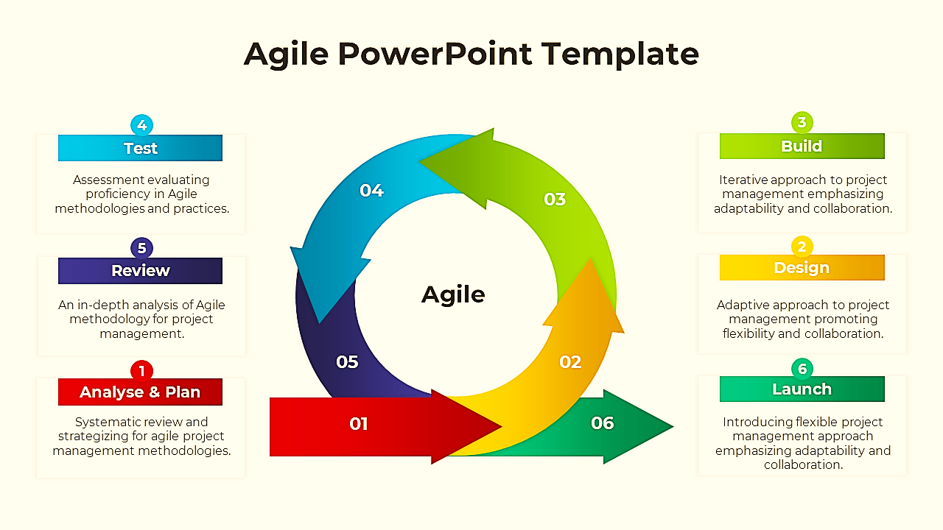
Figure ‎1.1 Agile SDLC Activities

Requirement Analysis

Literature Review
The field of three-dimensional object development and the augmented reality display have seen a lot of research activity in the last ten years. Wu et al. [1] seminal work laid the foundation of AI-driven creation of 3D models by introducing 3D Generative Adversarial Networks (3D-GANs) that learn probabilistic latent spaces of object shapes. They showed that deep neural networks could learn how to generate volumetric 3D representations given learned distributions and provided the theoretical basis on which contemporary text-to-3D pipelines are constructed. Nevertheless, this work was just research-based with no real time usage or correlation with visualization interfaces.
It is based on these generative foundations that Meshy AI [2] was one of the first commercially available web-based applications that allow users to create 3D models directly from text input or image input. Meshy is aimed at developers, game designers and VR artists, offering clean geometry and texture output that can be used in professional pipelines. Although Meshy has a high-quality generation, it is simply a generation tool, users have a downloadable model file but have no way to visualise or interact with the model in a real-world environment. It does not have any augmented reality integration at all, which is why it is not suitable in the product visualization use-case where spatial placement is a key consideration.
Tripo AI [3] enhances the speed aspect of text-to-3D generation, generating 3D assets out of text, images, or even a rough sketch in several seconds, as opposed to minutes. Its quick inference pipeline has been popular among digital creators who need quick prototyping of 3D assets. Tripo, too, does not have any AR placement features. The tool considers 3D generation as a standalone creative process that is independent of any downstream visualization process. In the case of the e-commerce field where the aim is not to create the model, but to make a customer see that model in their own physical space, the utility of Tripo is limited.
Sloyd AI [4] adopts a different parametric method to 3D generation on the web. Instead of re-creating, Sloyd uses user text prompts in conjunction with editable parametric templates to create lightweight, optimized 3D models. This way it is possible to render rapidly and with a regular topology making it useful in game asset pipelines. But since Sloyd is essentially template-driven, its creative expressiveness is limited to the template library available. It cannot develop absolutely new, unique product designs ex-novo. Additionally, Sloyd does not have an AR mode, and does not provide a way to display generated assets in a live camera view.
On the retail AR front, the ARsenal service by CGTrader [5] offers the service of allowing merchants of an e-commerce store to embed an AR preview of their product directly onto the page of an online store, supporting the integration with systems like Shopify. Shoppers can press a button and view a product model on their floor or table using their mobile browser. This is the closest existing solution to ARtisan's end goal. But ARsenal is purely based on ready-to-use, vendor-supplied, 3D models resources. The AI generation component is not present; retailers need to purchase or order 3D models separately and then it can be used on the platform. This places a huge obstacle in the path of small sellers and ends any chance of customer-driven customization or personalization.
The popular community platform Sketchfab [6] allows sharing and viewing 3D models displayed in the browser using WebGL and WebXR. It enables an entry-level AR preview experience on supported mobile devices, enabling users to place pre-rendered model in their environment. Although Sketchfab proves that WebXR AR, based on browsers, is technically and practically achievable and without the need to install an app, it is purely a model hosting and viewing platform. Creators are required to manually upload all 3D content; it does not have an AI generation capability. It does not have any e-commerce, product visualization workflow, does not provide prompting, customization, or composition of scenes.
In the analysis of available tools and literature, there was a clear and consistent gap. Meshy AI [1], Tripo AI [2] and Sloyd AI [3] are tools that only focus on the use of AI to generate images in 3D, but they do not provide any augmented reality placement feature. On the other hand, browser-based AR visualization is supported by platforms like CGTrader ARsenal [4] and Sketchfab [5], but rely completely on existing pre-made 3D assets, and do not have any AI-generation component. None of the existing solutions combine on-demand, text-based Generative AI model generation with real-time in-browser WebAR visualization in a single platform, which can be accessed without installation. ARtisan directly fills this gap by integrating both capabilities into one, accessible web application, and furthermore, provides role-based access, scene composition to designers, an AI recommendation system, and a personal asset management library.

Table ‎2.1 Literature Review Summary
Ref | Tool/Author | Year | Technology | Key Features | Limitations | ARtisan Advantage
[1] | Meshy Ai | 2024 | Diffusion based Gen Ai | Text & image to 3D | No AR, only generation | ARtisan adds WebXR and aR placement after generation
[2] | Tripo Ai | 2024 | Fast 3D Gen Ai | Fast text or image to 3D | No AR, only model generation | ARtisan enables immediate AR after generation
[3] | Sloyd Ai | 2023 | Parametric Gen Ai | Browser based, lightweight models. | No scratch generation, Template dependent, No AR | ARtisan generates custom model from sratch
[4] | CG Trader Arsenal | 2022 | WebAR(WebXR) | In browser AR preview | Premade models only, no generation. | ARtisan generates models on demand from text or image
[5] | Sketchfab | 2012 | WebGL(WebXR) | Browser 3D community | No generation or AR, only pre-uploaded models | ARtisan generates, places, saves and shares at once.
[6] | Wu et al. (NeurIPS) | 2016 | 3D Gen (deep learning) | Browser based 3D viewer community | Only research no implementation | ARtisan uses evolved real-time APIs built on such research

Stakeholders List
ARtisan involves multiple stakeholders who have a direct or indirect interest in the development, deployment and use of the software. The table below identifies each stakeholder, their role and their level of influence.

Table ‎2.2 Stakeholder Details
Sr. | Stakeholder | Role | Level of involvement
1 | Online Shoppers | Primary end users who generate 3D models and visualize products in AR to make confident purchasing decisions. They directly benefit from reduced purchase uncertainty. | High (Primary users who directly interact with all core platform features.)
2 | Interior Designers | Use Designer Mode to compose multi-object scenes, arrange virtual furniture layouts and share scenes with clients. | High (Power users of Designer Mode with advanced scene management needs.)
3 | E-commerce Sellers | Indirect beneficiaries who gain from reduced product return rates and increased customer confidence, resulting in lower logistical costs and higher sales conversion. | Medium (Indirect stakeholders who benefit from improved shopping outcomes.)
4 | Development Team | Development team including Warda Saeed, Saim Jamil and Syed Muaarij Nadeem are responsible for the design, development, integration, testing and documentation of entire ARtisan platform. | High (Core builders with full control over technical decisions and implementation.)
5 | FYP supervisor | Provide academic guidance, approves project milestones, deliverables and ensures the project meets university’s standards. | High (Approves scope, reviews progress and evaluates final deliverables.)
6 | CUI Lahore | The institution hosting and sponsoring the FYP. It evaluates the academic merit and professional quality of the project output. | Medium (Sets academic requirements and provides the evaluation framework.)
7 | Third-Party Ai API Providers | External service providers whose Gen Ai APIs are integrated for text-to3d and image-to-3d generation. Their service availability directly impacts platform functionality. | Medium (External dependency whose API availability affects core system features.)

Requirements Elicitation

Functional Requirements

FR-01: GENERATIVE AI (TEXT/IMAGE-TO-3D)
The system shall allow the users to generate 3D models via text or images.
FR-GAI-1: Text-to-3D Generation
The system shall enable the generation of 3D assets based on natural language descriptions.
Table ‎2.3 FR-GAI-1
Requirement ID | Requirement Description
FR-GAI-1.1 | The system shall provide a text input interface to facilitate the entry of natural language descriptions by the user.
FR-GAI-1.2 | The system shall analyse the input text to generate corresponding 3D geometry and meshes.
FR-GAI-1.3 | The system shall apply textures and colour profiles to the model in accordance with the provided textual description.

FR-GAI-2: Image-to-3D Conversion
The system shall facilitate the transformation of 2D images into 3D representations.
Table ‎2.4 FR-GAI-2
Requirement ID | Requirement Description
FR-GAI-2.1 | The system shall allow users to upload single or multiple 2D images as reference data for 3D reconstruction.
FR-GAI-2.2 | The system shall extract depth maps and geometric meshes from the uploaded images to construct a 3D model.

FR-02: 3D MODEL MANAGEMENT
The system shall allow user to search for model, view them and interact with them.
FR-MM-1: Interactive 3D Model Visualization
The system shall provide an interactive 3D viewer to preview generated models prior to AR placement.
Table ‎2.5 FR-MM-1
Requirement ID | Requirement Description
FR-MM-1.1 | The system shall allow user to search for models.
FR-MM-1.2 | The system shall load 3D models from an external API to preview.
FR-MM-1.3 | The system shall render the generated 3D model within a Web based viewer.
FR-MM-1.4 | The system shall initialize a virtual camera, lighting, and scene environment for model visualization.

FR-MM-2: User Interaction Controls
Requirement ID | Requirement Description
FR-MM-2.1 | The system shall allow users to rotate the 3D model using pointer or touch drag gestures.
FR-MM-2.2 | The system shall allow users to zoom in and zoom out using scroll or pinch gestures.
The system shall allow users to inspect generated 3D models using intuitive interaction controls.
Table ‎2.6 FR-MM-2

FR-03: WEB-BASED AUGMENTED REALITY (WEBAR)
The system shall allow user to place and manipulate models in AR environment by detecting surfaces.
FR-WAR-1: Real-World Surface Detection
The system shall detect real-world surfaces to enable accurate placement of 3D models in AR.
Table ‎2.7 FR-WAR-1
Requirement ID | Requirement Description
FR-WAR-1.1 | The system shall identify horizontal planes suitable for object placement.
FR-WAR-1.2 | The system shall provide a visual feedback when a valid surface is detected.

FR-WAR-2: AR Object Placement
The system shall allow users to place generated 3D models onto detected real-world surfaces.
Table ‎2.8 FR-WAR-2
Requirement ID | Requirement Description
FR-WAR-2.1 | The system shall place the 3D object on the detected surface upon user tap using hit testing
FR-WAR-2.2 | The system shall align the placed object relative to the detected plane orientation.
FR-WAR-2.3 | The system shall prevent object placement if no valid surface is currently detected.

FR-WAR-3: AR Object Manipulation
The system shall allow users to manipulate placed 3D models within the AR environment.
Table ‎2.9 FR-WAR-3
Requirement ID | Requirement Description
FR-WAR-3.1 | The system shall allow users to reposition placed objects using drag gestures.
FR-WAR-3.2 | The system shall allow users to rotate placed objects around the vertical axis.
FR-WAR-3.3 | The system shall allow users to scale placed objects using multi-touch gestures.
FR-WAR-3.4 | The system shall display real-time dimensions of the placed object during scaling.

FR-WAR-4: AR Interface Overlay
The system shall display UI controls over the active AR camera view.
Table ‎2.10 FR-WAR-4
Requirement ID | Requirement Description
FR-WAR-4.1 | The system shall overlay UI controls on camera view without interrupting AR session.

FR-04: USER AUTHENTICATION & ROLE MANAGEMENT
The system shall allow users to register, or login based on roles.

FR-UARM-1: User Registration & Authentication
The system shall allow users to register and authenticate using credentials.
Table ‎2.11 FR-UARM-1
Requirement ID | Requirement Description
FR-UARM-1.1 | The system shall allow new users to create an account by providing required registration details.
FR-UARM-1.2 | The system shall allow registered users to log in using valid credentials.
FR-UARM-1.3 | The system shall allow the user to reset their password if they forget it.
FR-UARM-1.4 | The system shall allow authenticated users to log out of the system.

FR-UARM-2: Role Assignment
The system shall manage predefined user roles within the platform.
Table ‎2.12 FR-UARM-2
Requirement ID | Requirement Description
FR-UARM-2.1 | The system shall ask user to select one of the two roles (either customer or designer).
FR-UARM-2.2 | The system shall allow users to access features according to their role within the platform.

FR-05: USER PROFILE MANAGEMENT
The system shall allow user to view and manage his profile.
FR-UPM-1: User Dashboard
The system shall allow user to view and manage his dashboard containing information about him.
Table ‎2.13 FR-UPM-1
Requirement ID | Requirement Description
FR-UPM-1.1 | The system shall allow the user to view his dashboard.
FR-UPM-1.2 | The system shall allow user to change his existing information.
FR-UPM-1.3 | The system shall allow user to switch his role from common user to Designer.

FR-06: SCENE & MULTI-OBJECT COMPOSITION (DESIGNER MODE)
The system shall allow designers to create a scene, manipulate objects in it and save it.
FR-SC-1: Scene Creation
The system shall allow designers to create scenes containing multiple 3D objects.
Table ‎2.14 FR-SC-1
Requirement ID | Requirement Description
FR-SC-1.1 | The system shall allow designers to add multiple 3D models into a single scene workspace.
FR-SC-1.2 | The system shall allow designers to define the spatial arrangement of objects within a scene.
FR-SC-1.3 | The system shall allow user to manipulate or use pre-built scenes.
FR-SC-1.4 | The system shall initialize a dedicated workspace for scene composition.

FR-SC-2: Object Arrangement within Scene
The system shall allow designers to organize multiple objects inside a scene.
Table ‎2.15 FR-SC-2
Requirement ID | Requirement Description
FR-SC-2.1 | The system shall allow designers to reposition objects within the scene.
FR-SC-2.2 | The system shall allow designers to rotate and scale objects within the scene.

FR-SC-3: Scene Persistence
The system shall allow designers to save and retrieve created scenes.
Table ‎2.16 FR-SC-3
Requirement ID | Requirement Description
FR-SC-3.1 | The system shall allow designers to save a composed scene.
FR-SC-3.2 | The system shall allow designers to retrieve previously saved scenes.
FR-SC-3.3 | The system shall allow designers to update existing saved scenes.

FR-07: ASSET MANAGEMENT
The system shall allow the user to manage his assets in a personalized asset library.

FR-AM-1: Personal Asset Library
The system shall maintain a personal asset library for each user.
Table ‎2.17 FR-AM-1
Requirement ID | Requirement Description
FR-AM-1.2 | The system shall associate generated 3D models with the respective user account.
FR-AM-1.3 | The system shall allow users to view all saved assets within their library.

FR-AM-2: Asset Storage
The system shall allow users to store generated 3D models.
Table ‎2.18 FR-AM-2
Requirement ID | Requirement Description
FR-AM-2.1 | The system shall allow users to save 3D models.
FR-AM-2.2 | The system shall store metadata associated with saved models (e.g., creation date).
FR-AM-3: Asset Deletion
The system shall allow users to remove saved 3D models.
Table ‎2.19 FR-AM-3
Requirement ID | Requirement Description
FR-AM-3.1 | The system shall allow users to delete selected models from their asset library.
FR-AM-3.2 | The system shall update the library view immediately after deletion.

FR-08: MODEL EXPORT & SHARING
The system shall allow user to download and share models.

FR-MES-1: Model Download
The system shall allow users to download generated or searhed 3D models.
Table ‎2.20 FR-MES-1
Requirement ID | Requirement Description
FR-MES-1.1 | The system shall allow users to download a generated or searched 3D model.
FR-MES-1.2 | The system shall allow download of previously saved models from the asset library.

FR-MES-2: Model Sharing
The system shall allow users to share models.
Table ‎2.21 FR-MES-2
Requirement ID | Requirement Description
FR-MES-2.1 | The system shall generate a shareable access link for selected models.
FR-MES-2.2 | The system shall allow recipients to view shared models within the browser.

FR-09: AI RECOMMENDATION SYSTEM
The system shall analyze user behaviour and environmental context to provide intelligent suggestions.
FR-AIR-1: Contextual Asset Suggestions
The system shall provide asset recommendations based on the current user environment and historical data.
Table ‎2.22 FR-AIR-1
Requirement ID | Requirement Description
FR-AIR-1.1 | During scene composition, the system shall suggest 3D assets that are aesthetically or functionally similar to the objects currently present in the workspace.
FR-AIR-1.2 | The system shall display "Trending" or "Frequently Used" models tailored to the specific usage history of the authenticated user.

FR-AIR-2: Smart Prompt Engineering
The system shall assist users in optimizing AI inputs to ensure high-quality output.
Table ‎2.23 FR-AIR-2
Requirement ID | Requirement Description
FR-AIR-2.1 | The system shall provide AI-powered "Prompt Suggestions" if the user-entered text is insufficient, ensuring the generation of optimized 3D models

Non-functional Requirements

NFR-1: Performance
The system shall provide high performance while rendering and generating models.
Table ‎2.24 NFR-1
Requirement ID | Requirement Description
NFR-1.1 | The system shall load the landing page within 2 seconds under a stable connection.
NFR-1.2 | The system shall load the asset library within 5 seconds.
NFR-1.3 | The system shall render a model in AR environment within 20 seconds.
NFR-1.4 | The system shall generate a high quality model within 1-3 minutes of prompting.

NFR-2: Usability
The system shall provide high usability to users without having technical knowledge.
Table ‎2.25 NFR-2
Requirement ID | Requirement Description
NFR-2.1 | A first-time user shall be able to prompt and generate a model within 5 minutes without any guidance.
NFR-2.2 | The system shall provide a consistent layout and icons for easy recognition.
NFR-2.3 | The system shall show the users multiple screen gestures to easily interact with models.

NFR-3: Compatibility
The system shall operate correctly across all major browsers and devices.
Table ‎2.26 NFR-3
Requirement ID | Requirement Description
NFR-3.1 | The web application shall function correctly on major browsers including Chrome, Edge, Brave.
NFR-3.2 | The system shall adapt its interfaces according to mobile, laptop and tablet screens.
NFR-3.3 | The system shall support all core features on mid-range devices with a minimum of 4GB RAM.

NFR-4: Error Handling
The system shall handle errors and failures gracefully and alert the user.
Table ‎2.27 NFR-4
Requirement ID | Requirement Description
NFR-4.1 | The system shall display proper error messages for failed API calls, invalid inputs and unsupported file formats.
NFR-4.2 | The system shall handle all major errors including session termination without crashing.
NFR-4.3 | The system shall continue working normally after encountering and displaying errors.

NFR-5: Security
The system shall protect user data, credentials and assets from unauthorized access or exposure.
Table ‎2.28 NFR-5
Requirement ID | Requirement Description
NFR-5.1 | The system shall restrict user to view and manage its own data only.
NFR-5.2 | The system shall store user password in hashed form.
NFR-5.3 | The system shall enforce role based access by allowing Designer mode features to designer type users only.
NFR-5.4 | The system shall protect all API calls, responses and authentication with HTTP protocol.

Requirements Traceability Matrix

Table ‎2.29 RTM
Req ID | Use Case ID | Use Case Name | Test Case ID | Activity Diagram | Sequence Diagram
FR-01: GENERATIVE AI (Text/Image-to-3D)
FR-GAI-1.1 | UC-01 | Generative AI | TC-01, TC-02, TC-03 | AT-01 | SQ-01
FR-GAI-1.2 | UC-01 | Generative AI | TC-01, TC-04, TC-06 | AT-01 | SQ-01
FR-GAI-1.3 | UC-01 | Generative AI | TC-01, TC-07 | AT-01 | SQ-01
FR-GAI-2.1 | UC-01 | Generative AI | TC-08, TC-09, TC-10 | AT-01 | SQ-01
FR-GAI-2.2 | UC-01 | Generative AI | TC-08, TC-09 | AT-01 | SQ-01
FR-02: 3D MODEL MANAGEMENT
FR-MM-1.1 | UC-02 | Preview and Interact with 3D Model | TC-11, TC-16, TC-17 | AT-02 | SQ-02
FR-MM-1.2 | UC-02 | Preview and Interact with 3D Model | TC-11, TC-18 | AT-02 | SQ-02
FR-MM-1.3 | UC-02 | Preview and Interact with 3D Model | TC-11 | AT-02 | SQ-02
FR-MM-2.1 | UC-02 | Preview and Interact with 3D Model | TC-12 | AT-02 | SQ-02
FR-MM-2.2 | UC-02 | Preview and Interact with 3D Model | TC-13, TC-14, TC-15 | AT-02 | SQ-02
FR-03: WEB-BASED AUGMENTED REALITY (WEBAR)
FR-WAR-1.1 | UC-03 | Detect Real-World Surface for AR | TC-19, TC-20, TC-21, TC-22 | AT-03 | SQ-03
FR-WAR-1.2 | UC-03 | Detect Real-World Surface for AR | TC-21 | AT-03 | SQ-03
FR-WAR-2.1 | UC-03 | Detect Real-World Surface for AR | TC-23, TC-24 | AT-03 | SQ-03
FR-WAR-2.2 | UC-03 | Detect Real-World Surface for AR | TC-23 | AT-03 | SQ-03
FR-WAR-2.3 | UC-03 | Detect Real-World Surface for AR | TC-24 | AT-03 | SQ-03
FR-WAR-3.1 | UC-03 | Detect Real-World Surface for AR | TC-25 | AT-03 | SQ-03
FR-WAR-3.2 | UC-03 | Detect Real-World Surface for AR | TC-26 | AT-03 | SQ-03
FR-WAR-3.3 | UC-03 | Detect Real-World Surface for AR | TC-27 | AT-03 | SQ-03
FR-WAR-3.4 | UC-03 | Detect Real-World Surface for AR | TC-27 | AT-03 | SQ-03
FR-WAR-4.1 | UC-03 | Detect Real-World Surface for AR | TC-28, TC-29 | AT-03 | SQ-03
FR-04: USER AUTHENTICATION & ROLE MANAGEMENT
FR-UARM-1.1 | UC-04 | Authenticate User | TC-30, TC-31, TC-32, TC-33 | AT-04 | SQ-04
FR-UARM-1.2 | UC-04 | Authenticate User | TC-34, TC-35, TC-36, TC-37, TC-38 | AT-04 | SQ-04
FR-UARM-1.3 | UC-04 | Authenticate User | TC-39 | AT-04 | SQ-04
FR-UARM-2.1 | UC-04 | Authenticate User | TC-30 | AT-04 | SQ-04
FR-UARM-2.2 | UC-04 | Authenticate User | TC-34 | AT-04 | SQ-04
FR-05: USER PROFILE MANAGEMENT
FR-UPM-2.1 | UC-05 | Manage Profile | TC-40 | AT-05 | SQ-05
FR-UPM-2.2 | UC-05 | Manage Profile | TC-41, TC-42 | AT-05 | SQ-05
FR-UPM-2.3 | UC-05 | Manage Profile | TC-43, TC-44 | AT-05 | SQ-05
FR-06: SCENE & MULTI-OBJECT COMPOSITION
FR-SC-1.1 | UC-06 | Create and Compose Multi Object Scene | TC-45, TC-46, TC-47 | AT-06 | SQ-06
FR-SC-1.2 | UC-06 | Create and Compose Multi Object Scene | TC-45, TC-48 | AT-06 | SQ-06
FR-SC-1.3 | UC-06 | Create and Compose Multi Object Scene | TC-51 | AT-06 | SQ-06
FR-SC-1.4 | UC-06 | Create and Compose Multi Object Scene | TC-45 | AT-06 | SQ-06
FR-SC-2.1 | UC-06 | Create and Compose Multi Object Scene | TC-48 | AT-06 | SQ-06
FR-SC-2.2 | UC-06 | Create and Compose Multi Object Scene | TC-49 | AT-06 | SQ-06
FR-SC-3.1 | UC-06 | Create and Compose Multi Object Scene | TC-50 | AT-06 | SQ-06
FR-SC-3.2 | UC-06 | Create and Compose Multi Object Scene | TC-51 | AT-06 | SQ-06
FR-SC-3.3 | UC-06 | Create and Compose Multi Object Scene | TC-52, TC-53 | AT-06 | SQ-06
FR-07: ASSET MANAGEMENT
FR-AM-1.1 | UC-07 | Manage Personal Asset Library | TC-54 | AT-07 | SQ-07
FR-AM-1.2 | UC-07 | Manage Personal Asset Library | TC-55, TC-56 | AT-07 | SQ-07
FR-AM-2.1 | UC-07 | Manage Personal Asset Library | TC-54 | AT-07 | SQ-07
FR-AM-2.2 | UC-07 | Manage Personal Asset Library | TC-54 | AT-07 | SQ-07
FR-AM-3.1 | UC-07 | Manage Personal Asset Library | TC-57, TC-58, TC-59 | AT-07 | SQ-07
FR-AM-3.2 | UC-07 | Manage Personal Asset Library | TC-57 | AT-07 | SQ-07
FR-08: MODEL EXPORT & SHARING
FR-MES-1.1 | UC-08 | Export and Share Model | TC-60, TC-61, TC-62 | AT-08 | SQ-08
FR-MES-1.2 | UC-08 | Export and Share Model | TC-60, TC-61 | AT-08 | SQ-08
FR-MES-2.1 | UC-08 | Export and Share Model | TC-63 | AT-08 | SQ-08
FR-MES-2.2 | UC-08 | Export and Share Model | TC-64, TC-65 | AT-08 | SQ-08
FR-09: AI RECOMMENDATION SYSTEM
FR-AIR-1.1 | UC-09 | Receive AI Recommendation | TC-66, TC-67, TC-68 | AT-09 | SQ-09
FR-AIR-1.2 | UC-09 | Receive AI Recommendation | TC-68 | AT-09 | SQ-09
FR-AIR-2.1 | UC-09 | Receive AI Recommendation | TC-69, TC-70, TC-71, TC-72 | AT-09 | SQ-09

Use Case Description

Table ‎2.30 UC Description-01
Use case ID: UC-01
Use case Name: Generative AI
Priority Critical (21)
Input 2D image or Text Description for 3D Model
Output Generated 3D Model
Actors: Registered User
Use Case Summary | An authenticated user will provide a natural language description of a desired 3D object. The system authenticates the input, sends it to the AI generation engine, and generates a high-fidelity 3D object - including geometry, mesh structure, and suitable textures and color profiles - which can be rendered in the interactive preview viewer and saved, exported or placed in AR.
Pre-condition: | - The user is valid and has a valid session.  - The user is in the Generative AI module.  - The AI generation service is available and accessible online.  - The account of the user has enough generation entitlements.
Normal Flow of Events |  |  | Alternative Path
- The use case starts when the user opens the Text-to-3D generation interface.
- In the system there is a text input field and a button to generate.
- The user gives a natural language description of the desired 3D object.
- The user will click on the 'Generate' button to post the description.
- The system checks whether the input is not empty and has not less than the minimum character requirement.
- The system sends text to the AI generation engine and displays a progress indicator.
- The description is processed by the AI engine to generate geometry, mesh topology and color/texture mappings.
- The 3D mesh is built out by the AI engine and the textures derived are applied.
- The model that is finished is put back into the system and displayed in the interactive 3D preview viewer. |  |  | 9a. The Smart Prompt engine detects the input being inadequate; the engine proposes optimized suggestions of prompts (see UC-AIR-01) and waits until a refined description is provided, after which generation is restarted.
- The system will inform the user that the generation is complete and give him/her a choice in order to save, export or put the model in AR.
Exceptions / Alerts
- When there is nothing in the text field or just whitespace, on submission, the system will show an inline validation error and stop the request.
- In the case when AI generation engine cannot be reached, a service-unavailability error is shown, and the input of the user is saved to be retried.
- Failure to respond to the generation engine within the predefined time period will cause the system to cancel the request and offer a Retry button.
- In case the text submitted breaches the content moderation policy, the system rejects the request, and an appropriate policy message informs the user.
Post Conditions
Step# |  |  | Description
 |  |  | 3D model based on the given text description has been generated successfully.
 |  |  | The model created is rendered and can be viewed in the 3D preview viewer, which is interactive.
 |  |  | The model can be saved to the asset library of the user, exported to a supported format or AR placed.
Use Case Cross References
Includes |  | UC-09, UC-02
Extends |  | None

Table ‎2.31 UC Description-02
Use case ID: UC-02
Use case Name: Preview and Interact with Generated 3D Model
Priority Critical (13)
Input A 3D model + User gestures
Output Real-time rendered model with applied rotations/zoom
Actors: Authenticated User
Use Case Summary | After a successful model generation or selection in the asset library, the system loads the 3D model into a web-based interactive viewer, loads a virtual camera, scene lighting, and environment and exposes rotation and zoom interaction controls, allowing the user to fully view the model before saving, exporting, or placing the AR.
Pre-condition: | - The user is an authenticated and active user.  - Valid 3D model created (UC-GAI-01) or chosen in the user’s asset library.  - WebGL is rendered by the browser of the user.
Normal Flow of Events |  |  | Alternative Path
- The use case starts when the model generation has succeeded or when the user chooses a model that is saved in the asset library.
- The 3D model asset is retrieved by the system powered by the external API or asset store.
- The system launches the web-based viewer and sets up a virtual camera, lighting rig and scene environment.
- The system makes the 3D model inside the viewer and renders it to the user.
- The system shows interaction controls (rotate (drag gesture) and zoom (scroll / pinch) and action options: Save, Export, AR Placement.
- The model can be rotated by the user via a pointer or touch drag gesture. |  |  | 6a. When the browser is unsupportive of WebGL, the system will display an unsupported-browser message with a recommended alternative, compatible browser.
- The system uses rotation transformation and re-renders the model in real time.
- A scroll wheel or pinch gesture enables the user to zoom in or out.
- The system changes the distance of the camera and re-renders.
- The user can leave the use case by navigating, saving, exporting, or starting an AR session.
Exceptions / Alerts
- In case the model asset cannot be loaded either via the API or the storage, the system shows an error report and offers a Retry button.
- When using a browser that is not compatible with WebGL, the system will issue a warning about compatibility.
- The 3D viewer can fail to start up, in which case the failure is recorded by the system, and a fallback view of a static preview is shown where available.
- When the performance of the renderer is greatly impaired during interaction, the system temporarily decreases the visual fidelity in order to remain responsive.
Post Conditions
Step# |  |  | Description
 |  |  | 3D model is completed and can be seen in the interactive viewer.
 |  |  | Any transformations by the user (rotation, zoom) are displayed in the current view.
 |  |  | The user can save, export or start an AR session.
Use Case Cross References
Includes |  | None
Extends |  | UC-01, UC-06

Table ‎2.32 UC Description-03
Use case ID: UC-03
Use case Name: Detect Real-World Surface for AR Placement
Priority High (21)
Input Camera feed + touch gestures
Output 3D Model placed and manipulated in AR on a real surface
Actors: Authenticated User
Use Case Summary | The model viewer provides an authenticated user with an AR session. It is the system that opens the device camera, scans real-world horizontal surfaces and when the user taps, the selected 3D model is placed on the detected surface. The user then controls the model placed, repositioning, rotating, scaling the model through touch gestures, and a consistent UI overlay offers session control all through the experience.
Pre-condition: | - The user is logged in and has an active session.  - A 3D model is ready to be placed in AR and is either generated or chosen.  - The device which is being used by the user has a functioning camera and the user has given permission to access the camera.  - The browser is WebXR or other AR-enabled.
Normal Flow of Events |  |  | Alternative Path
- The use case starts when the user clicks on Place in AR on the model viewer.
- The system will request permission for the camera in case it is not granted. |  |  | 2a. Should the camera permission be refused, a message of access-denied is shown and the user is redirected to device settings where he can manually permit it.
- The camera feed is triggered by the system and starts to render the live AR view.
- The system constantly scans the camera feed to identify horizontal real-world surfaces.
- When a valid surface is detected, the system overlays a visual placement indicator (e.g. animated ring or grid) on the detected surface. |  |  | 5a. When no valid surface is found within a given duration, the system will show a contextual guidance message, which will provide the user with advice to pan the camera over a flat and well-lit surface.
- The system makes the UI overlay on the camera view without interrupting the AR session (FR-WAR-4.1).
- The user will touch the placement indicator, and the 3D model will be placed at the location of the detected surface.
- The system does a hit-test to calculate accurate world-space coordinates and positions the model in the orientation of the plane found. |  |  | 8a. When no valid surface is found at the time of tap, the system ignores the placement event and gives a temporary notification to target an identified surface.
- The model is re-created in the AR environment at the given location.
- The user uses a one-finger dragging gesture to re-position the model inserted.
- The system keeps the model position in the world-space up to date.
- User does a rotating motion to spin the model around the vertical axis.
- The system uses rotation and re-renders the model respectively. |  |  | 13a. In case of an ambiguous gesture, the system will consider the most dominant gesture type, and the other conflicting gestures will be ignored.
- The user makes a two-finger pinch movement to resize the model, the system shows live dimensional data in the form of AR overlay.
- The user comes out of AR mode through the overlay control and the use case is terminated.
Exceptions / Alerts
- In case the device camera is not available or is out of order, the system gives a notification of hardware-error and leaves the AR mode.
- In case of a non-supportive browser, the system will show a message of compatibility and recommend the user to use a compatible browser.
- When the hit-test fails to give valid world coordinates, the system does not position the model and offers a retry prompt.
- In case the 3D model asset fails to appear in the AR environment, the system records the failure and displays an error message.
- When UI overlay cannot be rendered, the system offers fallback exit mechanism that the user can use to end the AR session.
Post Conditions
Step# |  |  | Description
 |  |  | The 3D model is positioned and displayed in the AR environment at the real-world location which is selected by the user.
 |  |  | Any repositioning, rotation and scaling changes made by the user are updated on the model.
 |  |  | In the scaling interaction, live dimensional data was shown correctly.
 |  |  | AR session was successfully closed, and the user was sent back to the model viewer.
Use Case Cross References
Includes |  | None
Extends |  | UC-02

Table ‎2.33 UC Description-04
Use case ID: UC-04
Use case Name: Authenticate User
Priority Critical (8)
Input User Credentials, registration form, or logout action
Output Authenticated session with role-based dashboard access
Actors: Unauthenticated User/Visitor
Use Case Summary | A guest user registers an account by filling in registration information and choosing a platform role (Customer or Designer). The system verifies the input, creates the account and provides role-appropriate access. Active users re-enter into a working session with a valid set of credentials. Authenticated users can also change a forgotten password or log out to end their session in a secure manner.
Pre-condition: | - To register: the user does not have a pre-existing account, and the registration service is free.  - In the case of Login: the user has registered account and availability of authentication service is present.  - To reset password: the user has a registered account and has a valid email address and email notification service is on.  - In case of Logout: the user has been authenticated and has an active session.
Normal Flow of Events |  |  | Alternative Path
- [Registration] Guest goes to the Registration page; the system displays the registration form (name, email, password, role selection).
- The user fills the form, chooses a role (Customer or Designer) and submits. |  |  | 2a. In case of a failed validation (format, empty, weak password) the error is denoted in-line, and the submission is stopped.
- The system verifies uniqueness of emails; establishes the account; attaches the role chosen; logs a user in; redirects to a role-specific dashboard. |  |  | 3a. In case the email is already registered the system informs the user and provides the option of Log in or Forget Password.
- [Login] Registered user comes into the Login page; types email and password and clicks it.
- The system authenticates credentials with data in accounts. |  |  | 5a. In case of invalid credentials, an error is shown in the system. Once the user has failed after a certain number of attempts, an account will be locked and the user informed.
- The system will create a secure authenticated session and redirect the user to a role-appropriate dashboard.
- [Password Reset] User clicks on the Forgot Password; enters registered email; system sends time-limited reset link. |  |  | 7a. If the email is not registered, then a generic confirmation message is displayed by the system to avoid account enumeration.
- The user clicks on the reset link; the system authenticates the token; it displays a new-password form; the user inputs a new password; system authenticates and redirects to login. |  |  | 8a. In case of an expired token, the system shows an expiry message and provides a reset request.
- [Logout] Authorized user clicks Log Out; the system invalidates server-side session token, removes local session information and redirects to the Login page.
Exceptions / Alerts
- When the registration or authentication service is not available then the system will show a service-error message and recommend that you re-try.
- In case the account of the user is suspended, the system informs the user and gives him/her a support contact route.
- If email notification service could not be used when resetting a password, the system would show an error and request that the user tries again.
- In the event of a network error causing the session invalidation during logout, the system will re-attempt and the local session data will still be cleared to ensure further local access is not possible.
Post Conditions
Step# |  |  | Description
 |  |  | On successful registration: a new account will be created, the role chosen will be assigned and user will be authenticated.
 |  |  | After successful log-in the user is granted an active authenticated session wherein he/she is allowed to access features of their role.
 |  |  | On successful password reset account information is changed, and all previous sessions are invalidated.
 |  |  | Upon logout: the user is not authenticated, and the server is ended.
Use Case Cross References
Includes |  | None
Extends |  | None

Table ‎2.34 UC Description-05
Use case ID: UC-05
Use case Name: Manage Profile
Priority Medium (5)
Input Updated profile fields or role-switch confirmation
Output Saved profile changes or upgraded Designer role and permissions
Actors: Authenticated User
Use Case Summary | An authenticated user will visit their personal dashboard to see account activity and role-specific quick access shortcuts. The user can add/edit personal profile information (name, contact details) that is verified by the system and stored. A Customer-role user can also request a role upgrade to Designer where the system modifies permissions and provides access to Designer-exclusive features.
Pre-condition: | - The user is logged-in and has an active session.  - To switch roles: the user is in Customer role.  - The profile management service is provided.
Normal Flow of Events |  |  | Alternative Path
- The user starts using the application at the Dashboard.
- The system retrieves and displays the profile summary, recent activity, and role-specific shortcuts of the user.
- [Update Profile] The user clicks on the Edit Profile; the system has a pre-filled profile edit form.
- The user makes the desired fields and submits.
- The system verifies the correct format and content of all fields changed. |  |  | 5a. When a field fails to validate, the system will draw attention by displaying an inline error message and stop submitting.
- The system continues with the updated information and shows successful confirmation with updated profile view.
- [Role Switch] A Customer picks a customer chooses a switch to designer; the system throws a confirmation dialogue with the consequences of the action.
- The role switch is confirmed by the user. |  |  | 8a. When the user disregards, the system rejects the dialogue and does not alter the role but leaves it the same.
- The system changes the role to Designer, reloads the session permissions, and redirects the user to the Designer dashboard where newly unlocked features are available.
Exceptions / Alerts
- In case of a service error during the profile update operation, the system provides an error notification, keeps the input of the user and provides a retry option.
- In case of failure in the role update operation, the system shows an error and does not change the role of the user partially.
- In case of inability to retrieve dashboard data, a partial dashboard with available information is displayed and user information is notified that certain content is temporarily unavailable.
Post Conditions
Step# |  |  | Description
 |  |  | The dashboard of the user shows up to date account and activity information.
 |  |  | In case profile was updated: the updated information is stored, and profile view shows the updated data.
 |  |  | In case of role switch: the role of the user is changed to Designer; the session permissions are changed to reflect the new role and Designer-only features are available.
Use Case Cross References
Includes |  | None
Extends |  | UC-04

Table ‎2.35 UC Description-06
Use case ID: UC-06
Use case Name: Create and Compose a Multi-Object Scene
Priority High (13)
Input Selected models + transformation actions + scene name
Output Saved profile changes or upgraded Designer role and permissions
Actors: Designer
Use Case Summary | A Designer starts a new scene composition. The system opens a special workspace where the Designer adds several 3D models to the asset library and determines how they should be positioned in space with positioning, rotation and scale tools. The Designer then stores the scene to be persistent; the existing scenes can be later accessed and modified.
Pre-condition: | - The user is logged in with the Designer role.  - The user has entered the Scene Composition module.  - The Designer has at least one 3D model in his/her asset library.
Normal Flow of Events |  |  | Alternative Path
- When the Designer decides on the creation of a new Scene, the use case commences. |  |  | 1a. As an alternative, the Designer chooses My Scenes, and then the system loads the previously saved configuration into the workspace to update.
- The system creates a default environment and spatial grid in an empty scene workspace.
- Designer chooses one or several 3D models in the asset library to include in the scene. |  |  | 3a. The Designer can also choose a pre-built scene template; the system loads the template configuration and loads the workspace with it.
- The system loads and displays each model chosen in the scene workspace.
- The Designer picks an object; the system underlines it and shows transformation handles.
- The Designer moves the chosen object with drag controls; the system changes its position in the real-world space as the Designer moves it.
- The Designer uses rotation and scale transformations; the system re-renders the object dynamically. |  |  | 7a. The system would limit the transformation and inform the Designer in case a transformation would lead to an invalid spatial state.
- The Designer rotates the chosen object with the help of a rotation gizmo or rotation input.
- The Designer clicks Save Scene; the system will prompt him or her to enter a scene name and description (optional).
- The Designer acknowledges the save; the scene configuration is serialized by the system and stored.
- The system verifies the successful save and changes the metadata of the save (last-modified timestamp).
- To update a scene that is already loaded, the Designer makes changes and chooses to update the scene; the system will overwrite the saved configuration and will confirm the update.
Exceptions / Alerts
- In case the scene workspace does not start up the system shows an error and provides a restart button.
- When a chosen model does not load into the workspace, the system will give a per-model error, and the failed asset will skip without affecting the rest of the scene.
- In case the save operation is not successful because of a storage error, the system will show an error message, and the unsaved state is stored in the active session.
- When a retrieved scene refers to those assets that have been deleted, the system will load the available assets and alert the Designer about the lost models.
Post Conditions
Step# |  |  | Description
 |  |  | The scene workspace is a workspace of all the added 3D models in the Designer-defined spatial arrangement.
 |  |  | The designed scene is saved in the scene library of the Designer with existing metadata.
 |  |  | The scene can be further edited, retrieved or AR placed.
Use Case Cross References
Includes |  | UC-07
Extends |  | None

Table ‎2.36 UC Description-07
Use case ID: UC-07
Use case Name: Manage Personal Asset Library
Priority High (8)
Input Save/Delete Action on a 3D model
Output Model stored or removed from library; updated library view
Actors: Authenticated User
Use Case Summary | An authorized user would store a created 3D model in their personal asset library, and the system identifies the asset with the user account and stores associated metadata. The user can then view all the assets saved in the library and permanently delete any chosen model, and the library view will update in real-time.
Pre-condition: | - The user is an authenticated user that has an active session.  - In case of Save: a 3D model generated is presently shown in preview viewer.  - In the case of View and Delete: the user will navigate to the Asset Library.
Normal Flow of Events |  |  | Alternative Path
- [Save] The case starts when the user clicks on the menu of the model viewer and chooses to save.
- The system will ask the user to save and give an optional model name/ tag.
- The user validates; the system links the model to the account of the authenticated user and stores the asset and metadata (date of creation, labels).
- The system sends confirmation of successful save and updates the library view to reflect the new model.
- [View] The user will navigate to the Asset Library; the system will get all 3D model assets that belong to the user account.
- The system makes the library view showing thumbnail previews, model names, and creation dates.
- The user navigates the library and can preview, export, share or delete a model. |  |  | 7a. When the library has no assets, the system will show an empty-state message and will ask to create a first model.
- [ Delete] A user chooses Delete on a model; the system will show a confirmation dialogue where it will inform the user that the action cannot be reversed.
- The user is sure that the deletion has occurred; the system will forever remove the model asset and the metadata of the model asset out of the storage. |  |  | 9a. In case the user cancels, the system discards the dialogue, and the model remains the same.
- The system deletes the deleted model off the library view instantly and ascertains the deletion success.
Exceptions / Alerts
- In case the storage service is unavailable at saving, the system will show an error and leave the model in the active session to re-try.
- When the asset retrieval fails when looking at the library, the system shows a service-error message and offers an option of a re-try.
- In case of a failure of the deletion operation, the system provides an error notification and puts the model back into the library.
Post Conditions
Step# |  |  | Description
 |  |  | In case of save: the 3D model and its metadata are stored in the asset library of the user and can be seen in the library view.
 |  |  | On sight: all the assets saved are presented to the user including relevant metadata.
 |  |  | On deletion: this model is deleted forever out of the library, and the view is updated instantly.
Use Case Cross References
Includes |  | UC-02
Extends |  | UC-01

Table ‎2.37 UC Description-08
Use case ID: UC-08
Use case Name: Export and Share Model
Priority Medium (8)
Input Selected model + export format or share action
Output Downloaded file or shareable view-only browser link
Actors: Authenticated and Unauthenticated Users
Use Case Summary | A user, who has been authenticated, downloads a 3D model generated (or library-stored) to their local machine in a chosen export format, and/or creates a sharing access link so that recipients can view the model in a 3D viewer in a browser without a platform account.
Pre-condition: | - The user is logged in and has an active session.  - An object is a 3D model that either is present in the preview viewer or is chosen in the asset library.
Normal Flow of Events |  |  | Alternative Path
- [Export/Download] The case usage starts when the user either chooses the option of exporting or downloading in the model viewer or asset library.
- The system offers the existing options of export formats (e.g., glb, .obj).
- The user chooses the type of export desired; the system packages the model in that manner.
- The system proceeds to download the file to the user’s device and the download is validated. |  |  | 4a. In case the browser blocks automatic downloads, the system will offer a direct download link as an alternative.
- [Share via Link] The user clicks on the model option of Share.
- The system creates a special shareable access link to the chosen model.
- The system shows the created connection with a 'Copy Link' button.
- The user replicates the link and shares it with the target audience.
- A recipient opens the link in a web browser; the system reads the shared model and displays it in a read-only web-based 3D viewer. |  |  | 9a. When the common link is revoked, or the model has been deleted the system will display a page indicating that the model is not found to the recipient.
Exceptions / Alerts
- In case of any failure in the packaging process when exporting, the system will show an error and give a chance to re-try.
- In case of a failure in the link generation, the system shows an error and provides a retrial facility.
- When the browser of the recipient is unable to support WebGL, the system will make a compatibility notification.
Post Conditions
Step# |  |  | Description
 |  |  | On export: the 3D model is now downloaded on the local machine of the user in the desired format.
 |  |  | Upon share: a distinct shareable access link is created; a viewer can see the model in a browser, without a platform account.
Use Case Cross References
Includes |  | UC-MPV-02 (3D Model Preview)
Extends |  | UC-AM-07 (Asset Management)

Table ‎2.38 UC Description-09
Use case ID: UC-09
Use case Name: Receive AI Recommendations
Priority Medium (13)
Input Active scene objects or a weak prompt
Output Suggestions for the existing models or prompts
Actors: Authenticated User
Use Case Summary | The system offers two types of AI-based recommendations. In scene composition, Designers are given contextual 3D asset recommendations, based on the objects in the workspace, and custom trending model recommendations. When generating the text model, users whose prompt is deemed too weak are given Smart Prompt, improved versions of their prompt generated by AI, prior to any further generation.
Pre-condition: | - The user has been authenticated and is actively logged in.  - In case of asset recommendations: the user is the Designer and there is at least one active scene with at least one 3D object in it; the recommendation engine is online.  - To get smart at making prompt suggestions: the user has typed in a prompt in the Text-to-3D interface and the Smart Prompt engine has considered it inadequate.
Normal Flow of Events |  |  | Alternative Path
- [Contextual Asset Suggestions] It starts with the Designer opening or placing an object in a live workspace.
- The system examines the objects that are in the workspace and forwards the context to the recommendation engine.
- The engine recognizes aesthetically or functionally similar assets of the platform catalogue and generates personalized recommendations of Trending and Frequently Used items, based on the usage history of the Designer. |  |  | 3a. In case, there is no history of usage by the Designer, the system offers globally trending model as an alternative to personalized recommendations.
- There is a panel of suggested assets and the scene workspace with the recommendations in the system.
- The Designer looks through suggestions and has an option to add a recommended asset to the scene.
- The system reacts to updates by updating recommendations as additional objects are introduced into the scene.
- [Smart Prompt Suggestions] The Smart Prompt engine identifies a given text description as not sufficiently good to produce quality 3D generation.
- When the system notices that the generation process is stopped, it informs the user that the prompt needs to be enriched.
- The engine processes the original text and produces a list of optimized prompt variants, with important additions (e.g., added material, scale or lighting descriptors) highlighted.
- The user chooses one of the recommended prompts or hand tweezes the original. |  |  | 10a. Should the user reject all the suggestions and choose to go with the initial prompt, the system sends it as typed with a warning that it might not be of quality output.
- The system sends the selected prompt to the AI generation engine and restarts the generation process (UC-GAI-01).
Exceptions / Alerts
- When the recommendation engine is offline when composing the scene, the suggestions panel will be hidden, and scene composition will proceed as usual.
- In case the Smart Prompt engine is not able to produce any suggestions, then it will use the original prompt and record the failure.
Post Conditions
Step# |  |  | Description
 |  |  | On asset suggestions: the Designer has been given contextually relevant suggestions and might have added one or more to the scene.
 |  |  | To make smart prompt suggestions: the user has already been shown optimized prompt options; an optimized or original prompt has been entered into the AI generation engine and the generation proceeds.
Use Case Cross References
Includes |  | UC-GAI-01, UC-SC-06
Extends |  | None

System Design

Use Case Design

UC-01 Generative AI
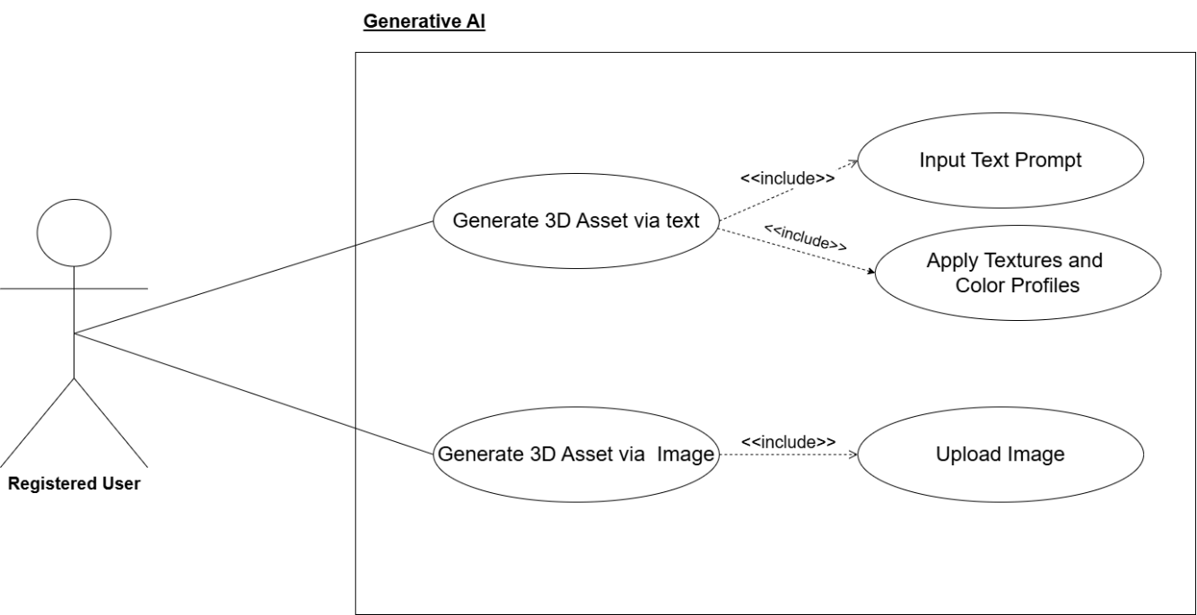
Figure ‎3.1 UC-01

UC-02 Preview and Interact with 3D Model
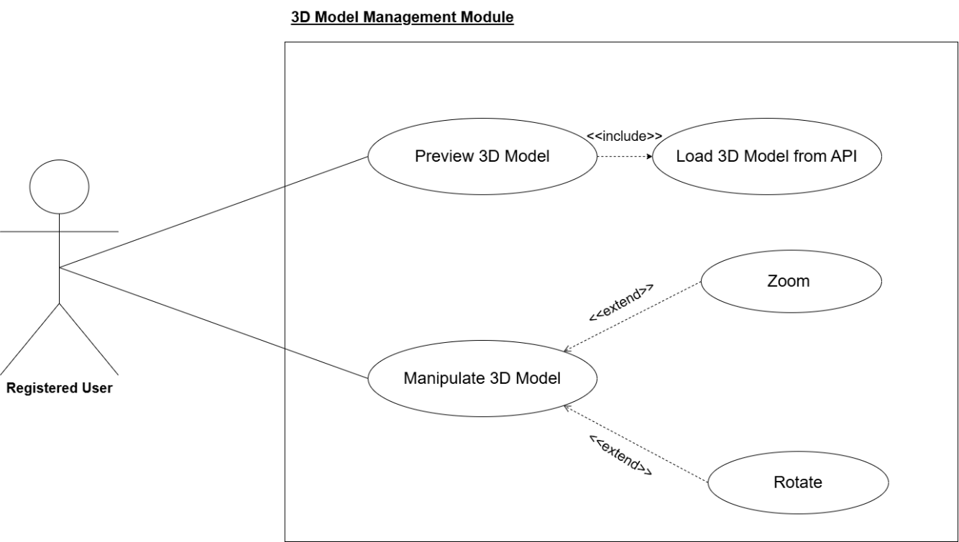
Figure ‎3.2 UC-02

UC-03 Detect Real-World Surface for AR
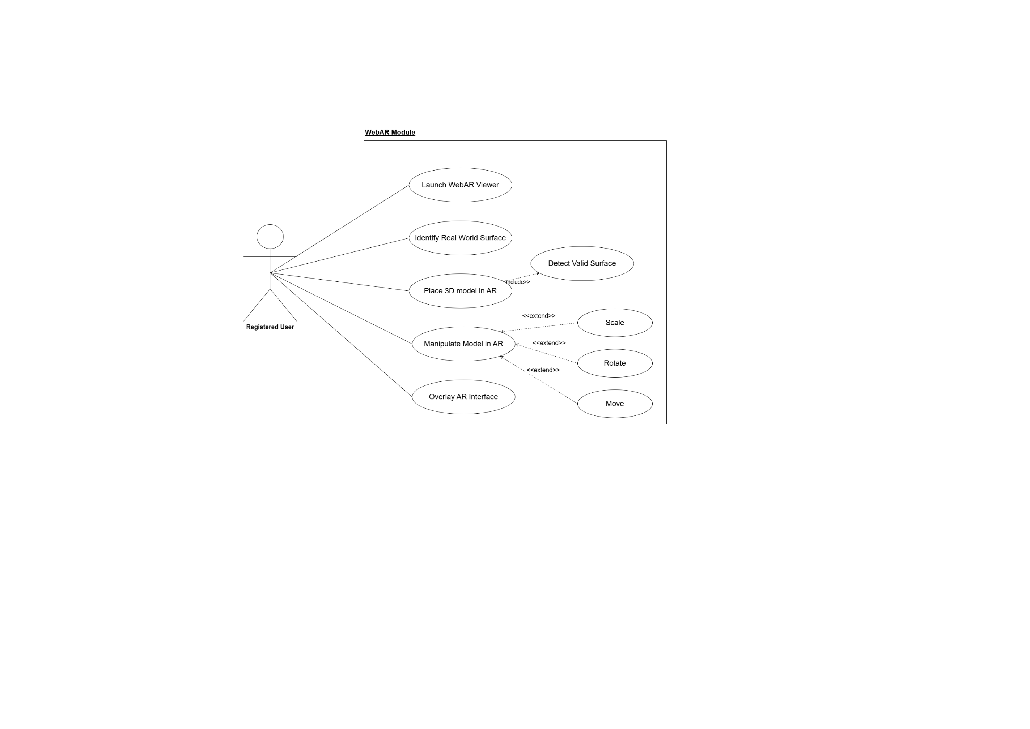
Figure ‎3.3 UC-03

UC-04 Authenticate User
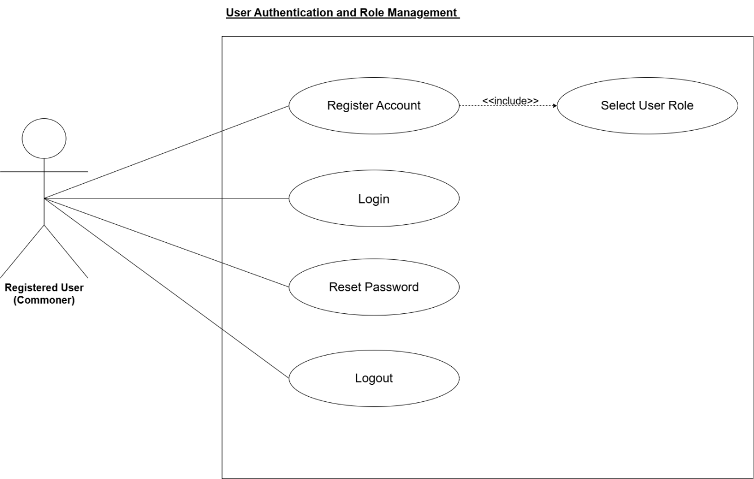
Figure ‎3.4 UC-04

Manage Profile
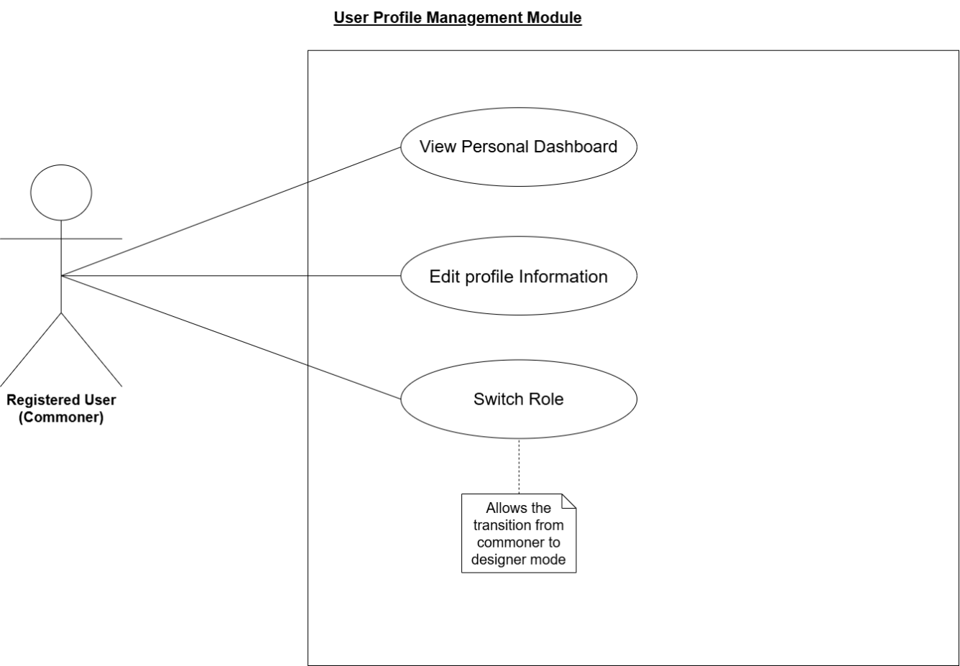
Figure ‎3.5 UC-05 Manage Profile

UC-06 Create and Compose Multi Object Scene
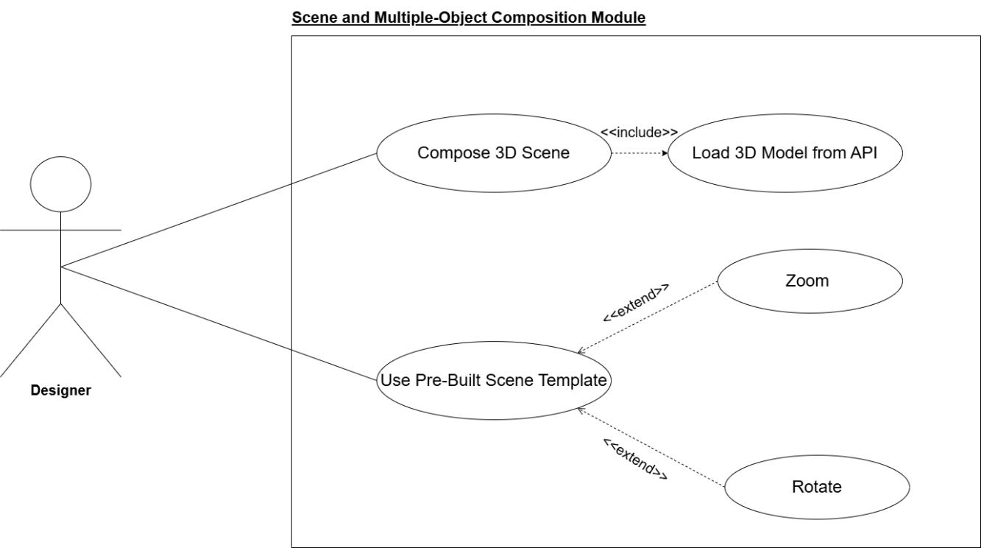
Figure ‎3.6 UC-06

UC-07 Manage Personal Asset Library

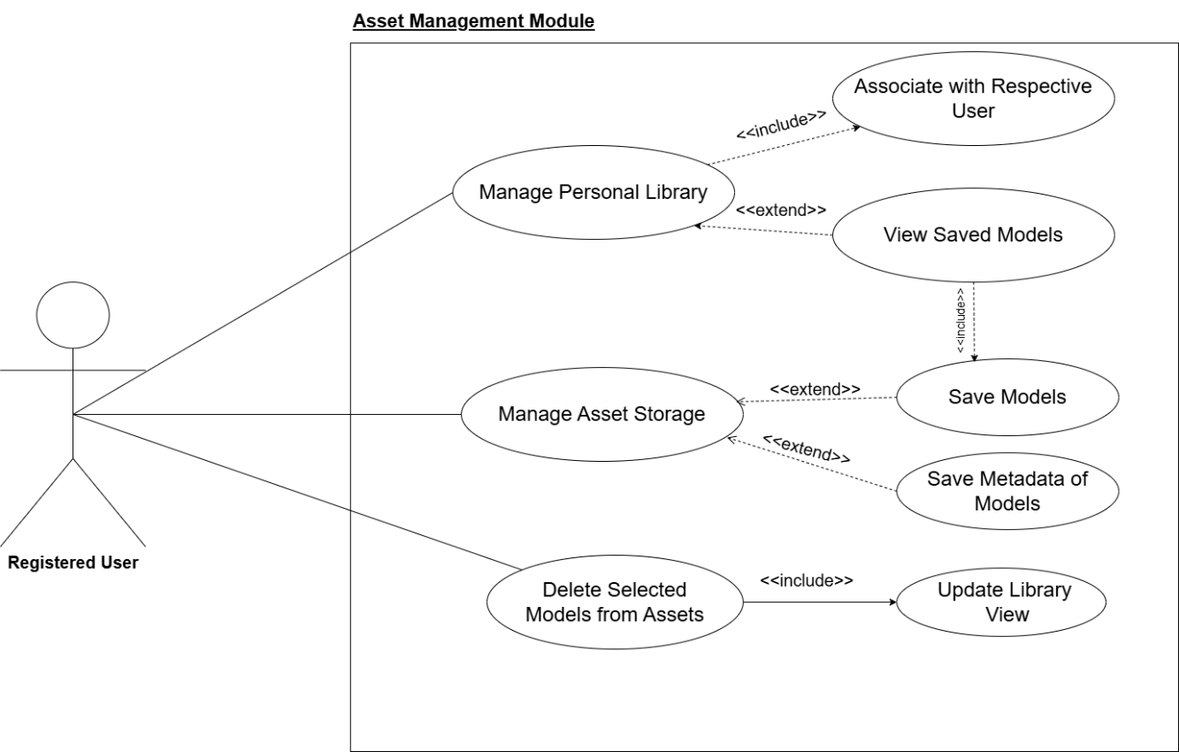
Figure ‎3.7 UC-07

UC-08 Export and Share Model

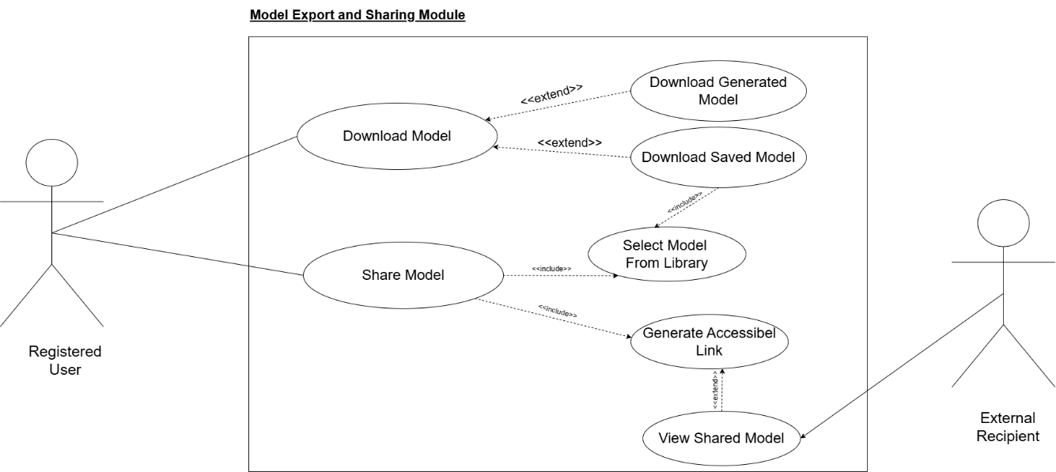
Figure ‎3.8 UC-08

UC-09 Receive AI Recommendations
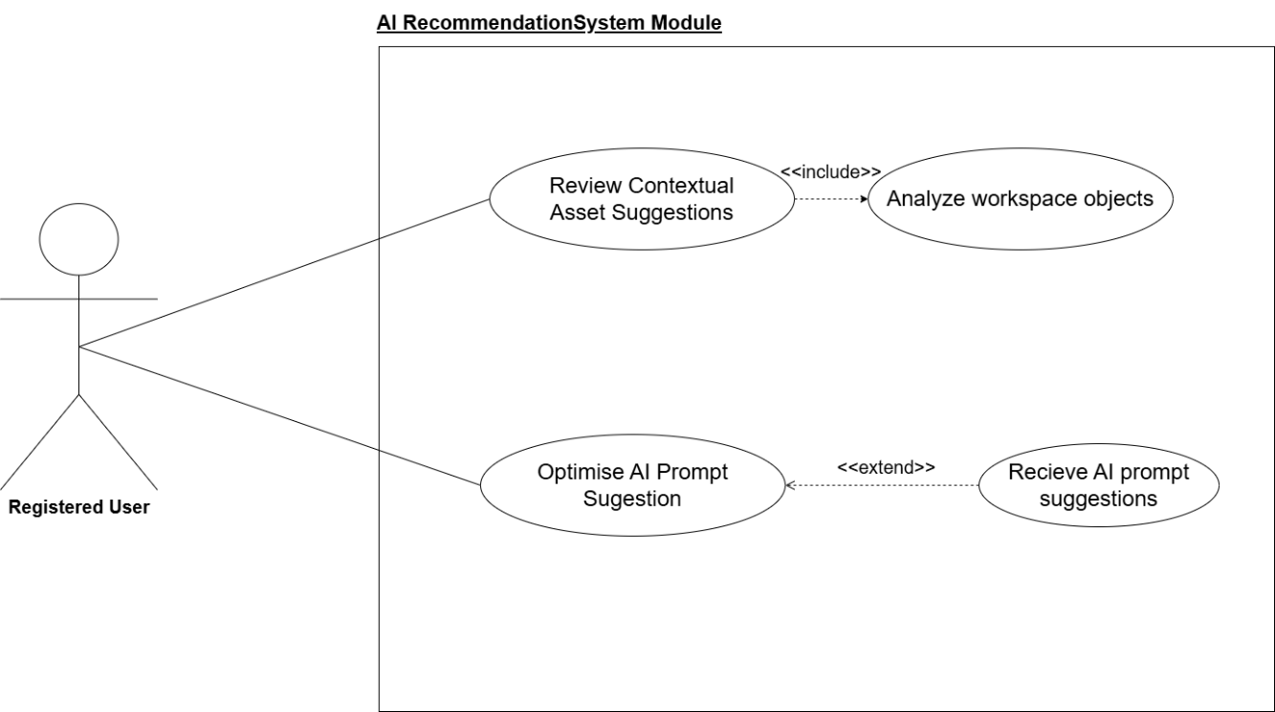
Figure ‎3.9 UC-09

Activity Diagram

AD-01 GENERATIVE AI (TEXT/IMAGE-TO-3D)

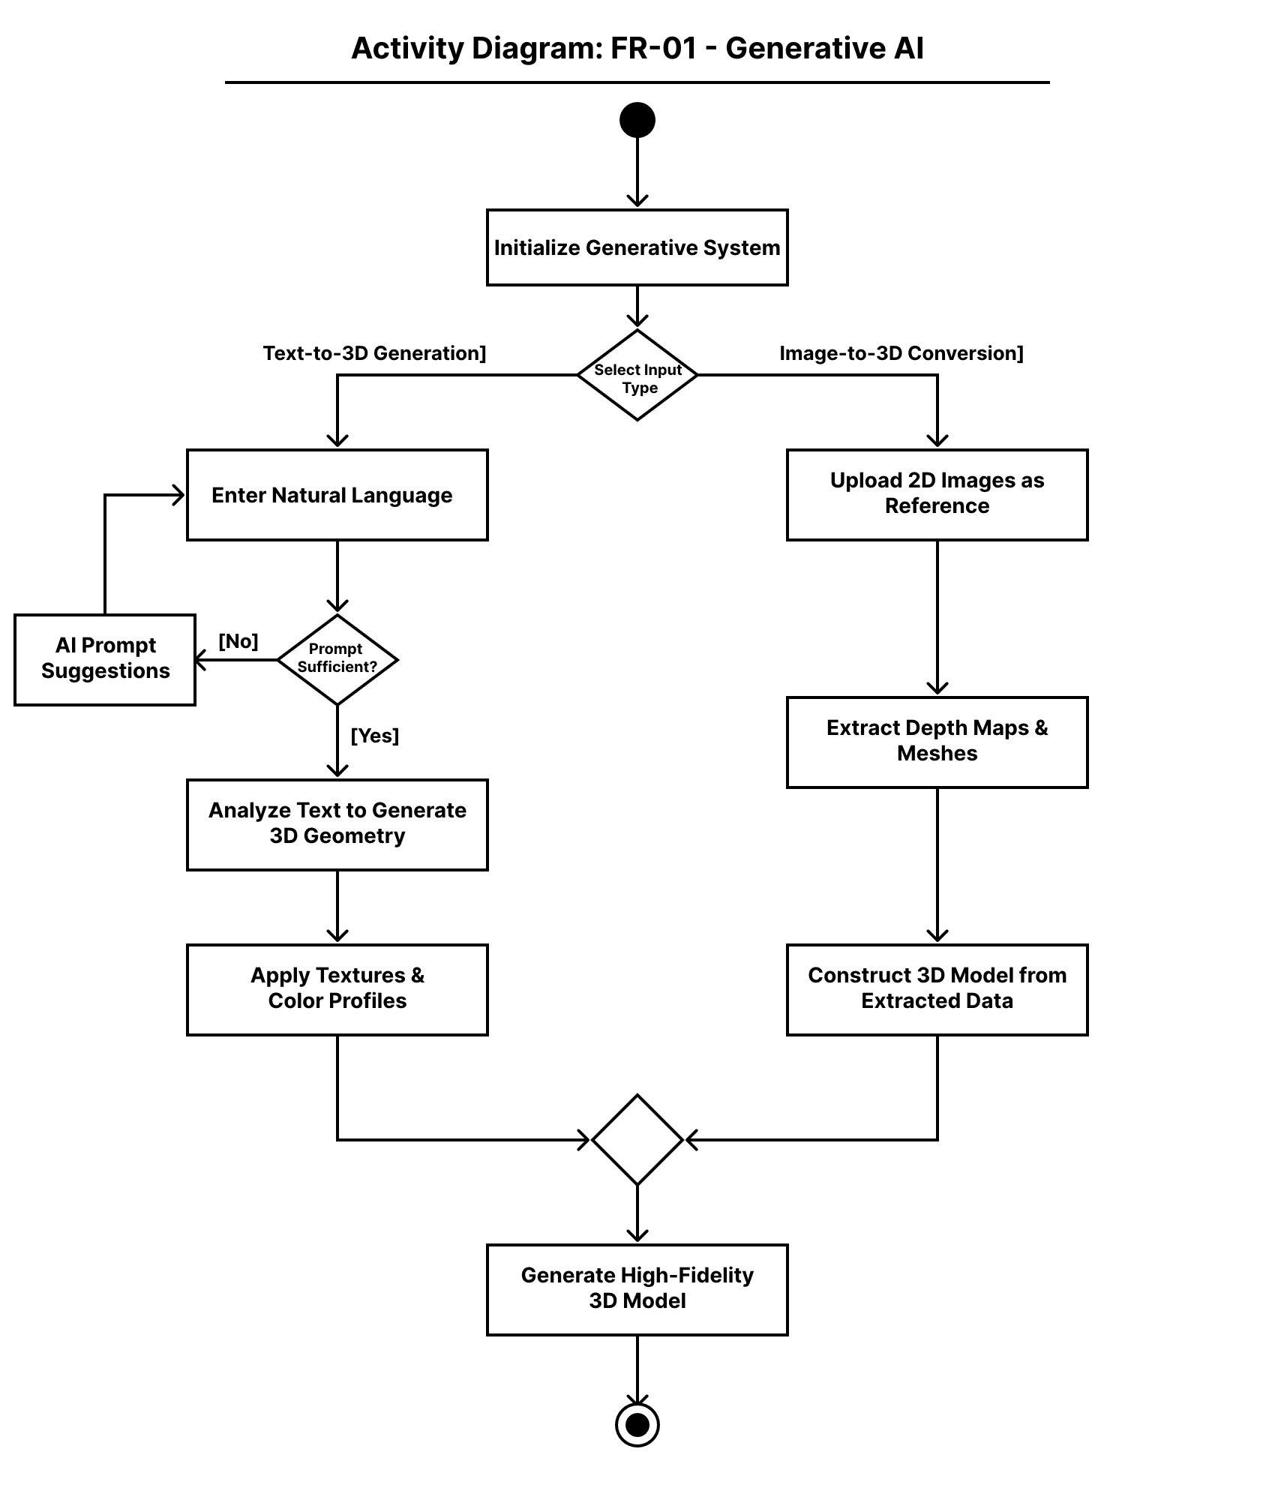
Figure ‎3.10 AD-01

AD-02 3D MODEL MANAGEMENT

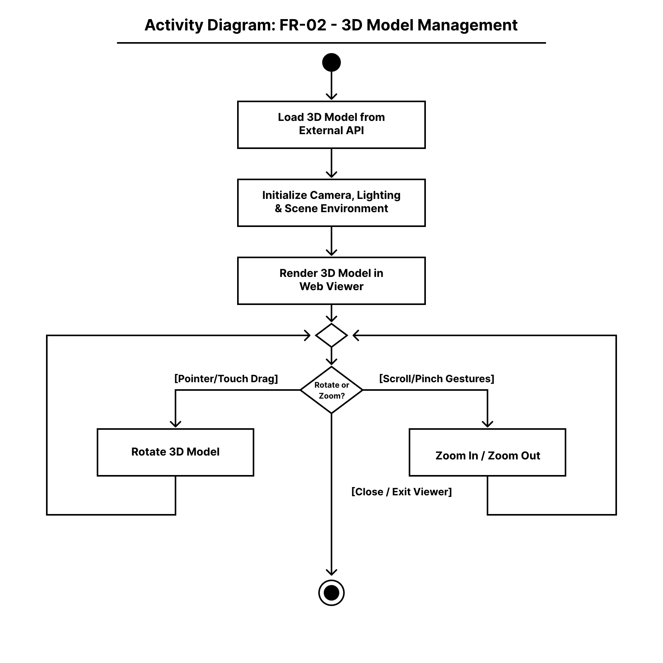
Figure ‎3.11 AD-02

AD-03 WEB-BASED AUGMENTED REALITY (WEBAR)

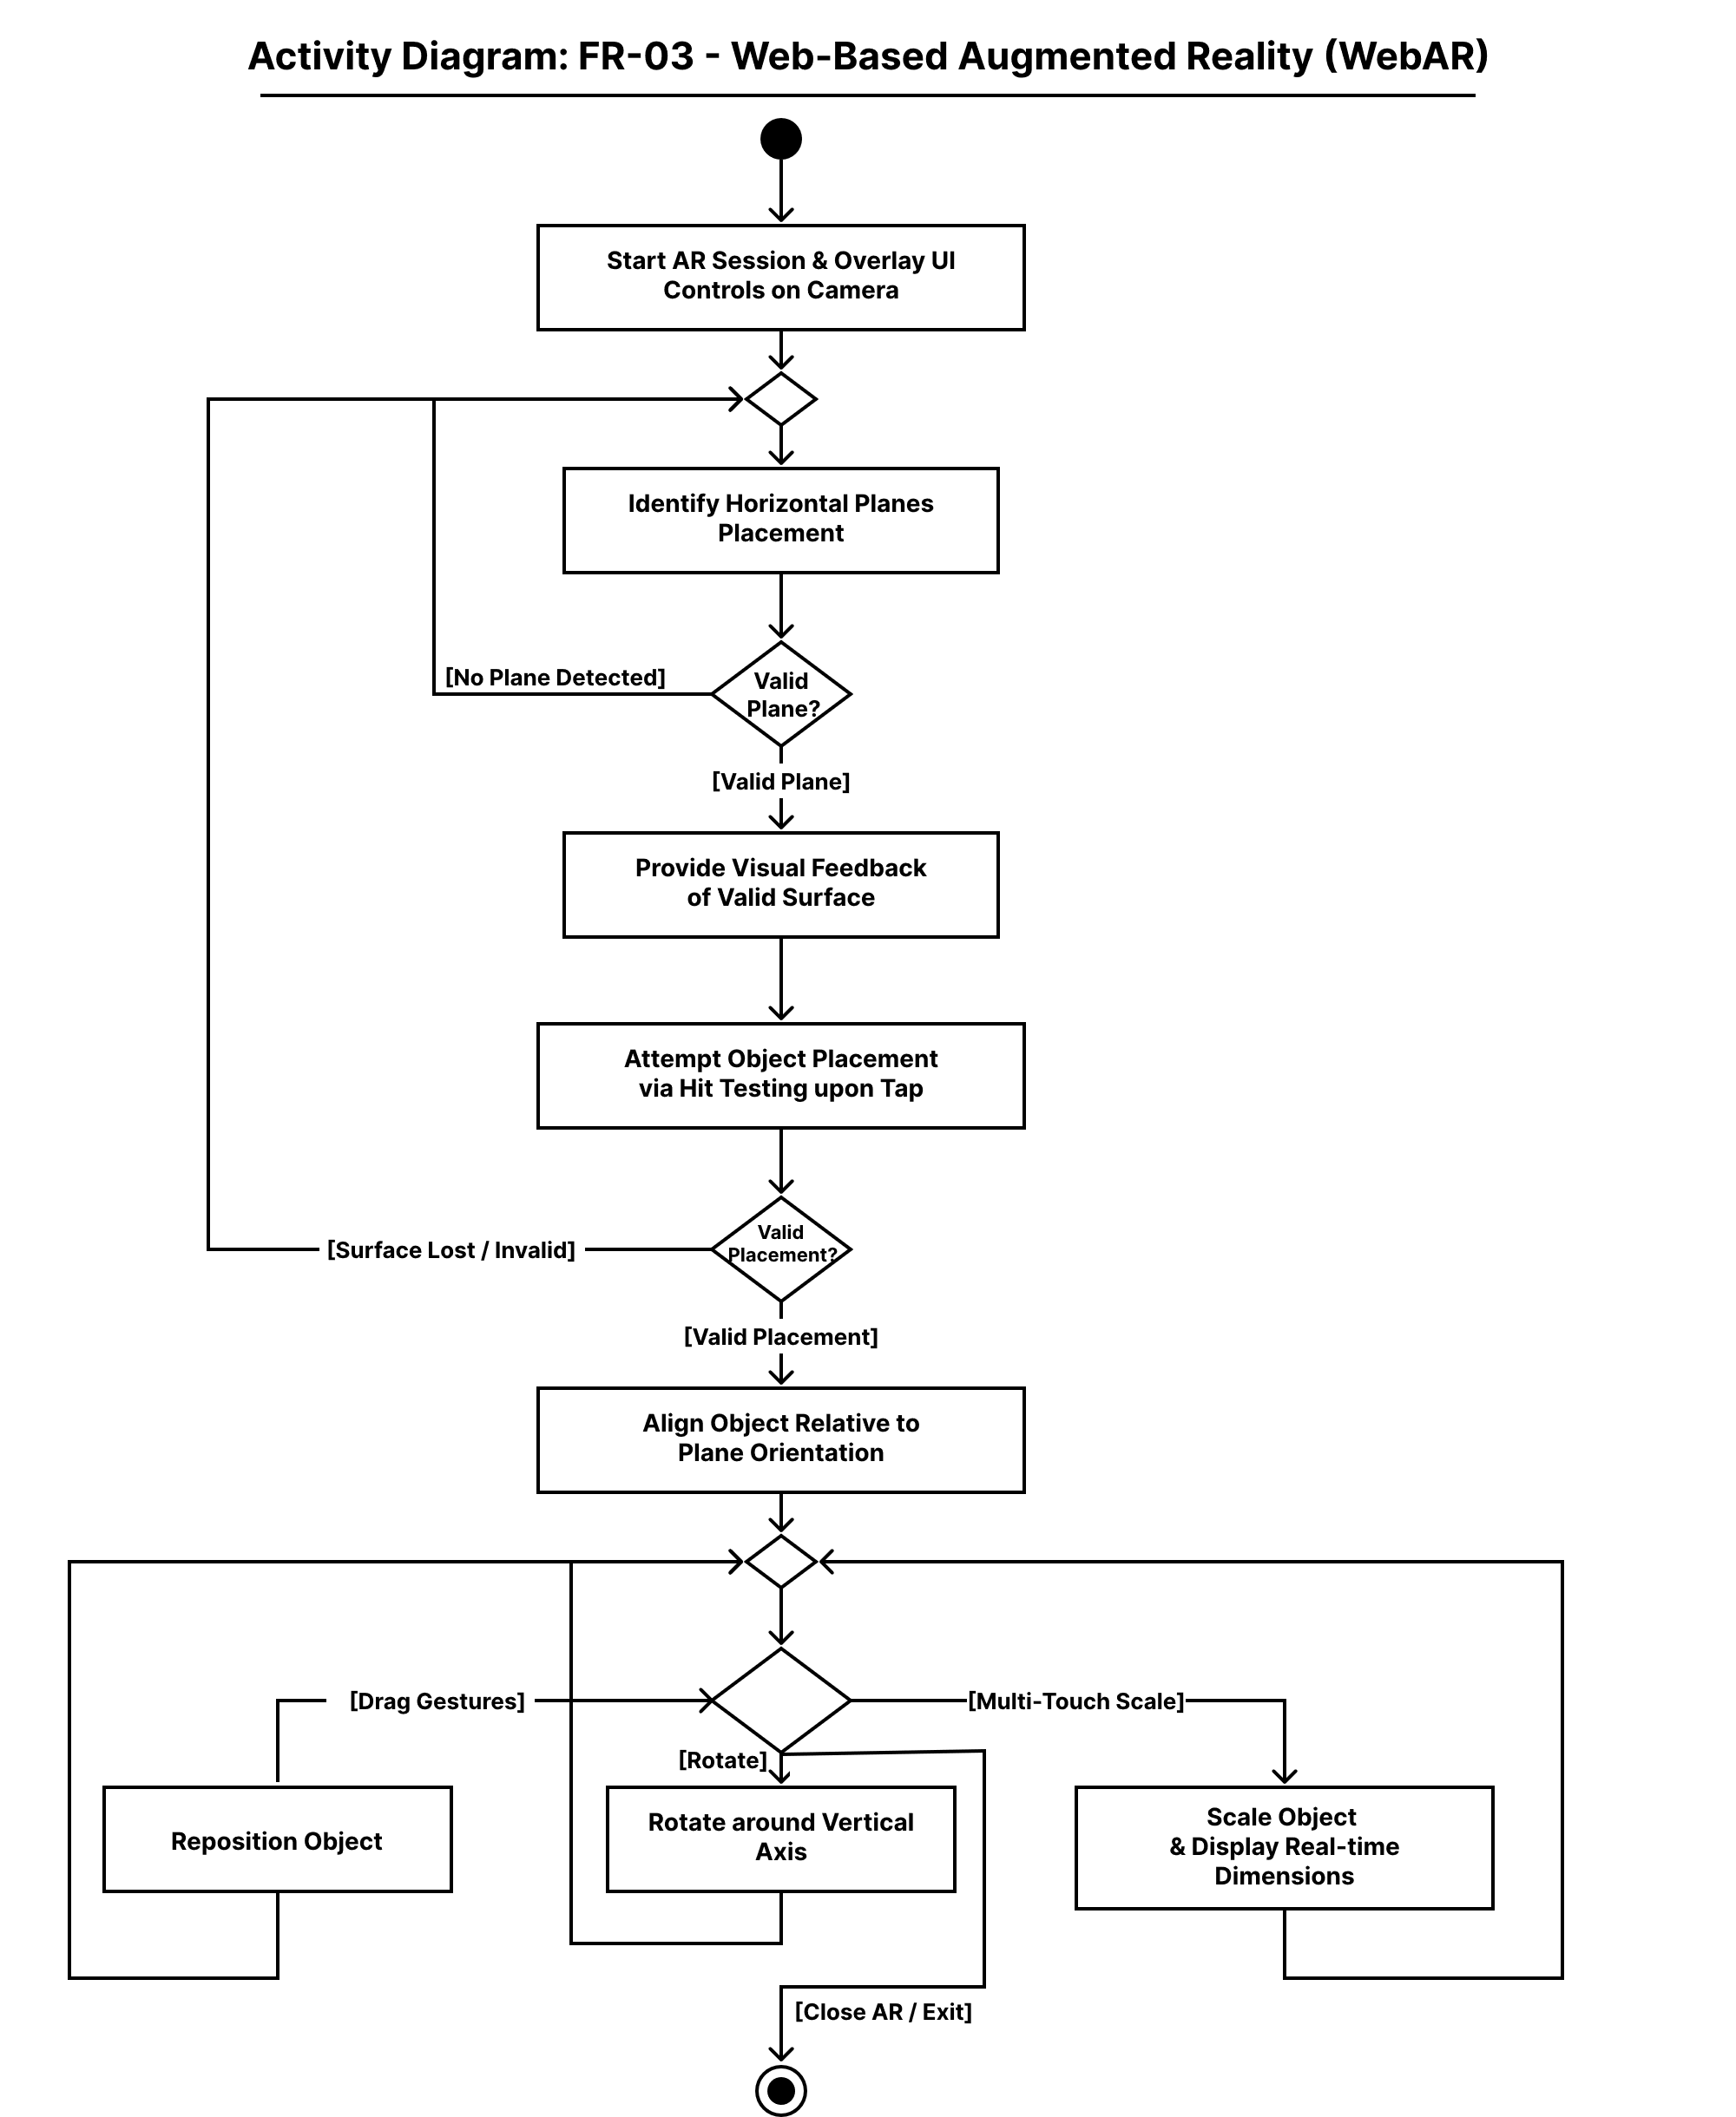
Figure ‎3.12 AD-03

AD-04 USER AUTHENTICATION & ROLE MANAGEMENT

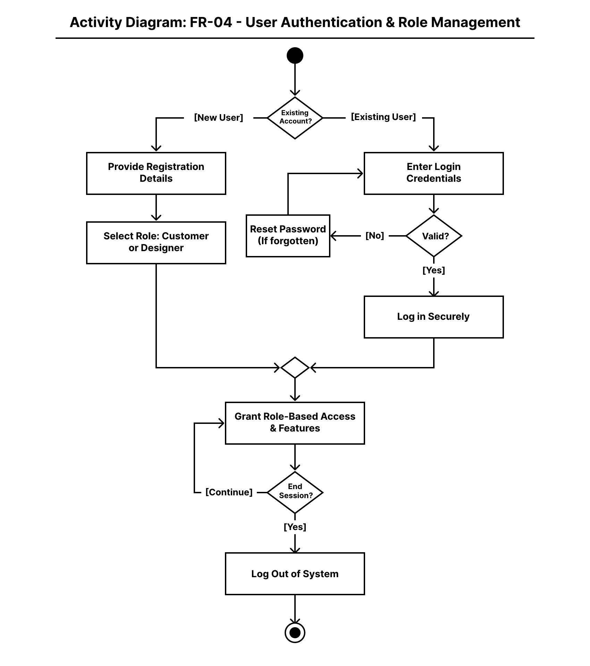
Figure ‎3.13 AD-04

AD-05 USER PROFILE MANAGEMENT

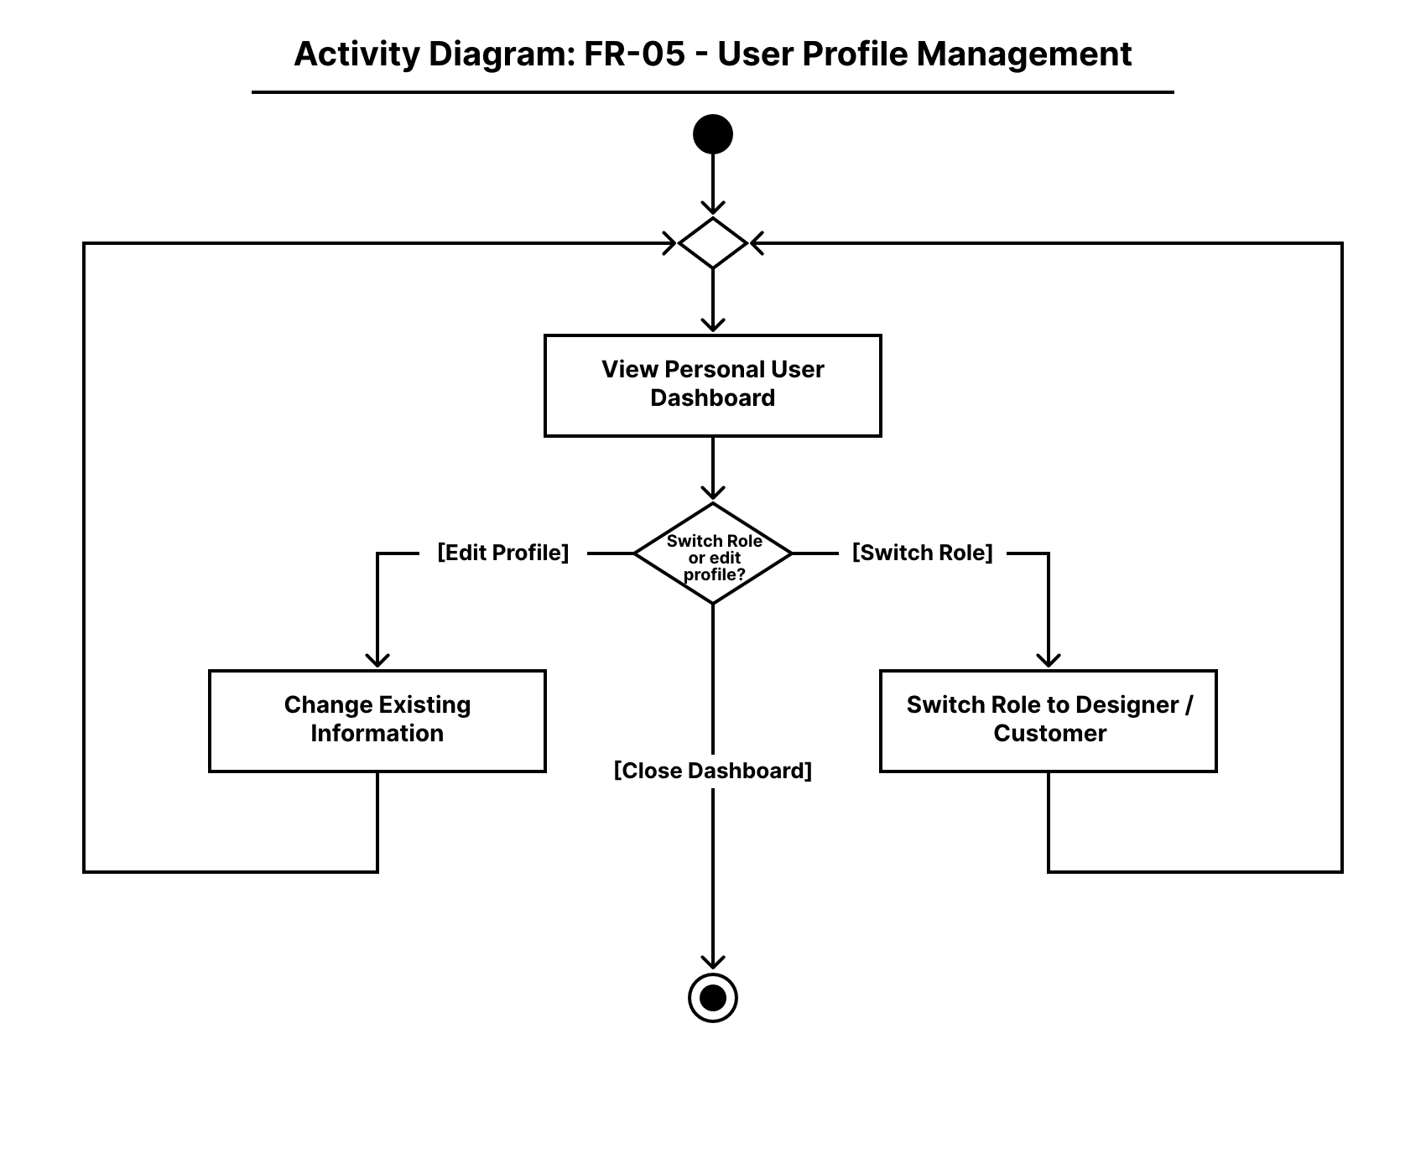
Figure ‎3.14 AD-05

AD-06 SCENE & MULTI-OBJECT COMPOSITION (DESIGNER MODE)

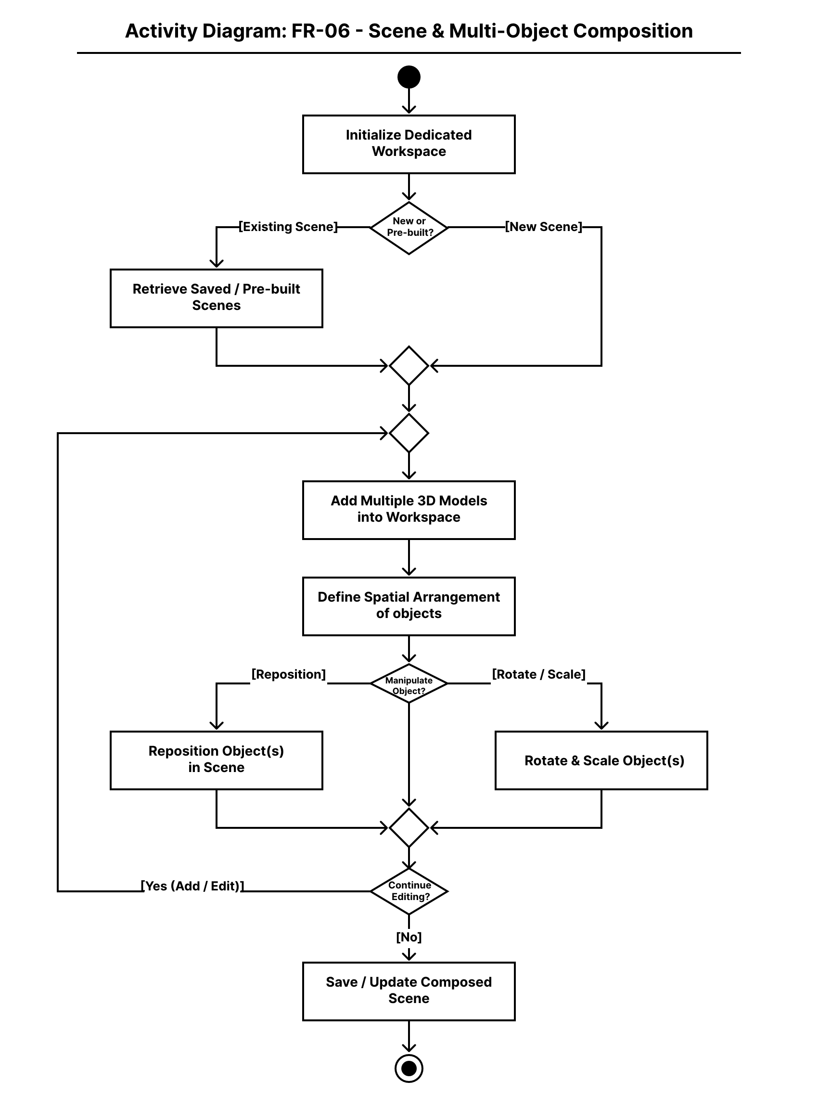
Figure ‎3.15 AD-06

AD-07 ASSET MANAGEMENT

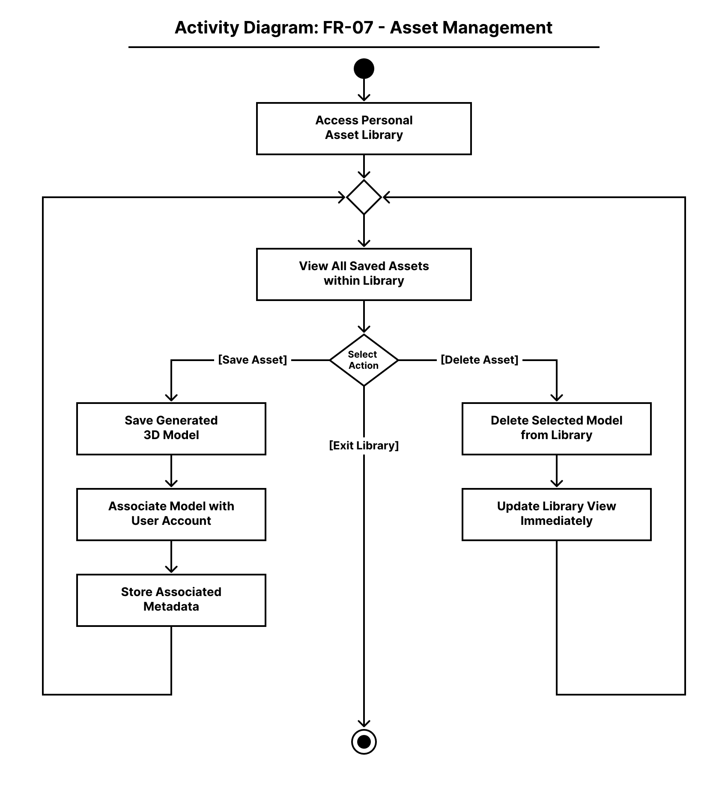
Figure ‎3.16 AD-07

AD-08 MODEL EXPORT & SHARING

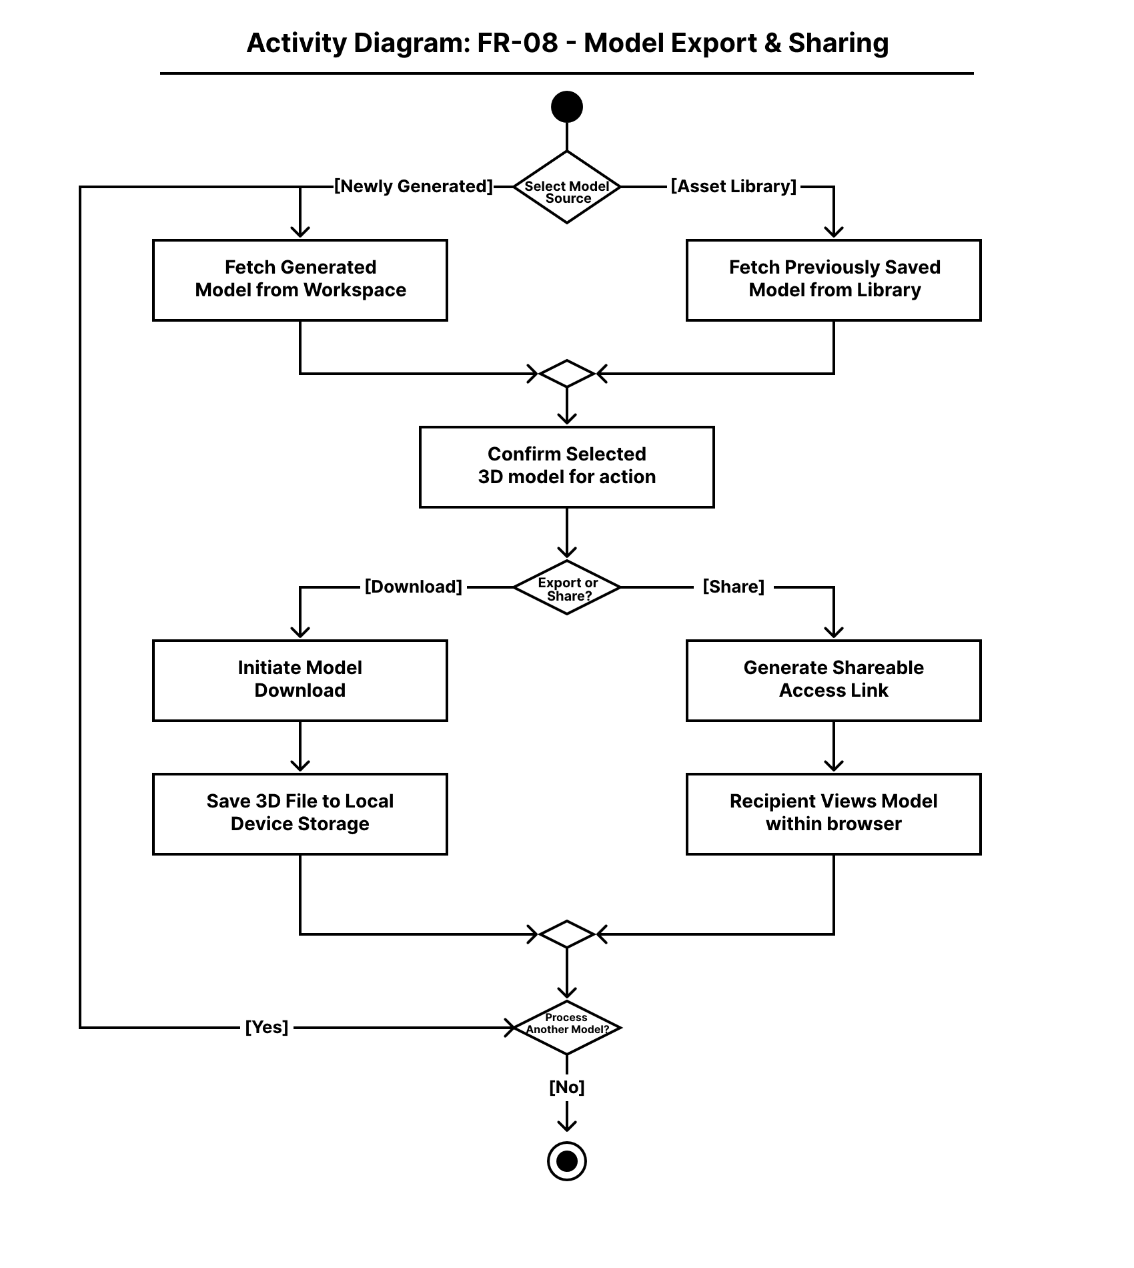
Figure ‎3.17 AD-08

AD-09 AI RECOMMENDATION SYSTEM

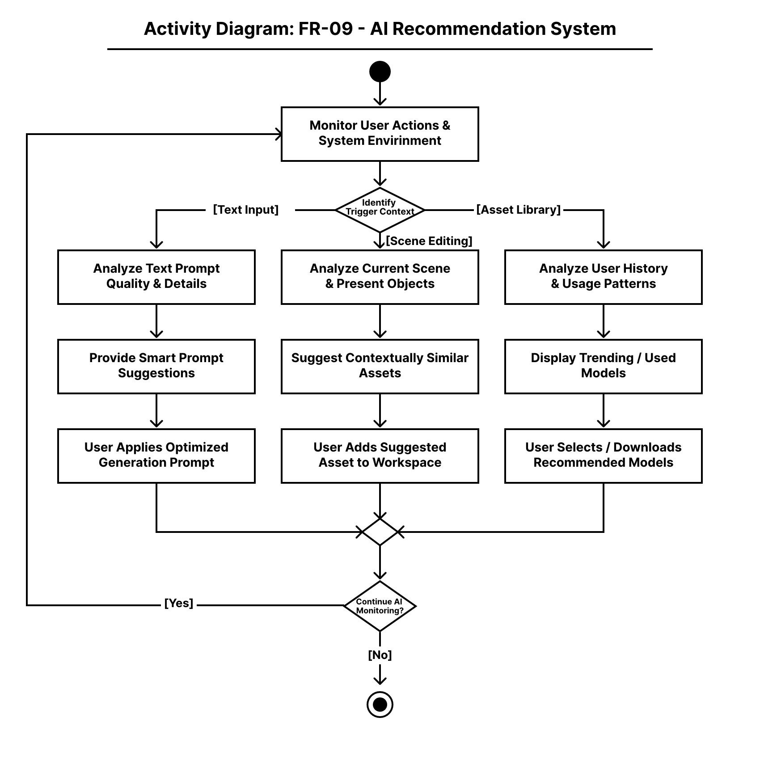
Figure ‎3.18 AD-09

Sequence Diagram

SD-01 GENERATIVE AI (TEXT/IMAGE-TO-3D)

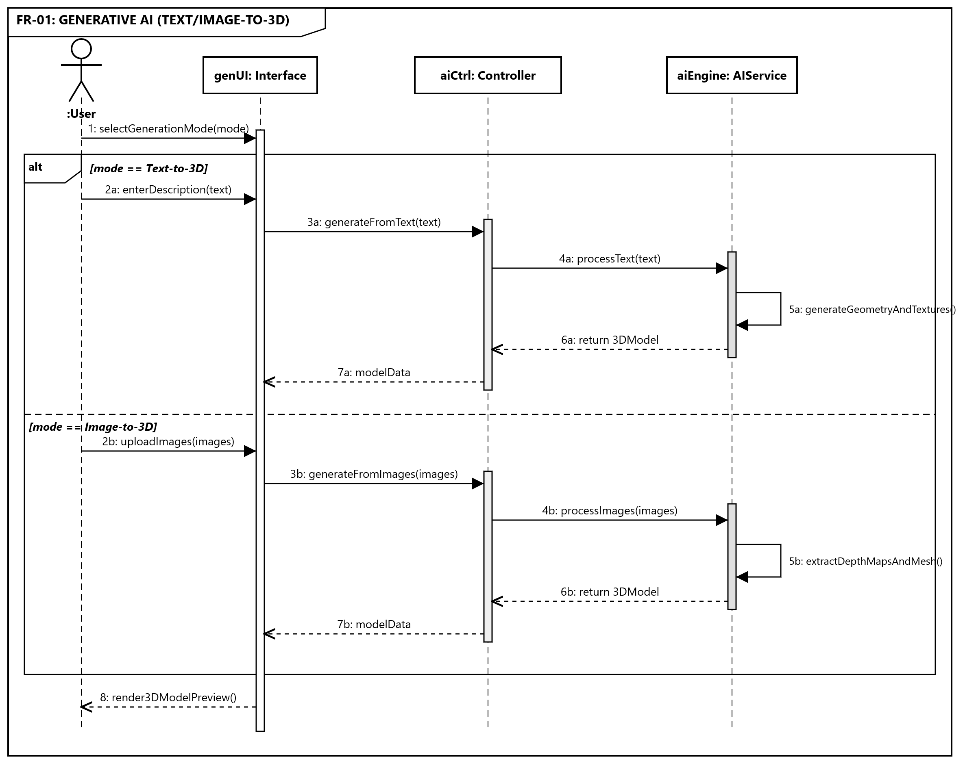
Figure ‎3.19 SD-01

SD-02 3D MODEL MANAGEMENT

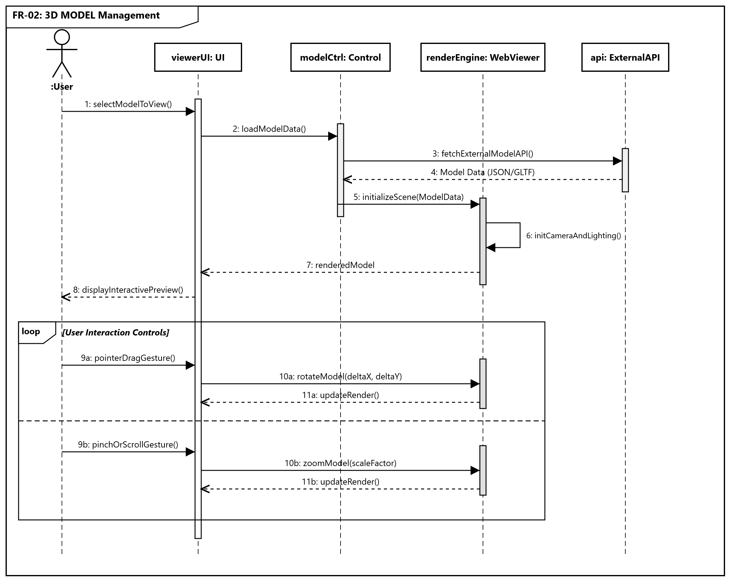
Figure ‎3.20 SD-02

SD-03 WEB-BASED AUGMENTED REALITY (WEBAR)

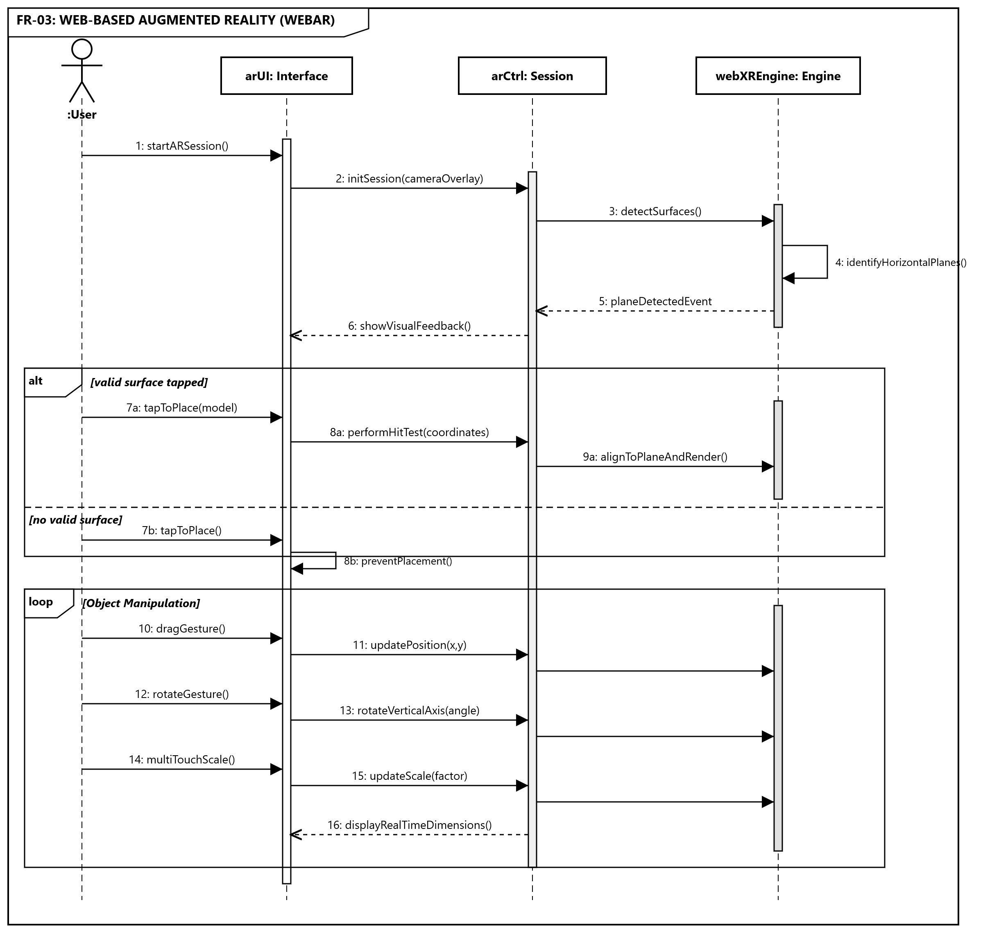
Figure ‎3.21 SD-03

SD-04 USER AUTHENTICATION & ROLE MANAGEMENT

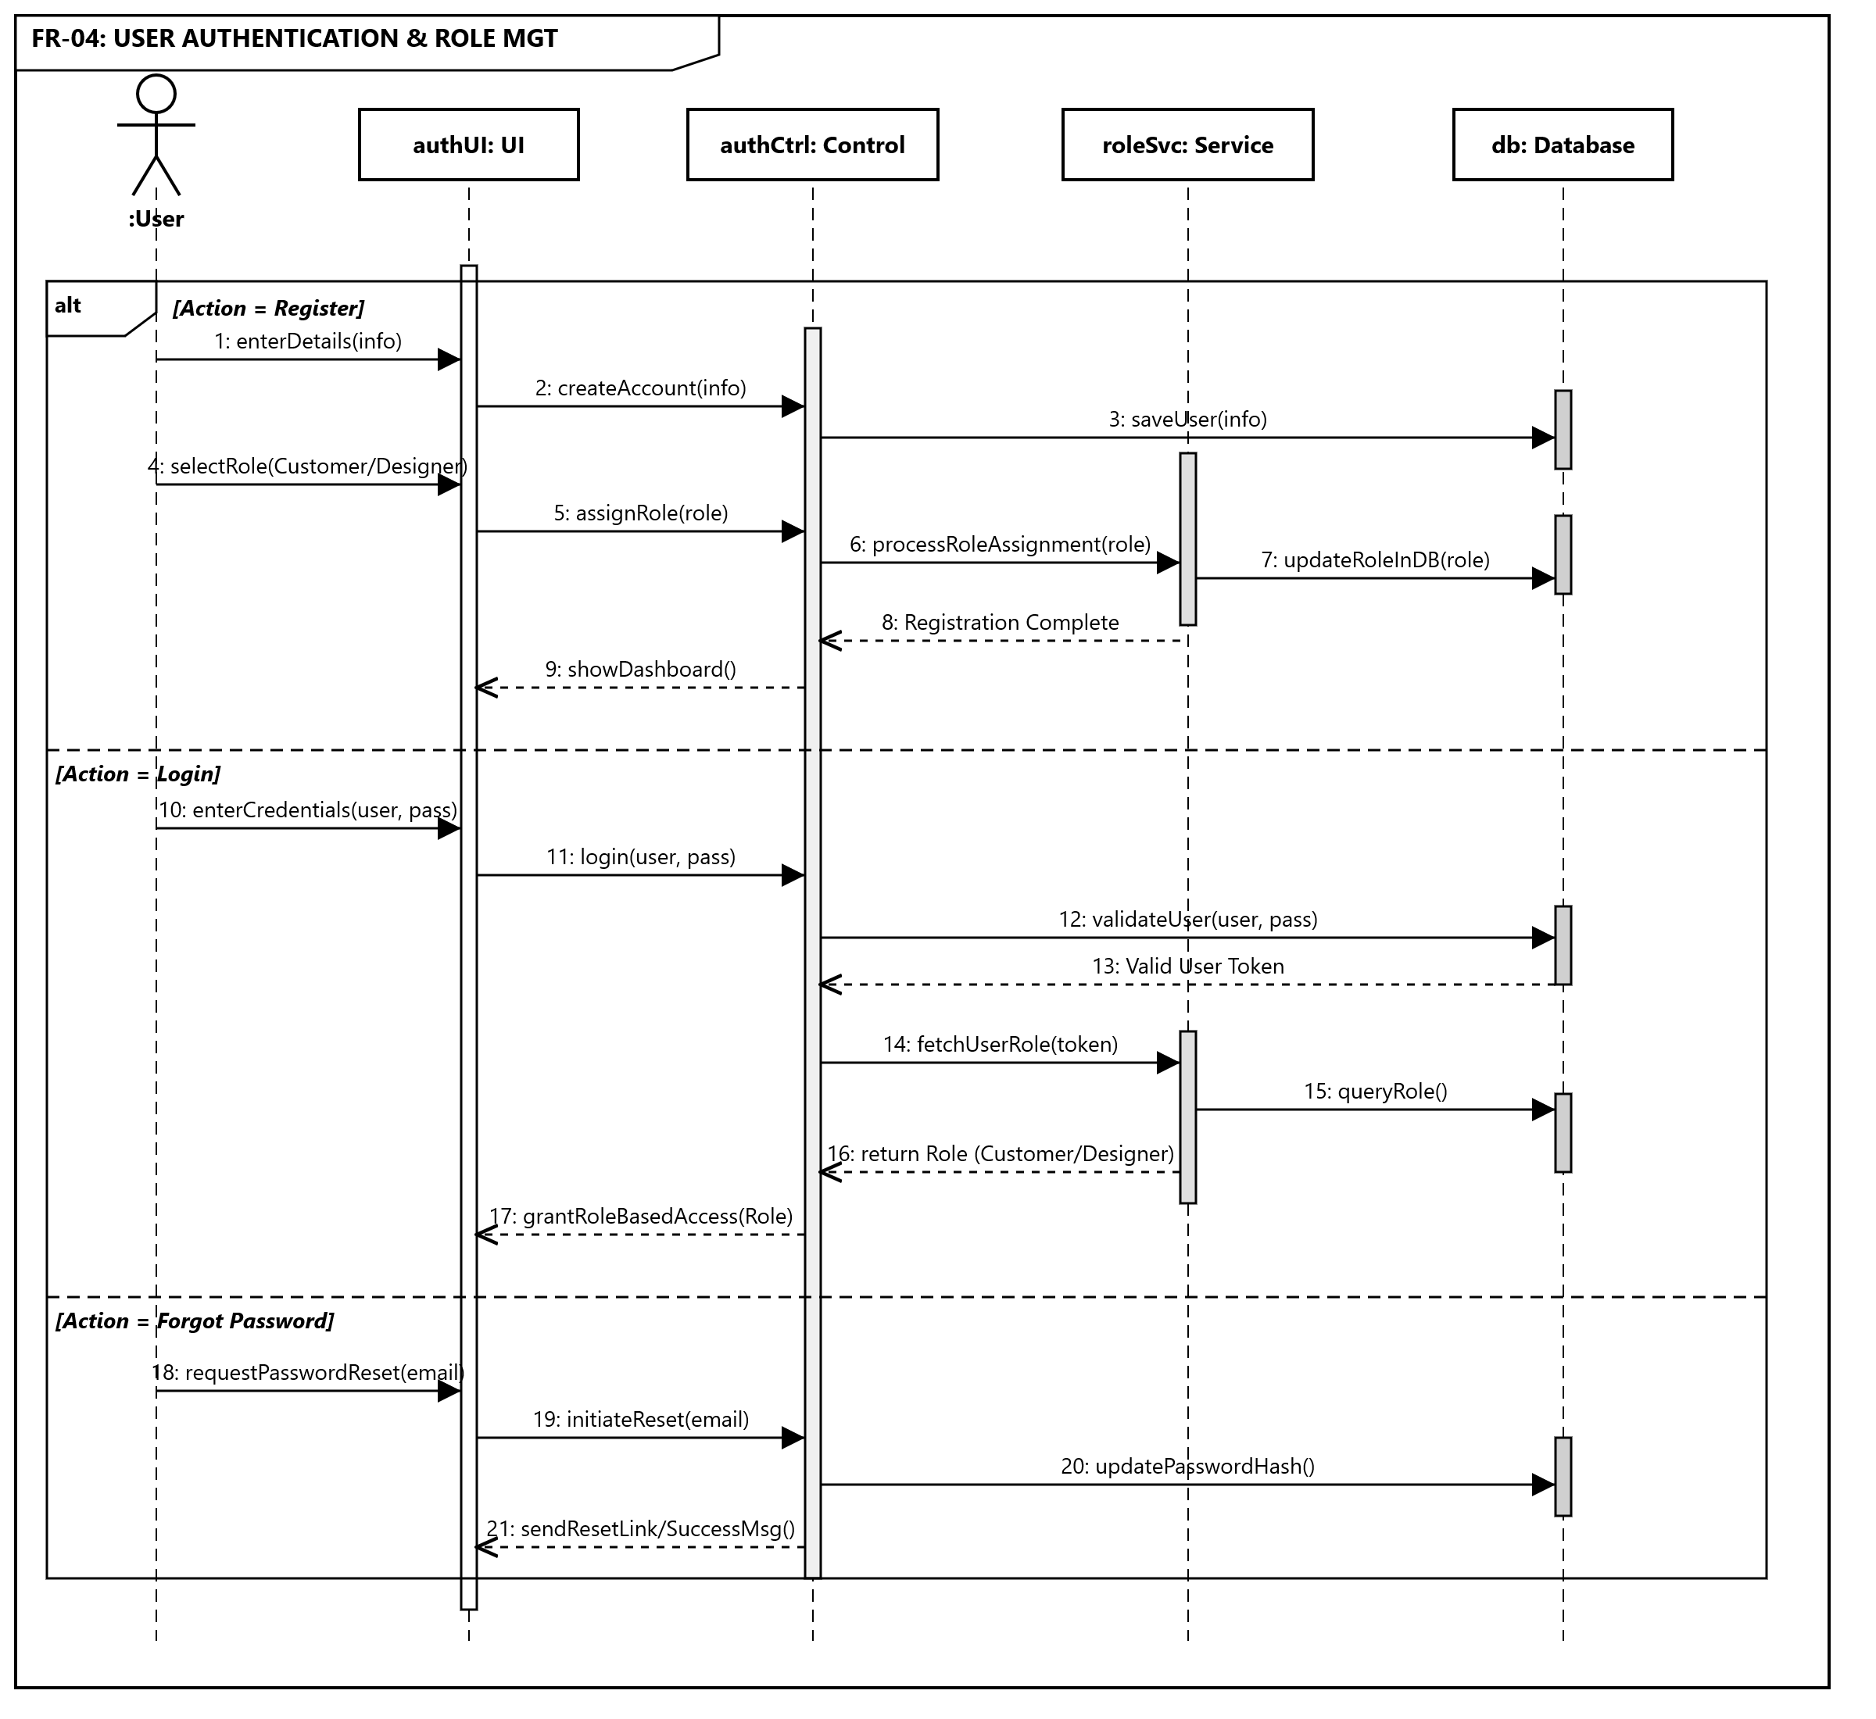
Figure ‎3.22 SD-04

SD-05 USER PROFILE MANAGEMENT

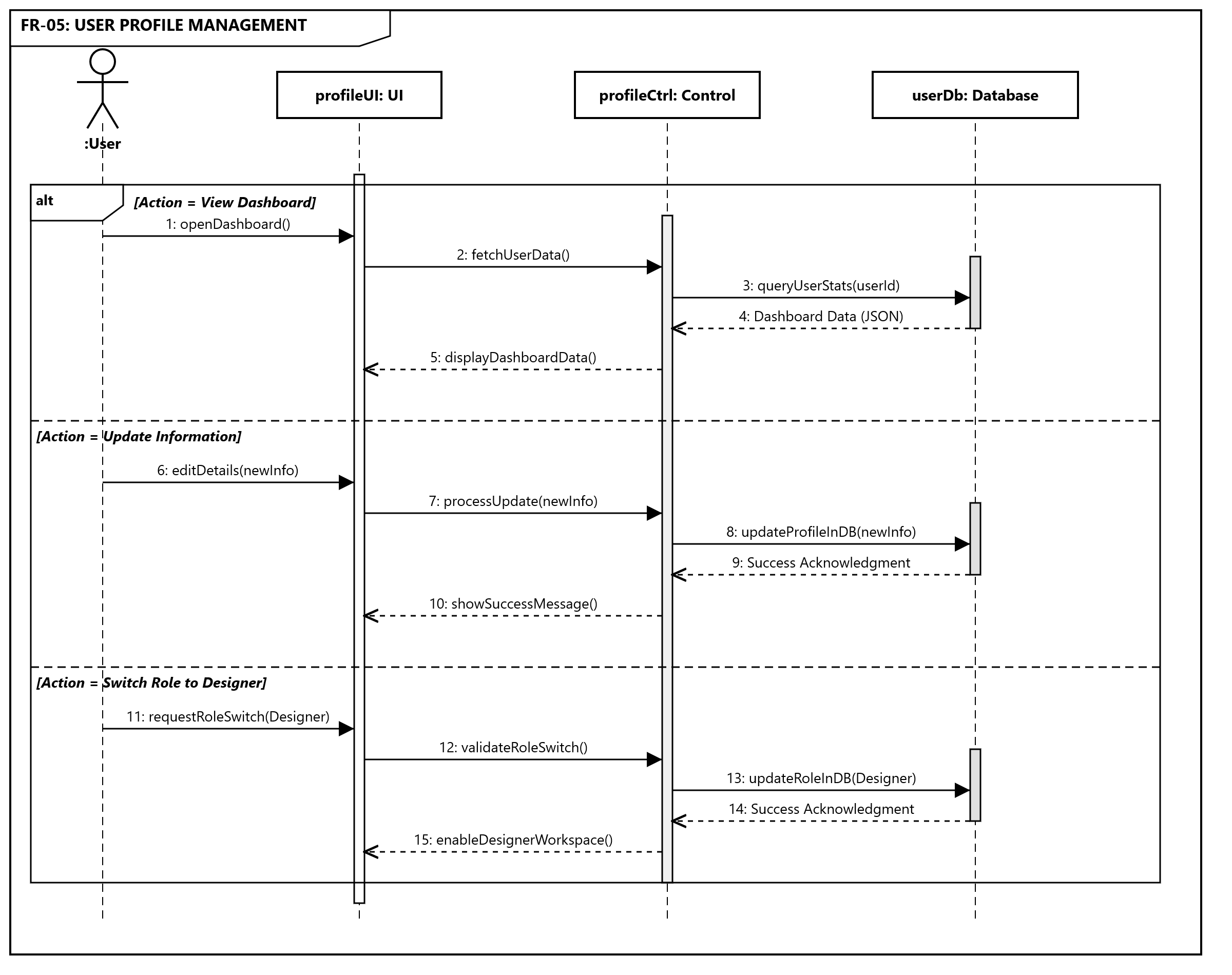
Figure ‎3.23 SD-05

SD-06 SCENE & MULTI-OBJECT COMPOSITION (DESIGNER MODE)

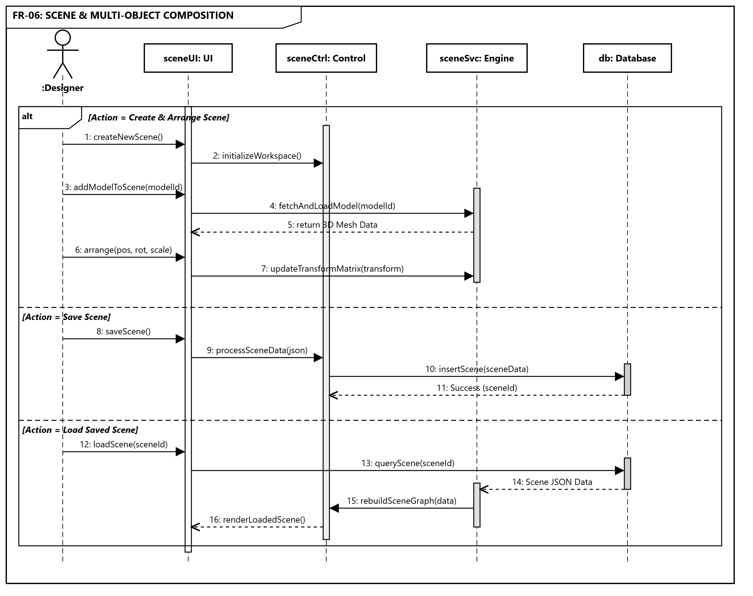
Figure ‎3.24 SD-06

SD-07 ASSET MANAGEMENT

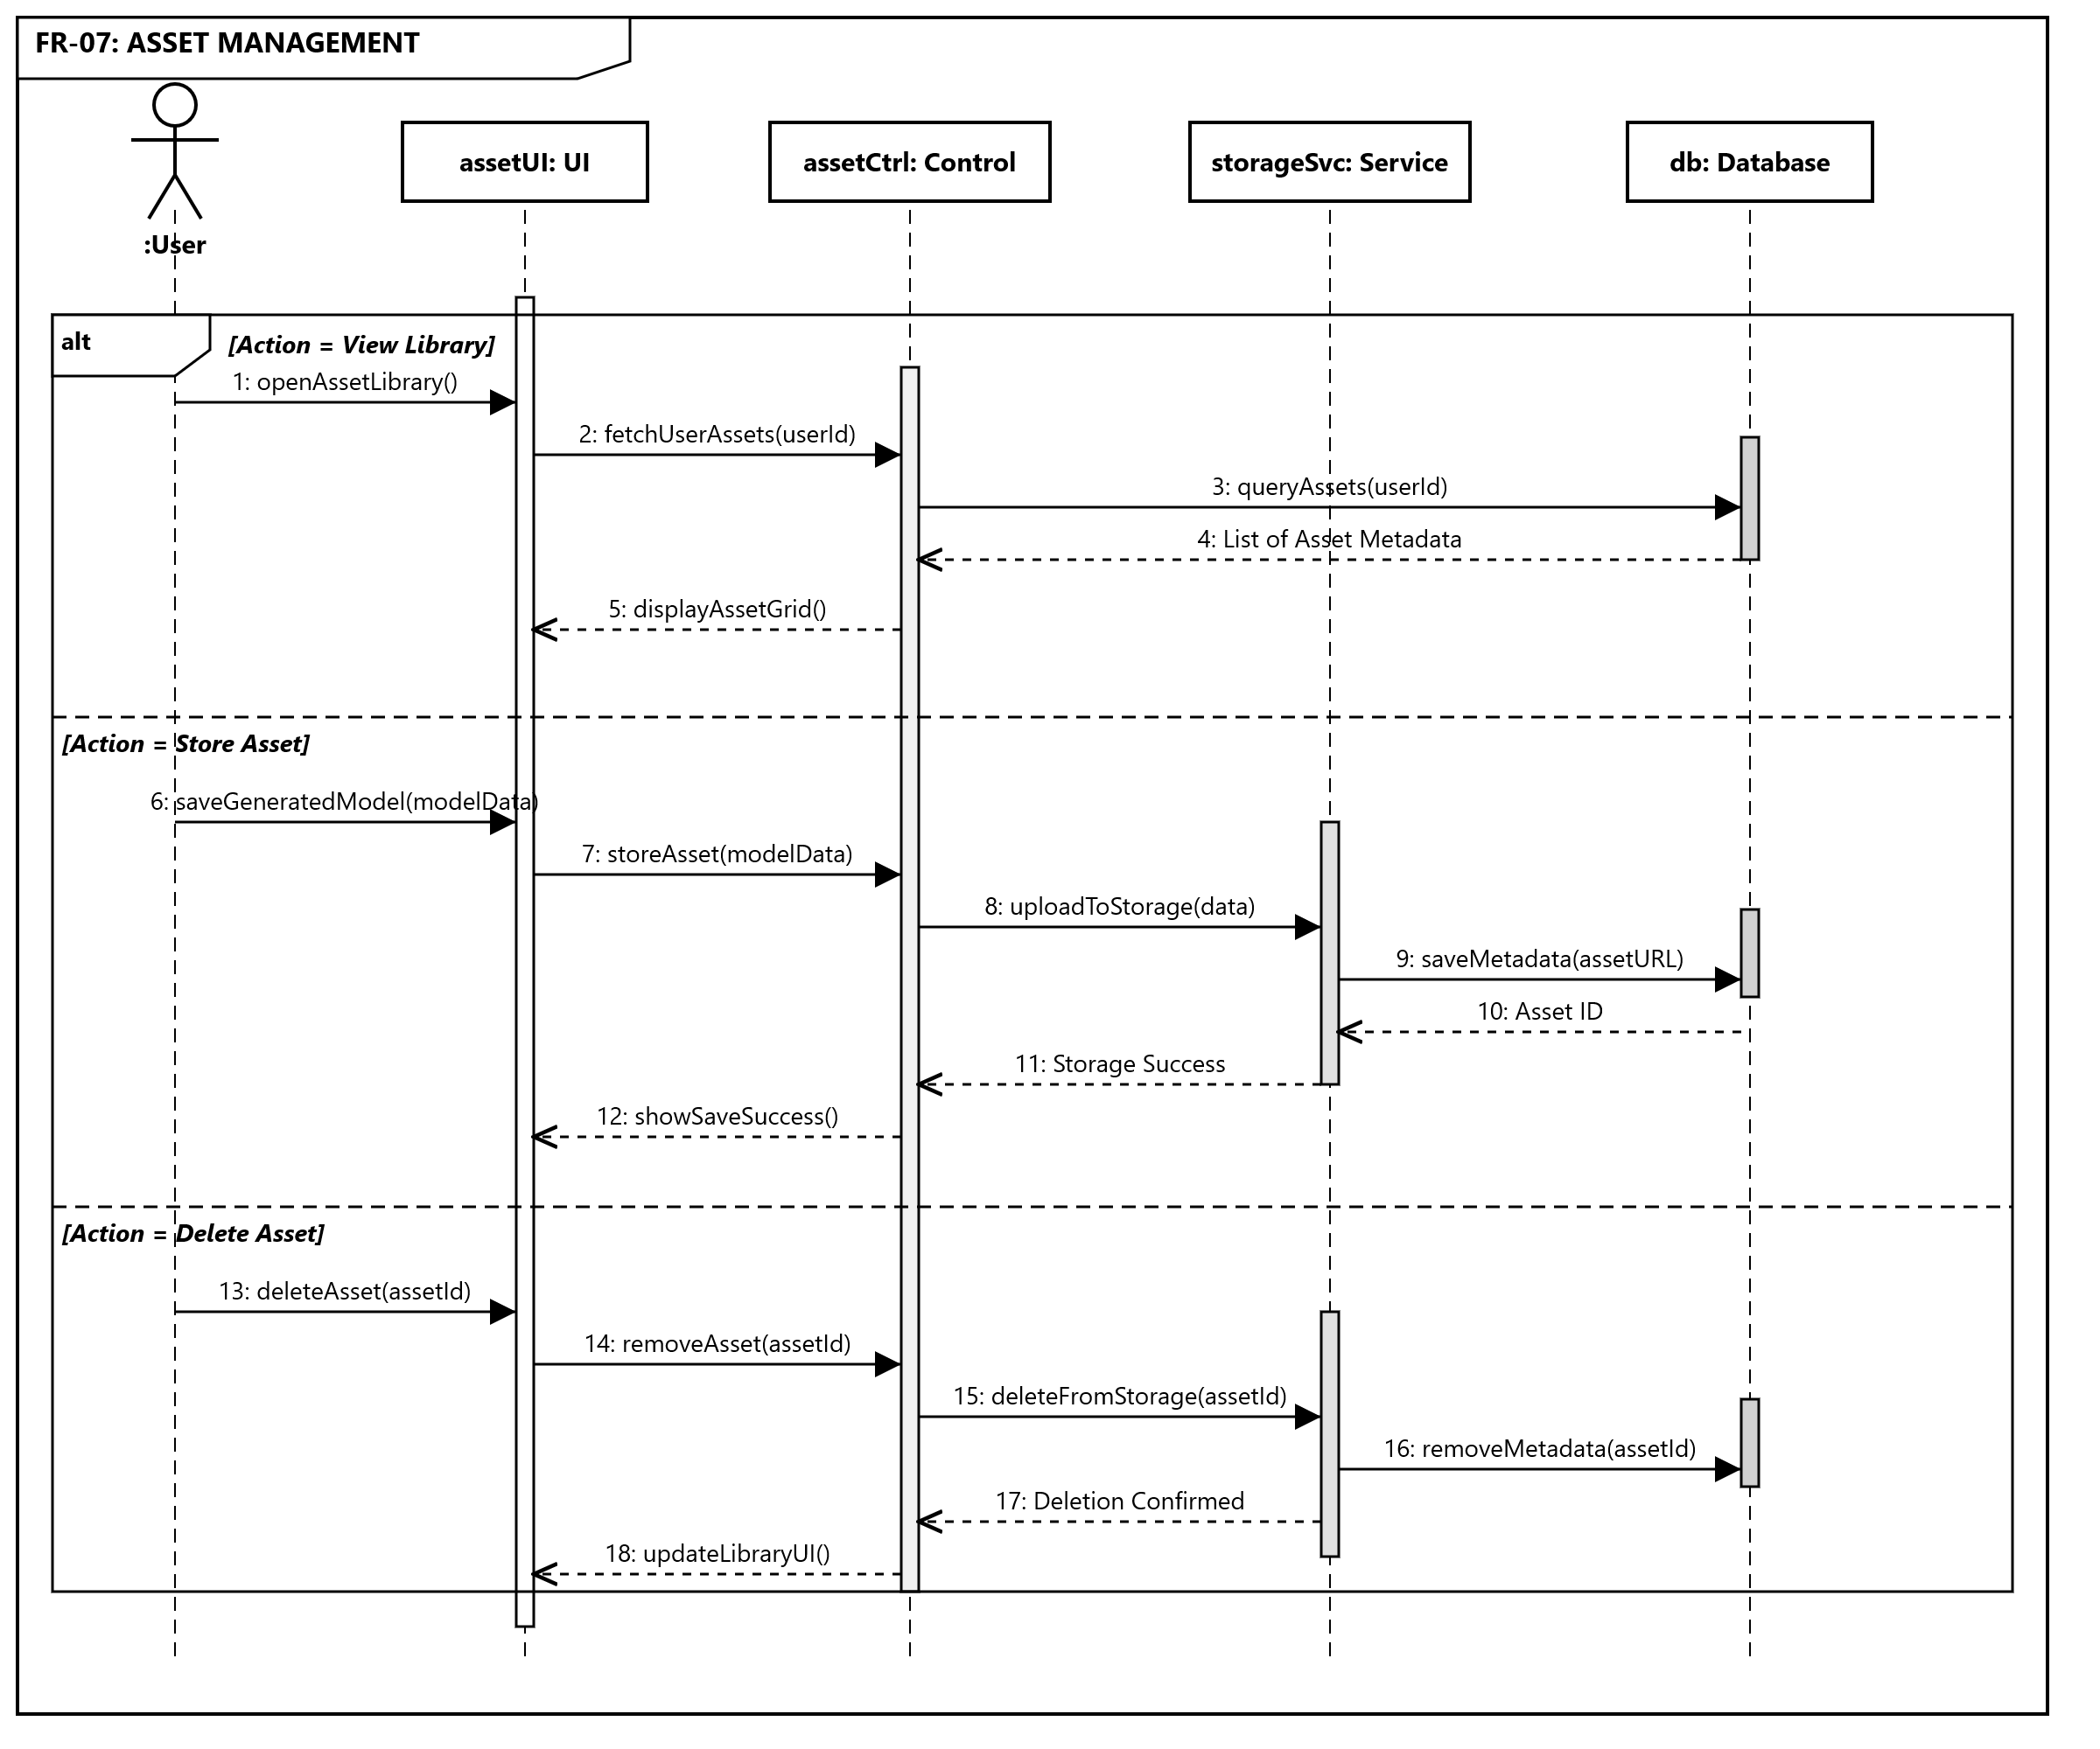
Figure ‎3.25 SD-07

SD-08 MODEL EXPORT & SHARING

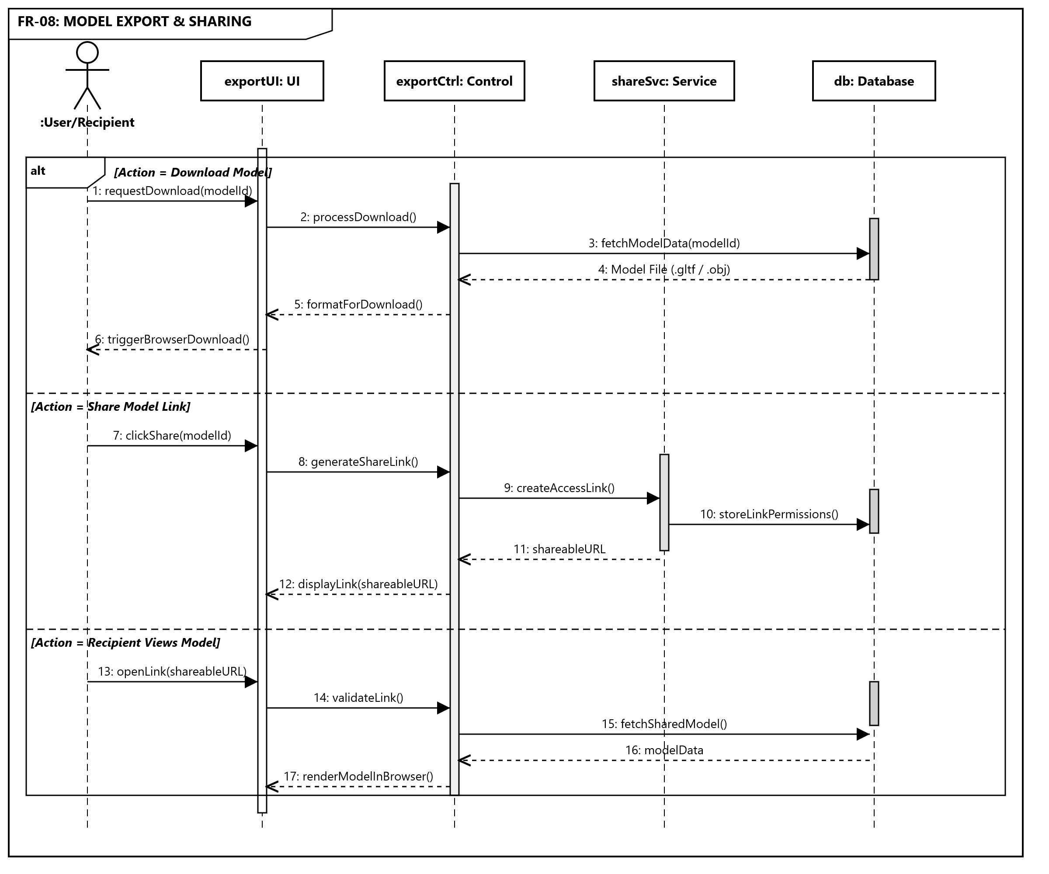
Figure ‎3.26 SD-08

SD-09 AI RECOMMENDATION SYSTEM

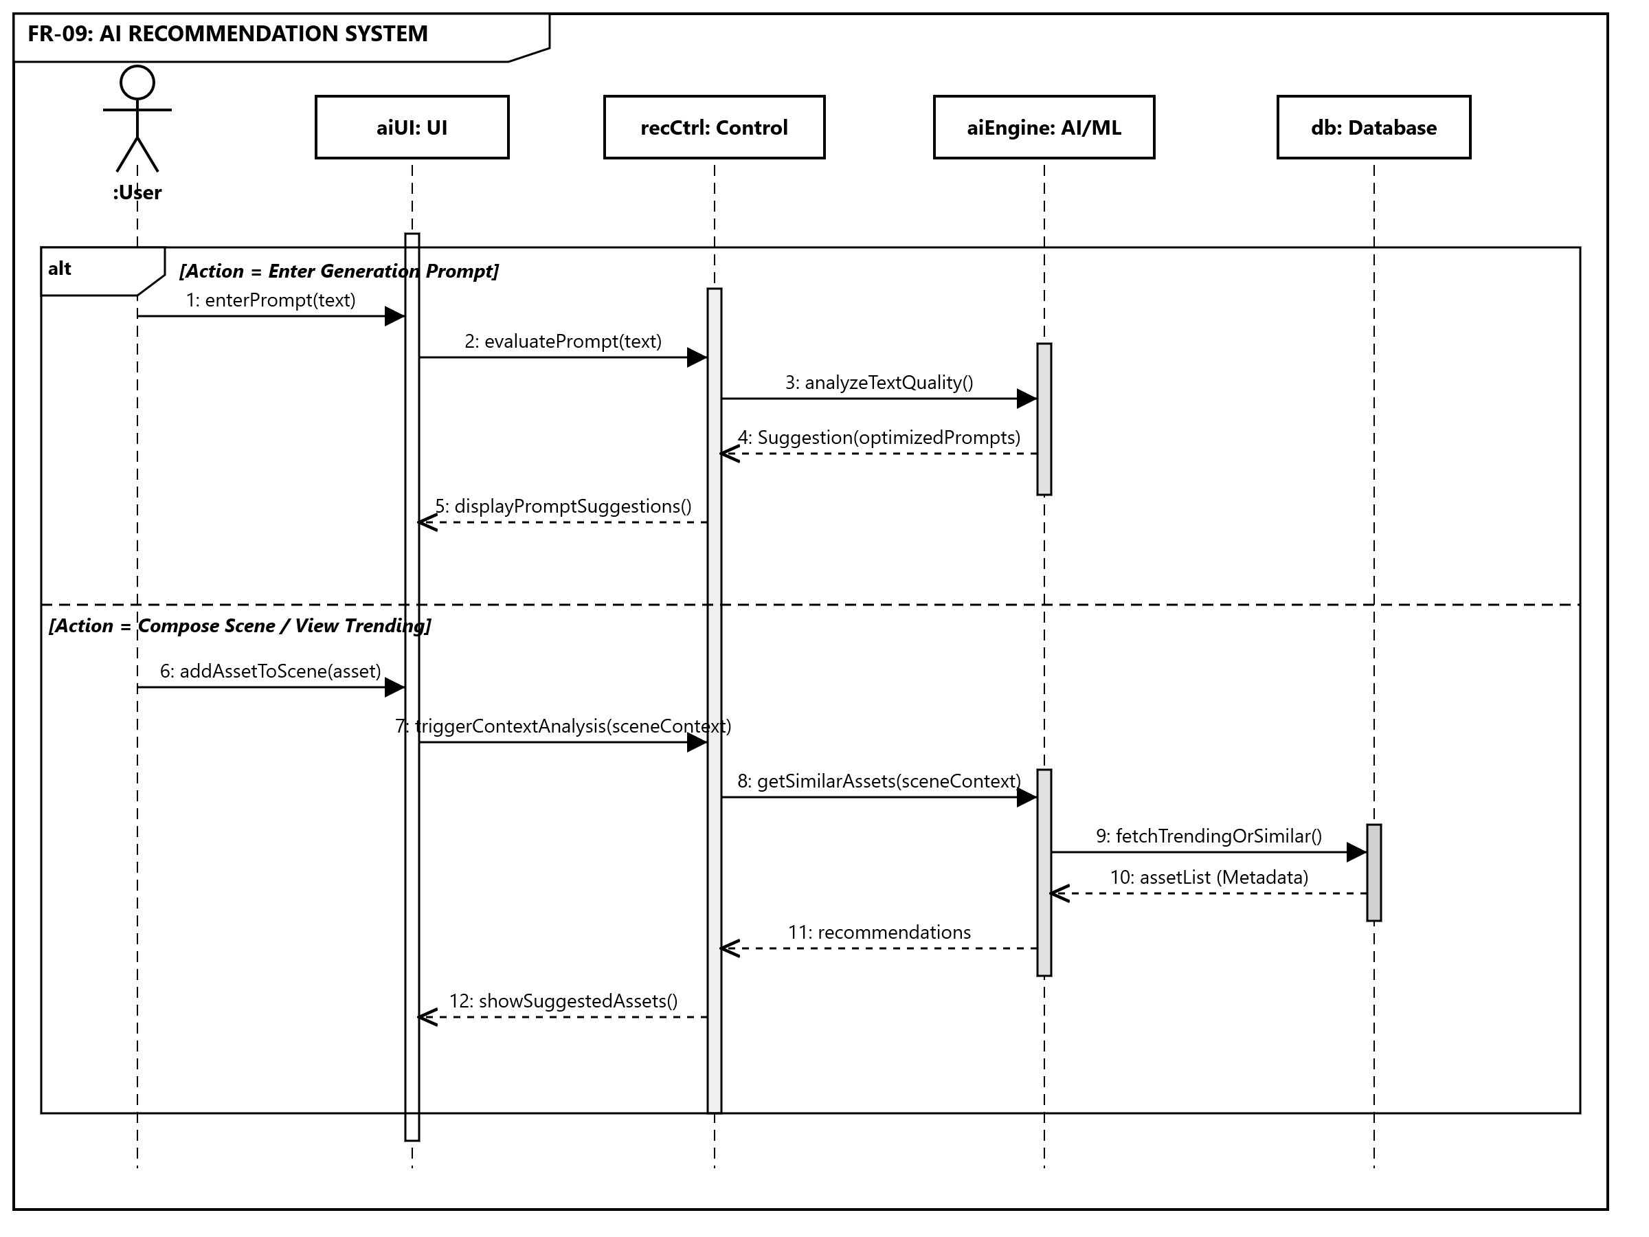
Figure ‎3.27 SD-09

Software Architecture Diagram
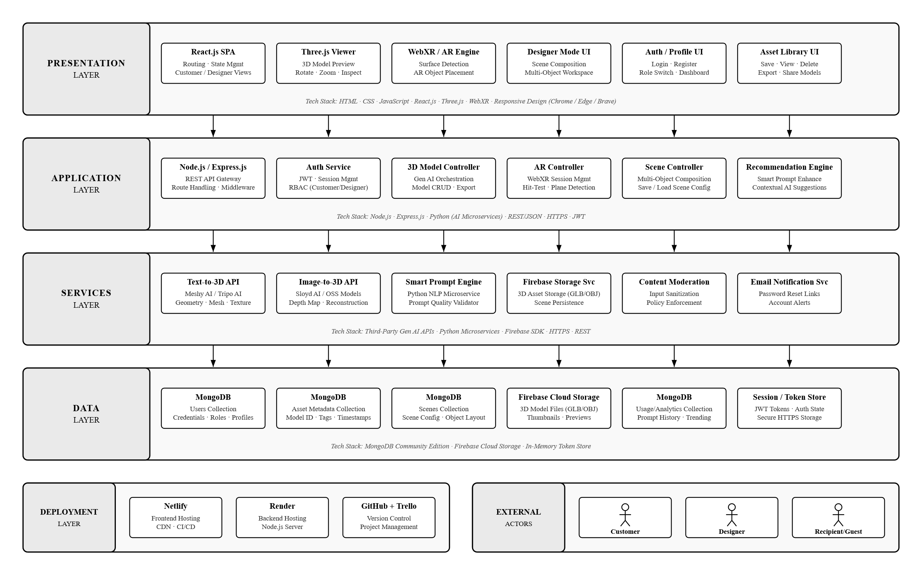
Figure ‎3.28 System Architecture Diagram

Class Diagram
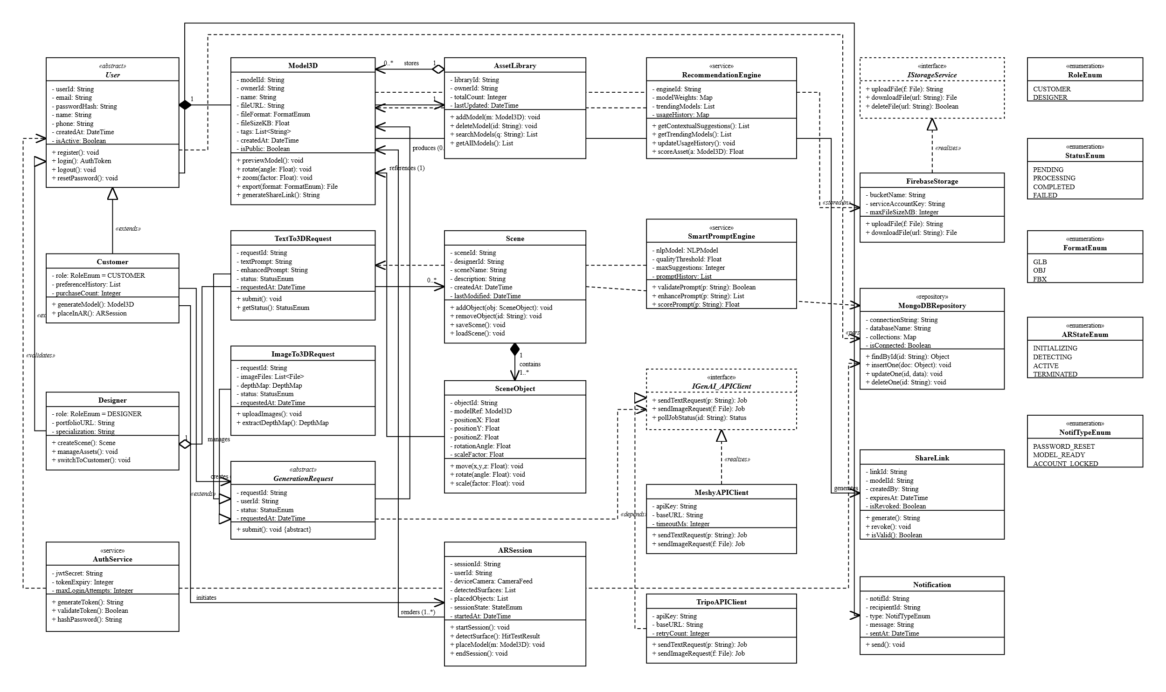
Figure ‎3.29 Class Diagram

Database Diagram
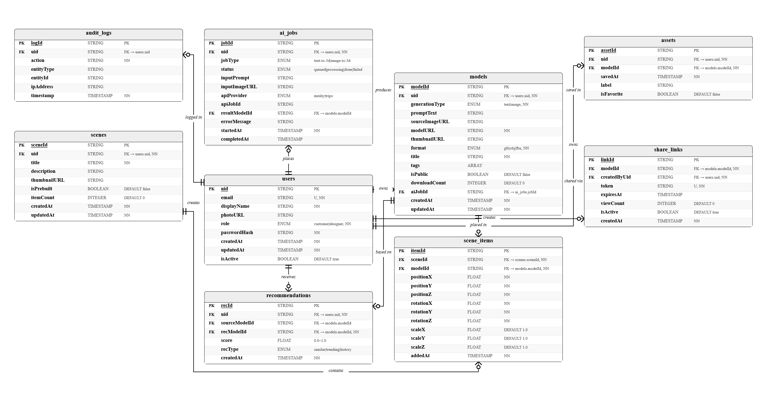
Figure ‎3.30 Database Diagram

Collaboration Diagram

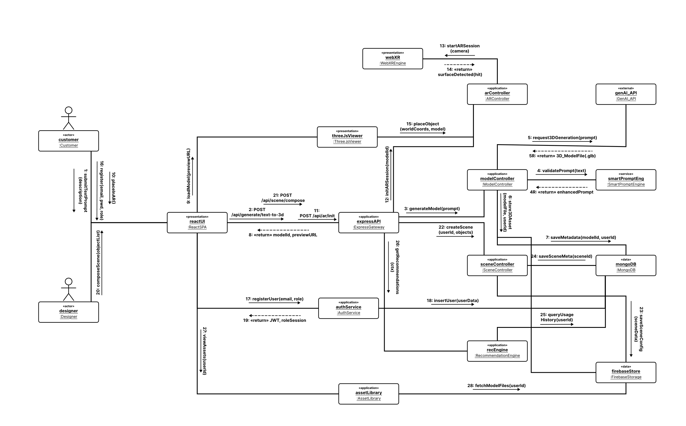
Figure ‎3.31 Collaboration Diagram

System Testing

Test Cases Design
Table ‎4.1 Test Cases-GAI
Project Name |  |  |  | ARtisan
Module Name |  |  |  | Generative AI
Created By |  |  |  | Syed Muaarij Nadeem
Created Date |  |  |  | 06/04/2026
Reviewed By |  |  |  | Saim Jamil
Reviewed Date |  |  |  | 6/05/2026
Scenario TID | Test Case ID | Scenario  Description | Pre-Condition | Test Case Description | Actions/  Test Steps | Test Data | Expected Results | Actual Results | Status | Post-Condition
TS_GAI_01 | TC-01 | Verify text to 3D generation functionality | User is logged in & on Text-to-3D page; AI service is online. | Create a 3D model using a suitable comprehensive prompt. | "1. Prompt: "A red ceramic coffee mug with a handle"  2.Click Generate" | Prompt: “A red ceramic coffee mug with a handle” | Correct geometry, mesh and red ceramic texture are applied to 3D model and displayed in preview viewer | Pending | Pending | You can save, export or place Model.
TS_GAI_01 | TC-02 | Verify text to 3D generation functionality | If text field is empty, user is authenticated. | Empty Text Prompt | "1. Leave text field blank  2.Click Generate" | Input: (empty) | The following API call was not made inline validation error shown. | Pending | Pending | User stays in the generation page showing the error message.
TS_GAI_01 | TC-03 | Verify text to 3D generation functionality | When a user is logged in, it will be displayed as text with 1-2 chars. | The prompt must be at least the length of the minimum required by the specification. | "1. Enter ""Hi""  2.Click Generate" | Input: “Hi” | The minimum length validation error was shown; submission was prevented. | Pending | Pending | User is asked to provide a more detailed text.
TS_GAI_01 | TC-04 | Verify text to 3D generation functionality | The user has been authenticated, so the AI API will timeout. | Gracefully handle missing availability of AI services. | "1. Simulate API timeout  2. Submit valid prompt" | Valid Prompt; simulated timeout | Service unavailable error displayed, user input retained, retry button displayed | Pending | Pending | User can resume without inputting the prompt again
TS_GAI_01 | TC-05 | Verify text to 3D generation functionality | The user is authenticated, and the prompt includes content that is policy-infringing. The user is authenticated, and content in the prompt is policy-infringing. | Deny content that breaches prompt's content moderation policy. Deny contents that breach prompt's content moderation policy. | "1. Enter forbidden content in prompt  2. Click Generate" | Prompt: (Offensive/prohibited text) | The request was not accepted because of a policy violation; the message is shown to the user. | Pending | Pending | No Model generated; Prompt cleared
TS_GAI_01 | TC-06 | Verify text to 3D generation functionality | User is authenticated and AI engine takes too long to respond. | If the generation timeout, cancel the request and display Retry | "1. Submit valid prompt  Set the engine timeout to a higher value to raise the timeout. | Valid prompt; forced timeout condition | A button to ask to cancel and to try again has been added. | Pending | Pending | User may try again, or change prompt
TS_GAI_01 | TC-07 | Verify text to 3D generation functionality | The user was authenticated but the prompt entered was weak and vague. | Smart Prompt catches and proposes enhancements | "1. Type in the ambiguous prompt: "thing"  2. Click Generate" | Input: “thing” | Smart Prompt engine intercepts: list of optimised prompt variants displayed before generation | Pending | Pending | Rewrite the user's prompt and continue generating.
TS_GAI_02 | TC-08 | Verify image to 3D conversion functionality | A valid 2D image is present and user is authenticated. | Convert 2D image into 3D model. | "1. Upload one image that is acceptable as a reference.  2. Initiate conversion" | 1 valid JPG/PNG reference image | While in preview, system reads a depth image and creates a 3D mesh. | Pending | Pending | Model will appear in the viewer and can be saved, exported, or used to create AR.
TS_GAI_02 | TC-09 | Verify image to 3D conversion functionality | User is authenticated; 3 valid images ready | Convert several 2D images to a combined 3D model | "1. Upload 3 reference images  2. Initiate conversion" | 3 valid reference images | System builds a 3D model from all the images it is given. | Pending | Pending | This is the combined model in preview viewer.
TS_GAI_02 | TC-10 | Verify image to 3D conversion functionality | User is authenticated; progress monitoring: | Vibrant progress indicator while generating. | "1. Submit valid prompt  2. "Observe UI while generating" | Valid prompt | A loading / progress indicator shows throughout the generation. | Pending | Pending | Indicator will not appear after model is rendered.

Table ‎4.2 Test Cases-MM
Project Name |  |  |  |  | ARtisan
Module Name |  |  |  |  | 3D Model Management
Created By |  |  |  |  | Syed Muaarij Nadeem
Created Date |  |  |  |  | 06/04/2026
Reviewed By |  |  |  |  | Saim Jamil
Reviewed Date |  |  |  |  | 6/05/2026
Scenario TID | Test Case ID | Scenario  Description | Pre-Condition | Test Case Description |  | Actions/  Test Steps | Test Data | Expected Results | Actual Results | Status | Post-Condition
TS_MM_01 | TC-11 | Verify interactive 3D viewer rendering and controls | A successful 3D model was created (TC-GAI-001). | If the generation is successful, the model will be displayed in the viewer. |  | "1. Complete a successful generation  2. Observe viewer" | Created a 3D model asset. | Use a virtual camera and light to render models in interactive viewer. | Pending | Pending | Save, Export, AR Placement Actions are available
TS_MM_01 | TC-12 | Verify interactive 3D viewer rendering and controls | This model is displayed in the viewer, and a pointer device is available. | Drag model to rotate it. |  | "1. Hold down the mouse button on model  2. Drag left/right/up/down" | Mouse drag gesture | The model is smooth in the drag direction, and the real-time re-render effect was applied. | Pending | Pending | A rotation transformation that is reflected in the current view.
TS_MM_01 | TC-13 | Verify interactive 3D viewer rendering and controls | Model loaded in viewer. | Press On-screen Magnifier to zoom in (use scroll wheel) |  | "1. Place cursor over model  2. Scroll mouse wheel up" | Mouse scroll up | The zoom zooms in on the model, who then becomes larger in real time. | Pending | Pending | The zoom level is changed in the viewer.
TS_MM_01 | TC-14 | Verify interactive 3D viewer rendering and controls | Model has been loaded in the viewer. | Zoom out using scroll wheel |  | "1. Place cursor over model  2. Scroll mouse wheel down" | Mouse scroll down | A zoom out from the camera so the model appears smaller. | Pending | Pending | The zoom level was changed in the viewer.
TS_MM_01 | TC-15 | Verify interactive 3D viewer rendering and controls | Model loaded, touch capable device | Use pinch-to-zoom on touch device |  | When you need to use two fingers to pinch on the touch screen, please do so. Please use two-finger pinch gesture on touch screen. | Two-finger pinch gesture | Zoom behaviour is the same as scroll-wheel zoom. | Pending | Pending | The Viewer Zoomer was updated successfully.
TS_MM_01 | TC-16 | Verify interactive 3D viewer rendering and controls | Failure to retrieve asset from model was simulated. | If the model load fails, it will show error with a "Retry" option. |  | "1. Simulate failure of the asset retrieval system  2. Observe UI" | Simulated API failure | "Error" message was displayed; User was given opportunity to try again by clicking on the "Retry" button. | Pending | Pending | The user is allowed to try to load the model again.
TS_MM_01 | TC-17 | Verify interactive 3D viewer rendering and controls | On this page, WebGL is disabled because of your browser. | Unsupported browser message when there is no WebGL support. |  | "1. Open viewer in browser, but with WebGL turned off.  2. Observe UI" | Browser: WebGL disabled | Supported-browser message displayed with suggestion of browser. | Pending | Pending | Using a redirect for more compatible browsers.
TS_MM_01 | TC-18 | Verify interactive 3D viewer rendering and controls | Model loaded - System under heavy load | Degradation leads to loss of quality |  | "1. Test the viewer with high loads.  2. Observe rendering" | Simulated high-load environment | For responsiveness, visual fidelity is temporarily lowered in system. | Pending | Pending | It is still interactive, but with Viewer, it is possible to view without freezing.

Table ‎4.3 Test Cases-WAR
Project Name |  |  |  |  |  |  | ARtisan
Module Name |  |  |  |  |  |  | Web Based Augmented Reality (WebAR)
Created By |  |  |  |  |  |  | Syed Muaarij Nadeem
Created Date |  |  |  |  |  |  | 06/04/2026
Reviewed By |  |  |  |  |  |  | Saim Jamil
Reviewed Date |  |  |  |  |  |  | 6/05/2026
Scenario TID |  | Test Case ID |  | Scenario  Description | Pre-Condition | Test Case Description |  | Actions/  Test Steps | Test Data | Expected Results | Actual Results | Status | Post-Condition
TS_WAR_01 | TC-19 |  | Verify AR session initiation and surface detection |  | The viewer has a model loaded and is a camera-capable device. | An AR session starts when a model viewer is opened. When a model viewer is opened, an AR session is started. |  | To add an already loaded model, click on the "Place in AR" button. | The device has a camera and has a button called "Place in AR". | Permission to use camera, AR camera feed is activated. | Pending | Pending | Sets up the AR session and starts the placement indicator scan. Initializes the AR session and starts the placement indicator scan.
TS_WAR_01 | TC-20 |  |  | Verify AR session initiation and surface detection | Permission for camera was shown. | The camera was not available and was handled gracefully. |  | "1. Click on ""Place in AR""  2. Deny camera permission" | Camera permission: denied | Access denied message turned up; user switched to device settings. | Pending | Pending | AR session not started; user guided to enable permission.
TS_WAR_01 | TC-21 |  |  | Verify AR session initiation and surface detection | AR will be active; a flat lit surface is in the field of view. | A horizontal surface was found and an indicator was displayed. Horizontal surface found and indicator displayed. |  | "1. Start AR session  2. Point camera at a level horizontal surface" | Flat well-lit horizontal surface | Superimposed marker indicating the placement position (ring/grid) over the detected surface | Pending | Pending | Surface locked; model is ready to be placed
TS_WAR_01 | TC-22 |  |  | Verify AR session initiation and surface detection | When there is no flat surface, AR session is active. | The guidance message reads No surface detected! |  | "1. Start AR session  2. Pan the camera across the surface for 5+ seconds (if it is not flat). | This is an error that occurs when no valid flat surface is found. | Contextual guidance message displayed advising user to pan to flat surface | Pending | Pending | Scan continues, guidance is still in view
TS_WAR_02 | TC-23 |  |  | Verify AR model placement and manipulation | Surface detected and placement indicator is visible. | An object detected on a surface and placed on it in 3D. |  | Tap on valid placement indicator | Click with two fingers on placement indicator. Double-click on placement indicator. | The 3D model is correctly positioned at world space coordinates determined by the detected plane. | Pending | Pending | Model is visible in AR environment, but manipulation controls are not. Manipulation controls are active, but model is not.
TS_WAR_02 | TC-24 |  |  | Verify AR model placement and manipulation | No valid surface found. No surface found in the AR session. | If no valid surface is found, tap with no valid surface is ignored. |  | Tap screen if no surface detected. | Tap on screen with no surface | Temporary notification is shown; system ignores tap; Temporary notification is shown, but then system ignores the tap; | Pending | Pending | No model placed yet, user asked for a valid surface model.
TS_WAR_02 | TC-25 |  |  | Verify AR model placement and manipulation | Model placed in AR | Dragging and dropping the model into the position with reposition placed. |  | "1. Place model  2. Drag model with one finger to new position" | One-finger drag gesture | Model follows finger, moving position of the model is updated in real-time in world space. | Pending | Pending | The position of the model has been updated in the AR scene.
TS_WAR_02 | TC-26 |  |  | Verify AR model placement and manipulation | Model placed in AR | Rotate Rotated Model around vertical axis |  | "1. Place model  2. Apply rotation gesture" | Rotation gesture | Model will spin around its vertical axis. | Pending | Pending | All containers are rotated every 10 weeks and maintained.
TS_WAR_02 | TC-27 |  |  | Verify AR model placement and manipulation | Model placed in AR | Use pinch gesture to scale model, with live overlay. |  | "1. Place model  2. Pinch to scale" | Two-finger pinch gesture | In the case of live dimensional data, multiple data sets are shown as AR overlays (i.e. models are shown proportionately) | Pending | Pending | The scale has been updated; dimensional overlay is visible.
TS_WAR_02 | TC-28 |  |  | Verify AR model placement and manipulation | Active AR session and placed model. | Leave AR session through the UI overlay |  | You need to press exit/close control in AR overlay. | Tap exit button | The AR session ends, and user goes back to the model viewer. | Pending | Pending | Clean end of AR session, viewer restored.
TS_WAR_02 | TC-29 |  |  | Verify AR model placement and manipulation | Non-WebXR browser used | Supported by non-WebXR browser, with a compatibility message |  | Navigate to the AR app without WebXR support. Open AR session in browser that does not support WebXR. | This browser does not support WebXR. | A message is displayed to alert the user that there is an incompatibility; the AR session did not start. | Pending | Pending | User is notified and directed to an appropriate browser.

Table ‎4.4 Test Cases-UARM
Project Name |  |  |  | ARtisan
Module Name |  |  |  | User Authentication and Role Management
Created By |  |  |  | Syed Muaarij Nadeem
Created Date |  |  |  | 06/04/2026
Reviewed By |  |  |  | Saim Jamil
Reviewed Date |  |  |  | 6/05/2026
Scenario TID | Test Case ID |  | Scenario  Description |  | Pre-Condition | Test Case Description | Actions/  Test Steps | Test Data | Expected Results | Actual Results | Status | Post-Condition
TS_URM_01 |  | TC-30 | Verify user registration functionality |  | Registration is available; registration is open over the Internet. | Create new user using valid data | "1. Enter name, email address, password.  2. Select role (Customer)  3. Click Register" | Name: Test User, Email: test@test.com, Password: P@ssw0rd1 and Role: Customer. | An account was created; a role was assigned to it and it was redirected to the Customer dashboard. | Pending | Pending | An active session has been created for the User. A session has been established for the User.
TS_URM_01 |  | TC-31 | Verify user registration functionality |  | Registration page open | Don't allow invalid email registration. Do not accept invalid e-mail registration. | "1. Enter email: ""user@""  2. Fill other fields  3. Submit" | Email: user@ (invalid format) | An error in the form of an inline email was found; submission is blocked. | Pending | Pending | You can keep the user on the form after the registration.
TS_URM_01 |  | TC-32 | Verify user registration functionality |  | Registration page open | If you offer a poor password when registering, you will be rejected. | "1. Enter password: ""123""  2. Fill other fields  3. Submit" | Password: 123 (too weak) | A weak-password error was shown; it was not submitted. | Pending | Pending | User will be prompted to enter a stronger password.
TS_URM_01 |  | TC-33 | Verify user registration functionality |  | There is already an email that is registered in the system. | Prevent duplicate email sign-up. | "1. Enter already-registered email  2. Submit form" | Email: existing_user@test.com | System has user's e-mail address; Login and Forgot Password area is provided. | Pending | Pending | No duplicate account created!
TS_URM_02 |  | TC-34 | Verify login and session management |  | Registered account exists | You have logged in successfully with a valid username and password. | "1. Enter correct email & password  2. Click Login" | First help desk contact: test@test.com with the password | Created a session that is authenticated; redirected to the role specific dashboard. | Pending | Pending | User can access the site and all its content as assigned by his/her role.
TS_URM_02 |  | TC-35 | Verify login and session management |  | Registered account exists | Unfortunately, login was not successful due to bad credentials. | "1. Please enter a valid e-mail address and incorrect password.  2. Click Login" | To qualify for the quiz, you must submit your answers by email to test at test.com with the correct password: wrong pass. | There was an error flashing the message, but no session has been created. | Pending | Pending | User stays on Login page.
TS_URM_02 |  | TC-36 | Verify login and session management |  | Registered account exists | Your account was locked because you tried to log in five times but failed. | 1. Enter wrong password 5 consecutive times | Password: wrong (x5) | The account is locked after 5 failures, and the user is reminded about the lock. After 5 failures, the account becomes locked and the user is warned of the account lockout. | Pending | Pending | There will be more logon attempts until unlocked.
TS_UARM_02 |  | TC-37 | Verify login and session management |  | You must register an account on which you have an email address. | Your password was sent to you. | "1. Click Forgot Password  2. Enter registered email  3. Submit" | Email: test@test.com | A time limited reset password link is e-mailed to you. | Pending | Pending | User can reset password using an email link
TS_URM_02 |  | TC-38 | Verify login and session management |  | If you don't remember your password, you can use the password reset link provided with an expired token. | The password reset token is no longer valid. | "1. Wait for Reset Token to expire  2. Click reset link" | The reset token URL has expired. | Expiry message is displayed; option for a new reset link is offered. | Pending | Pending | A change in the password does NOT happen
TS_URM_02 |  | TC-39 | Verify login and session management |  | Customer logged in with valid session. | Secure logout is not valid - it invalidates session. | Log out when logged in. | Authenticated session active | Session has expired on the server, and data has been removed from the local machine; redirected to the login page. | Pending | Pending | These are protected routes that have been completely cut off during the session.

Table ‎4.5 Test Cases-UPM
Project Name |  |  |  |  |  | ARtisan
Module Name |  |  |  |  |  | User Profile Management
Created By |  |  |  |  |  | Syed Muaarij Nadeem
Created Date |  |  |  |  |  | 06/04/2026
Reviewed By |  |  |  |  |  | Saim Jamil
Reviewed Date |  |  |  |  |  | 6/05/2026
Scenario TID | Test Case ID |  | Scenario  Description | Pre-Condition | Test Case Description |  | Actions/  Test Steps | Test Data | Expected Results | Actual Results | Status | Post-Condition
TS_UPM_01 |  | TC-40 | Verify dashboard and profile update functionality | User logs in and goes to the sign-in dashboard. | Dashboard loads the correct user data. |  | "1. Authenticate  2. Navigate to dashboard" | Authenticated user session | Recent activity, role-specific shortcuts and profile summary shown correctly | Pending | Pending | Personalized dashboard appears to the User. The User sees the personalized dashboard.
TS_UPM_01 |  | TC-41 | Verify dashboard and profile update functionality | User on Edit Profile page | If the data in the profile is valid, updating it succeeds. |  | "1. Click Edit Profile  2. Modify name  3. Save" | New Name: "New Name" | Data saved, and success confirmation and updated profile view are displayed | Pending | Pending | The updated name appears in the profile instead. A new name was used instead in a profile.
TS_UPM_01 |  | TC-42 | Verify dashboard and profile update functionality | Viewing Profile page as a user. | The update to the profile was rejected because the data was not valid. |  | "1. Please enter invalid characters in name field.  2. Submit" | Name: "@@##!!" (invalid) | Inline validation error(s) are shown; submission is prevented. | Pending | Pending | Profile data unchanged
TS_UPM_02 |  | TC-43 | Verify role upgrade from customer to designer | You are logged in as a customer. | You have been upgraded to the Customer role: Designer |  | "1. Click on ""Switch to Designer""  2. Confirm in dialogue" | Current role: Customer | The role has been changed to Designer; permissions reloaded; Designer dashboard displayed. | Pending | Pending | Designer-only features accessible
TS_UPM_02 |  | TC-44 | Verify role upgrade from customer to designer | Shows confirmation dialogue when changing roles. Displays confirmation dialog box when changing roles. | Role switch cancelled - No change in role |  | "1. Open role switch dialogue  2. Click Cancel" | Action: Cancel | The dialogue is rejected, and the role will keep its original name. | Pending | Pending | There were no changes in the role.

Table ‎4.6 Test Cases-SC
Project Name |  |  |  |  | ARtisan
Module Name |  |  |  |  | Scene & Multi-Object Composition
Created By |  |  |  |  | Syed Muaarij Nadeem
Created Date |  |  |  |  | 06/04/2026
Reviewed By |  |  |  |  | Saim Jamil
Reviewed Date |  |  |  |  | 6/05/2026
Scenario TID | Test Case ID | Scenario  Description | Pre-Condition | Test Case Description |  | Actions/  Test Steps | Test Data | Expected Results | Actual Results | Status | Post-Condition
TS_SC_01 | TC-45 | Verify scene creation and object manipulation | This is a user logged in as Designer and the Scene module is displayed. | The initialisation of the new scene workspace is correct. Initialization of the new scene workspace is proper. |  | 1. Click "New Scene" | Designer role; module open | Clears workspace and initialises the environment and spatial grid. | Pending | Pending | The designer can add models to the workspace.
TS_SC_01 | TC-46 | Verify scene creation and object manipulation | A scene workspace is open, and the model library has models. A scene workspace is open, and there are models in the model library. | The 3D model was imported from the asset library to the scene. |  | "1. Open asset library  2. Select a model  3. Add to scene" | The library has at least one saved model. There is 1 saved model in library. | Selected model loaded and displayed in the Scene Workspace. | Pending | Pending | Export model that can be seen and picked in the scene.
TS_SC_01 | TC-47 | Verify scene creation and object manipulation | When you load models, the model will be displayed in the scene workspace. | Multiple models co-exist in single scene. |  | 1. Add 3 different models from library | 3 different saved assets | All 3 models are rendered at the same time in workspace | Pending | Pending | The models can be selected individually.
TS_SC_01 | TC-48 | Verify scene creation and object manipulation | The selected object in the scene workspace. The currently selected object from the scene workspace. | The object has been moved to a different location in the scene. |  | "1. Select object  Click on 2. Drag to new position" | Drag gesture on selected object | Object positions are updated in real time as the object is dragged. | Pending | Pending | New Position has been stored in the Scene State.
TS_SC_01 | TC-49 | Verify scene creation and object manipulation | The picked object in the scene workspace. The object picked in the scene workspace. | Object was rotated and scaled in the scene. |  | "1. Apply rotation to object  2. Apply scale transform" | Rotate and scale gestures / input. | When the scale and rotation values change in the object, it re-renders dynamically. | Pending | Pending | The variations of the state of the scene. The changes in the state of the scene.
TS_SC_02 | TC-50 | Verify scene save, retrieve and update | Place objects in workspace - Scene | The scene was saved with valid scene name. |  | "1. Click Save Scene  2. Type in the name "Living Room Setup".  3. Confirm" | Position name: "Living Room Setup" | Scene serialised and stored; success confirmed with a last modified time stamp displayed. | Pending | Pending | The scene is in the list of My Scenes. The scene is in the list of My Scenes.
TS_SC_02 | TC-51 | Verify scene save, retrieve and update | The Saved scene is in My Scenes. | Previously saved scene retrieved. |  | "1. Go to My Scenes. Click on My Scenes.  2. Open saved scene" | The Living Room Setup was saved. | The loaded workspace contained all the objects in it. All the objects were loaded in the workspace. | Pending | Pending | After finishing the scene, Designer can continue to edit it.
TS_SC_02 | TC-52 | Verify scene save, retrieve and update | This is the scene loaded from My Scenes and altered. | If an update of the scene is performed the saved scene will be over-written. |  | "1. Load scene  2. Modify objects  3. Click Update Scene" | Modified scene configuration | If a new configuration is set, then the earlier saved configuration will be overwritten and the change will be confirmed; if the configuration is not changed, the earlier save will remain. | Pending | Pending | This is an updated scene, incorporating all the latest changes.
TS_SC_02 | TC-53 | Verify scene save, retrieve and update | This error occurs when one of the assets that make up a scene can't be retrieved. | Asset load failure gracefully skips failed model. |  | Simulate one asset failing to load during the population of the scene. Simulate the failure of one asset to load during the population of the scene. | The simulation of asset failure for one model | Skipped a failed asset, loaded remaining assets; an error per asset was displayed. | Pending | Pending | There is a partial load for this scene. Partial load of this scene, the designer told.

Table ‎4.7 Test Cases-AM
Project Name |  |  |  |  |  | ARtisan
Module Name |  |  |  |  |  | Asset Management
Created By |  |  |  |  |  | Syed Muaarij Nadeem
Created Date |  |  |  |  |  | 06/04/2026
Reviewed By |  |  |  |  |  | Saim Jamil
Reviewed Date |  |  |  |  |  | 6/05/2026
Scenario TID | Test Case ID | Scenario  Description | Pre-Condition |  | Test Case Description |  | Actions/  Test Steps | Test Data | Expected Results | Actual Results | Status | Post-Condition
TS_AM_01 | TC-54 | Verify save, view, and delete asset functionality | Created model in preview viewer; user was authenticated | Every model was created and saved to the asset library. All models were created and stored in the asset library. |  |  | "1. Once the generation is complete, click Save.  2. Enter optional name  3. Confirm" | Model to viewer; optional name: "My Mug" | Model is linked to account, metadata is stored, library view is updated. | Pending | Pending | Model in Asset Library that shows visible in thumbnail and date.
TS_AM_01 | TC-55 | Verify save, view, and delete asset functionality | Models have been saved in the asset library. Models are stored in the asset library. | All saved models are displayed in the asset library. |  |  | Select Asset Library. Click on Asset Library. | Users can save their assets and use them later. | All models are stored with thumbnails, names and creation dates displayed | Pending | Pending | All listed assets are open for user's interaction
TS_AM_01 | TC-56 | Verify save, view, and delete asset functionality | You have not connected any assets to your account (new account). | If the library is empty, it displays the appropriate empty state. The empty state is shown when the library is empty. |  |  | Create a new account without saving models in 1. Create a new account in 1 without saving models. | The data is not stored in the account. | Empty state message appears and user is prompted to make a first model; appearance of message and prompt; | Pending | Pending | User guided to generate first model
TS_AM_01 | TC-57 | Verify save, view, and delete asset functionality | Asset library has at least one model. | If confirmed, the asset will be permanently deleted. |  |  | "1. Select model  2. Click Delete  3. Confirm deletion" | Target model selected | The Library View is automatically updated when the model is deleted. | Pending | Pending | Model no longer in library or storage
TS_AM_01 | TC-58 | Verify save, view, and delete asset functionality | Removes the confirmation dialog box when deleting. | The deletion of an asset is cancelled if the model is still in use. |  |  | "1. Select model  2. Click Delete  3. Click Cancel" | Action: Cancel | Left in Library; dialogue is discarded. | Pending | Pending | It is not valid to change the model in the library.
TS_AM_01 | TC-59 | Verify save, view, and delete asset functionality | The deletion of storage service is simulated. Storage service is simulated to delete. | Failure to delete without loss of data. |  |  | "1. Select model  2. Click Delete  3. Confirm  4. Simulate storage error" | Simulated storage failure | An error is displayed; the model is still visible in the library. An error is displayed and the model will stay in the library. | Pending | Pending | No partial deletion - model data is intact.

Table ‎4.8 Test Cases-MES
Project Name |  |  |  | ARtisan
Module Name |  |  |  | Model Export & Sharing
Created By |  |  |  | Syed Muaarij Nadeem
Created Date |  |  |  | 06/04/2026
Reviewed By |  |  |  | Saim Jamil
Reviewed Date |  |  |  | 6/05/2026
Scenario TID | Test Case ID | Scenario  Description | Pre-Condition |  | Test Case Description | Actions/  Test Steps | Test Data | Expected Results | Actual Results | Status | Post-Condition
TS_MES_01 | TC-60 | Verify model download in supported formats | Model loaded in viewer or asset library (user authenticated) |  | An imported 3d model in the GLB file format. A 3d model imported from a GLB file. | "1. Select model  2. Click Export  3. Select GLB  4. Download" | Format selected: GLB | This model is packaged and downloaded to the device as .glb. | Pending | Pending | A .glb file stored on device; can be opened in the compatible viewer.
TS_MES_01 | TC-61 | Verify model download in supported formats | You can model in a viewer or asset library. You can do modelling in a viewer or asset library. |  | A 3D model downloaded from the OBJ format. | "1. Select model  2. Click Export  3. Select OBJ  4. Download" | Format selected: OBJ | Model in .obj format with download to device. | Pending | Pending | .obj file on device
TS_MES_01 | TC-62 | Verify model download in supported formats | A web browser set to reject automatic downloads. A web browser that is set to deny automatic downloads. |  | If the download link is blocked with the browser, you will see the direct download link here. | "1. Initiate download  2. Browser blocks automatic download" | Browser: auto-download blocked | This is the direct download link that is displayed if none of the other links are available. | Pending | Pending | User can download by clicking the provided link.
TS_MES_02 | TC-63 | Verify model sharing via link | For a model, enter the viewer or library and user has been authenticated. Model entered viewer or library (user is authenticated). |  | For the model, the following shareable link was created. | "1. Select model  2. Click Share" | Target model selected | A link for sharing the content has been created and is displayed with a Copy Link button. A shareable access link has been generated and is displayed with a Copy Link button. | Pending | Pending | The link has been copied to your clipboard and is shareable outside.
TS_MES_02 | TC-64 | Verify model sharing via link | The shared link is not valid for the recipient; it is the recipient's responsibility to verify its authenticity. |  | Shows model in browser which is shared by recipient. Displays model in shared browser. | Open shared link in new incognito browser window | Unauthenticated session is also known as a Shared URL. | A 3D model that is displayed in a browser-based 3D viewer, without the need to log in. | Pending | Pending | Model view to which the result is transferred, which cannot be edited or saved.
TS_MES_02 | TC-65 | Verify model sharing via link | A model that was deleted by the owner after it was linked. |  | Revoked/Deleted Shared Link - returns not found page | "1. Delete shared model  To link to a previous open, click on 2. Open previous share link. | Model: removed, old share link | Not-found/model-unavailable page displayed to recipient | Pending | Pending | A clear 404 message displayed, no broken viewer.

Table ‎4.9 Test Cases-AIR
Project Name |  |  |  | ARtisan
Module Name |  |  |  | AI Recommendation System
Created By |  |  |  | Syed Muaarij Nadeem
Created Date |  |  |  | 06/04/2026
Reviewed By |  |  |  | Saim Jamil
Reviewed Date |  |  |  | 6/05/2026
Scenario TID | Test Case ID | Scenario  Description | Pre-Condition |  | Test Case Description | Actions/  Test Steps | Test Data | Expected Results | Actual Results | Status | Post-Condition
TS_AIR_01 | TC-66 | Verify contextual asset suggestions in scene | Recommendation engine online (designer has an active scene with at least one object) |  | Contextual suggestions shown when there are objects in the scene. | Open a scene window having at least one object in it that is a 3D object. Open a scene window containing at least one 3D object. | Create a scene with 1+ objects; Designer role | Suggestions panel shows aesthetically/functionally similar assets | Pending | Pending | Designed can add suggested assets to scene
TS_AIR_01 | TC-67 | Verify contextual asset suggestions in scene | On: the first object is already there. |  | Suggestions update when new object added. | "1. Add another object to active scene.  2. Observe suggestions panel" | Added a second object to the scene. | As you type, the suggestion panel refreshes with new context-relevant suggestions. | Pending | Pending | New suggestions are based on new scene context
TS_AIR_01 | TC-68 | Verify contextual asset suggestions in scene | New account that has no history of use. |  | Abstracts that follow world trends displayed if no usage history. Shows abstracts following world trends when none are found in usage history. | "1. Log in as new Designer  Open scene 1 object" | The designer has not used this item before. | System shows world trendy models rather than showing personalised recommendations | Pending | Pending | A generic trending panel is displayed to new Designer.
TS_AIR_02 | TC-69 | Verify smart prompt suggestion functionality | User on Text-to-3D page; weak prompt entered. |  | Text suggestions provided by Smart Prompt for poor input | "1. Type in the generic word "thing".  2. Click Generate" | Prompt: "thing" (vague) | Variants of prompts optimised and shown; key improvements highlighted | Pending | Pending | User has the option to choose "improved prompt" or "original prompt
TS_AIR_02 | TC-70 | Verify smart prompt suggestion functionality | You can see the Smart Prompt suggestions when you hover over them. |  | User clicks on optimised Smart Prompt; generation continues | "1. Choose first suggested variant from suggestions  2. Confirm" | Selected prompt: First AI suggestion | Selected prompt that is sent to the AI generation engine; the generation is repeated | Pending | Pending | Ensuring high quality 3D model with enhanced prompt.
TS_AIR_02 | TC-71 | Verify smart prompt suggestion functionality | Smart Prompt suggestions visible |  | User takes over and uses original input for Smart Prompt | "1. Dismiss all suggestions  2. Proceed with original prompt" | Action: remove all; continue with the original. | First message sent; warning for poor quality is shown. | Pending | Pending | Original distributed to user, warned of danger. Original given to user, warned of danger
TS_AIR_02 | TC-72 | Verify smart prompt suggestion  functionality | The recommendation engine was simulated as an offline one. The recommendation engine was simulated offline. |  | Offline gracefully dealt with by recommendation engine | "1. The simulation of service recommendation is unavailable.  2. Open scene with objects" | Recommendation service: offline | Suggestions will now appear in a panel in the lower right corner, and the composition of the scene will not be disrupted. | Pending | Pending | No blocking on scene work, just a silent degradation.

Unit / Integration / Acceptance Testing
ARtisan's testing methodology comprises of three stages: Unit testing, Integration testing and User acceptance testing (UAT). Each level targets a different notion of system correctness and will be rolled out in stages throughout the implementation process.
- Unit Testing:
Testing of individual functions/parts. Frontend: UI components will be tested using React component unit tests (Jest, React Testing library) to ensure that UI components are displayed correctly, that they respond to user events in a proper way and that they include validation for empty input and API failures. Each route handler and service function in Express.js (like the asset save function, the prompt validation middleware) will be tested with Jest with mocked database calls. There are some significant unit tests: Validation logic for users’ registration, JWT token generation and verification, Asset metadata generation, Enhancing prompt suggestions.

- Integration Testing:
Once every module is tested individually then integration test will check any interaction between the parts of the system. The main integration test scenarios are:
- Complete process of generating a 3D from the text starting on the front end to Express API call and then to the AI service call, save the 3D to Firebase, save the metadata to the MongoDB collection and return it to the viewer.
- The user authentication flow - users register, log in, and receive a token, which can then be used to access protected routes.
- Asset library retrieval flow - A model is saved and returned to the viewer, with the model being correctly associated to the user, and it being returned through the dashboard. The tests will be integration tests that will use a test instance of MongoDB for the API endpoints tests and will be run using Supertest.

- User Acceptance Testing (UAT):
UAT will take place at a formal usability testing session with a sample of potential users from the target users (home shoppers and interior design students). Participants will have to perform five tasks on their own:
- Register and log in.
- Create a 3D model from a prompt.
- Place the model into AR.
- Save and retrieve the model from the asset library.
- Share the model using a generated link. In order to assess usability, completion rate, time on task and a post-session SUS (System Usability Scale) questionnaire will be used.
The acceptance criterion is SUS score of 75 or above.

Implementation
This section provides information about implementation of ARtisan for FYP mid report.

Work Breakdown Structure (WBS)

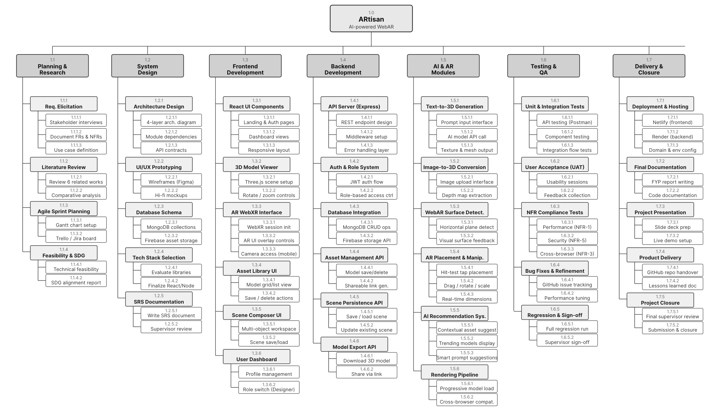
Figure ‎5.1WBS

Team Roles and Responsibilities

Table ‎5.1 Individual Activities
Team Member | Activity
Syed Muaarij Nadeem | Integration with Text-to-3D APIs  object placement,  Personalized Dashboard
 | Integration with Image-to-3D API
UI/UX development for Customer Mode,
Presentation Preparation
Warda Saeed | Requirement gathering,  Backend development with Node.js and database setup
 | Object manipulation (move, rotate, scale)
 | Progressive rendering pipeline implementation
Saim Jamil | Designer Mode features (project saving, scene management),  AR/3D module setup,  Asset Library
 | Final testing of features
 | Documentation

Table ‎5.2 Gantt Chart
Task / Phase | Jan | Feb | Mar | Apr | May | Jun | Jul | Aug | Sep | Oct | Nov | Dec
Requirement Gathering & Research
Literature Review & Related Work
System Design (UI/UX + Architecture)
Frontend Development (React + AR)
Backend Development (API + DB + AI)
AI & AR Module Implementation
Integration & Middleware Setup
Testing & Debugging
Refinement & Performance Tuning
Documentation & Report Writing
Final Presentation & Submission

Tools and Technologies
The development of ARtisan will employ a modern and scalable technology stack that supports Generative AI, Web-based Augmented Reality, and 3D rendering. The following tools and technologies will be used,
- Presentation Layer:
The frontend will be developed using HTML, CSS, JAVASCRIPT with React.js for building responsive components, and Three.js with WebXR for rendering AR-based 3D models.

- Application Layer:
The backend will utilize Node.js with Express.js for API handling and communication.

- Services Layer:
Generative AI functionalities will be supported through python and open-source AI models.

- Data Layer:
The MongoDB Community Edition will manage user data, while firebase will be used for storing 3D assets.

- Deployment and Hosting:
Deployment will be handled on Netlify for frontend and Render for Backend.

- Project Management and Testing:
For project management and testing GitHub, Trello/Jira, Postman will be employed

Implementation Details
This section outlines the progress of the implementation accomplished in the first period of the ARtisan project (January 2026 - May 2026) and constitutes around 30% of the ARtisan project implementation range. The idea of design, the technologies adopted and the development of the modules to date are explained below.
- Project Structure:
Project set up has been carried out in a monorepo structure in the client folder and server folder from the GitHub platform. The frontend has adopted a more starter style; Create React App, React 18, React Router v6 with authentication not appearing until after the JWT is saved to local storage (protected routes). The back end consists of Express.js server with CORS middle ware, helmet.js to set security headers and dotenv as an environment variable.Back end Express.js server with call files, the server is configured, divided into call files and equipped with CORS middle ware, helmet.js as a security header and dotenv as an environment variable.

- User Authentication module:
The authentication module is completely developed. The input body at the endpoint /api/auth/register is validated against express-validator, the passwords are encrypted using bcryptjs (with 10 rounds of salt) and the user document is stored in the MongoDB database using Mongoose. Signs and returns a signed JWT (expires in 24 hours) in /api/auth/login endpoint with the library: jsonwebtoken. JWT is validated and read for all routes that are declared as protected using a custom authenticateToken middleware. Built a sign up/sign in screen for the front-end using React and dynamically added error messages for the Form validation.

- 3D Model Viewer:
3D model viewer component with 3D model viewer based on Three.js framework has been implemented. Creates a WebGL renderer and a perspective camera, and ambient/directional lights in a React useEffect hook. Three.js's GLTFLoader is used to load the GLTF model files. Rotate model by mouse; zoom in or out of model by scrolling in the canvas element using OrbitControls plugin. The viewer component is wrapped with React.memo so that it doesn't re-render when the parent component state changes.

- WebAR Integration:
This module is being integrated into WebXR AR (In Progress). The following is known to work with Chrome for Android (immersive-AR mode flag). Horizontal surface detection has been implemented based on the XRHitTestSource API. It can be used for very basic (easiest) tatting without any complicated cases. Multi touch gestures are added in the XR frame loop with pointer event listeners which are used for scale / rotation manipulation. This is the main focus during development sprint.

- GenAI API Integration:
This is a proxy endpoint which forwards the generation request to the Meshy AI API, so the API Key is not displayed on the Express page. The endpoint will send a json body with a prompt and return a model URL when it is called by the text-to-3D generation API of the Meshy, and waits for the generation to be completed. You have Firebase Admin SDK set up to download the model file from the Meshy CDN and store it in /models/{userId}/{assetId}.glb. on the server. On successful upload of the assets, an asset meta data record is added in MongoDB. Prompt user input and loading state with UI for front end. Full end-to-end pipeline testing is on-going.

Screenshots of Prototype / System

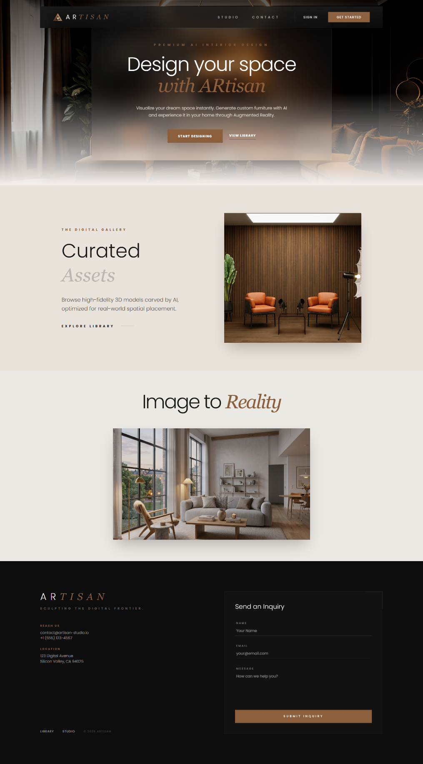
Figure ‎5.2 Landing Page
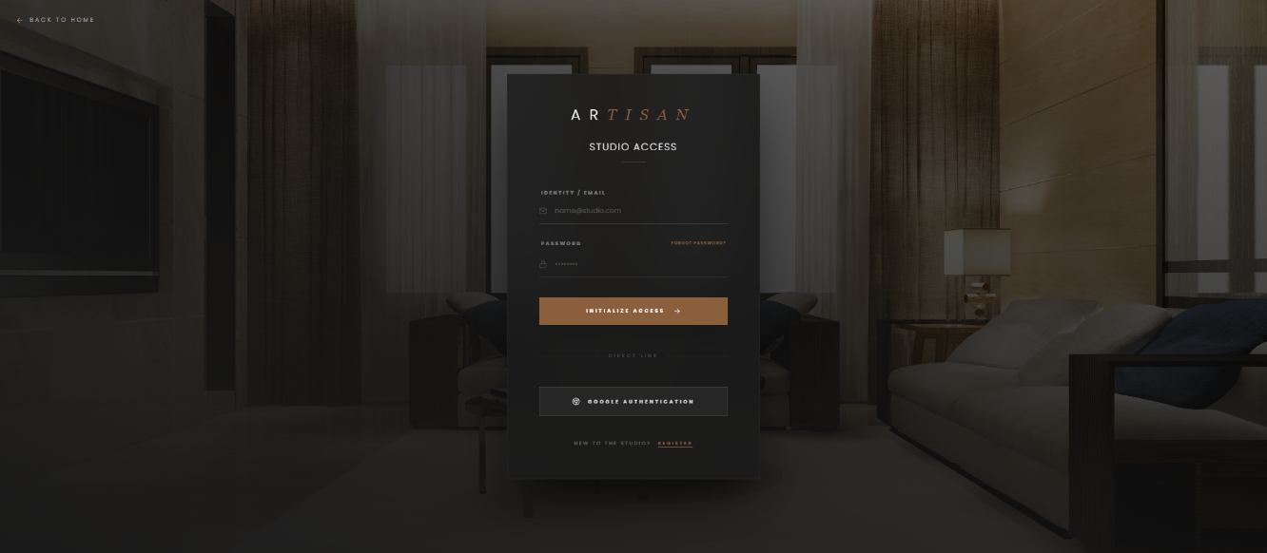
Figure ‎5.3 Login Screen

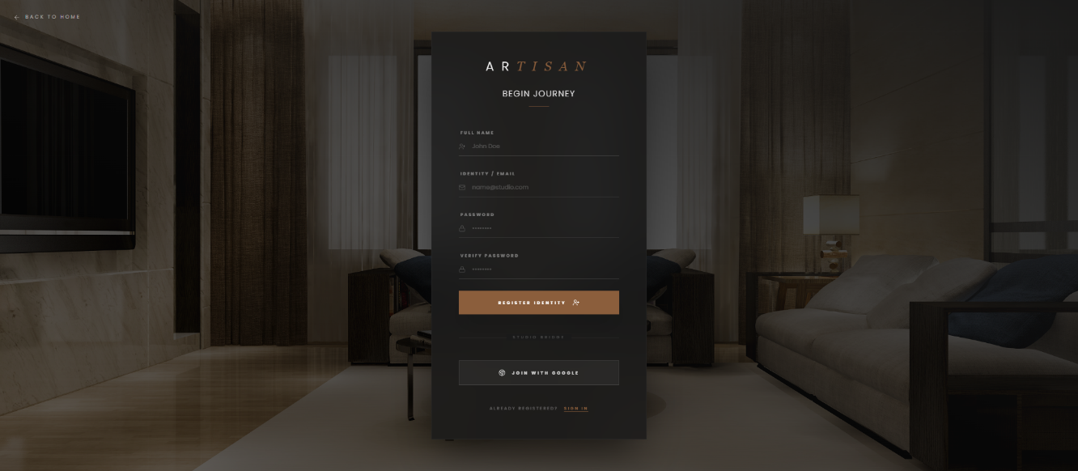
Figure ‎5.4 Register Screen
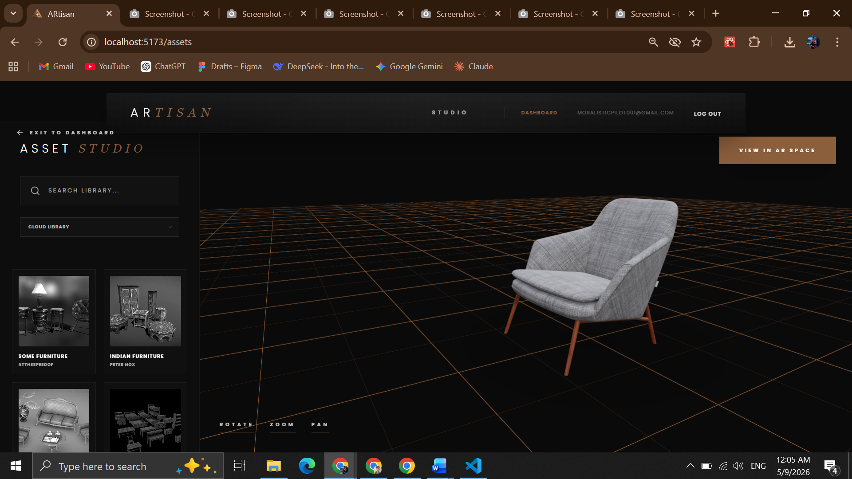
Figure ‎5.5 Asset Studio Page

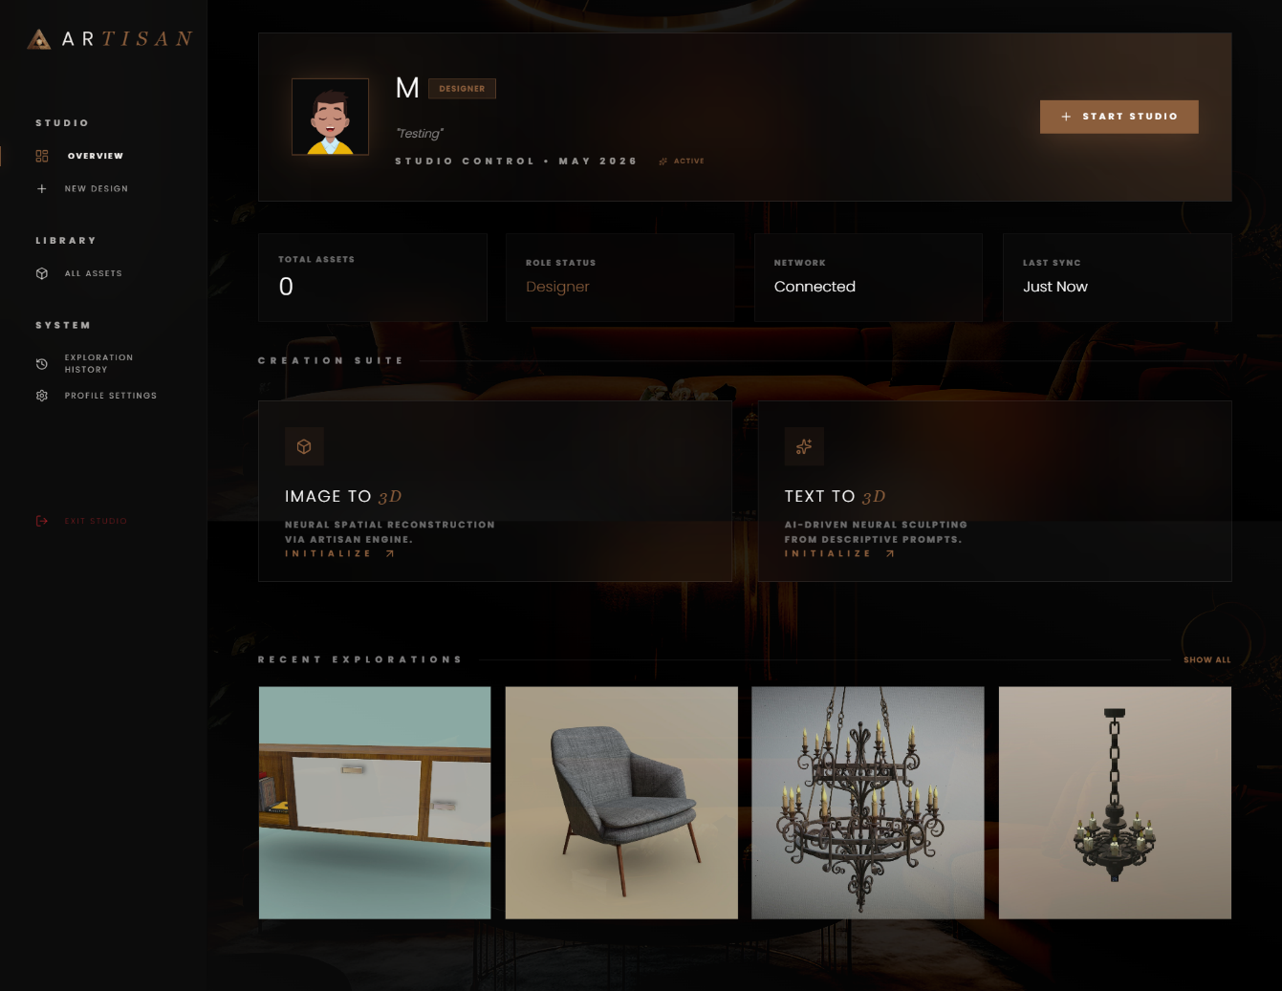
Figure ‎5.6 Personalized Dashboard

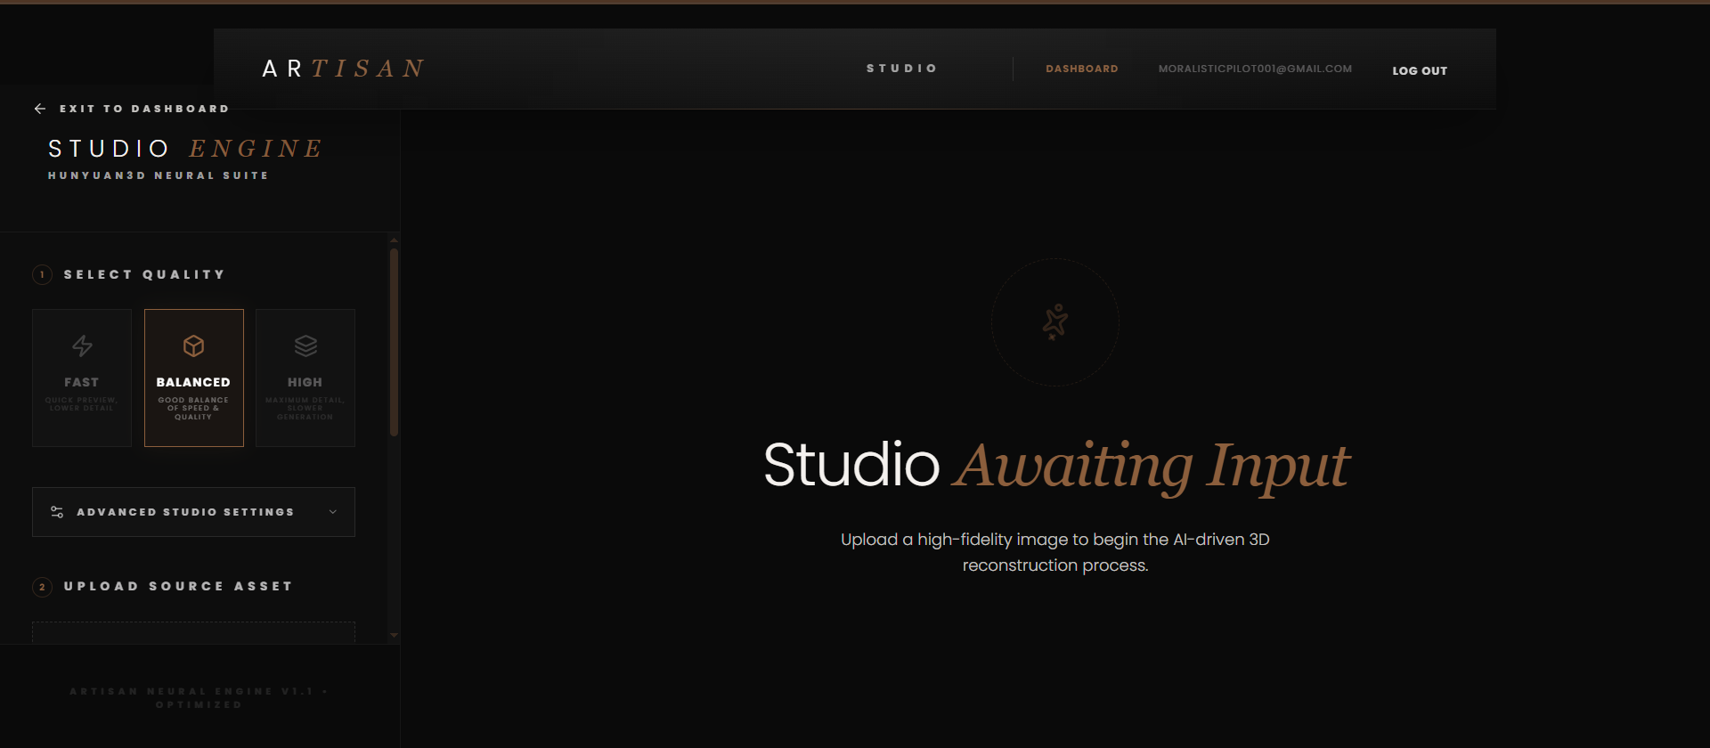
Figure ‎5.7 Image-to-3D Screen

Challenges During Implementation
There were some technical issues raised in the initial phase of ARtisan. A description of the challenges and the actions taken or planned to respond to a challenge.
- WebXR Browser Compatibility:
WebXR Device API is a requirement for immersive AR sessions, and not all the browsers support it. However, Safari for iOS and AR experience are not at all supported natively as well, and on Android devices, AR is supported only in Chrome and Edge. This was determined early by compatibility of the browser. This is accomplished by checking if the browser supports WebXR at the beginning of the sessions and then switching to an alternative (non-AR) 3D Viewer if it doesn't support WebXR, with a nicer message for the user about the limitations. This is the same as the NFR-3.1 'compatible' requirement.

- GenAI API Latency and Polling:
The difference between the in-house Generative AI API and the third-party Generative AI API (Meshy AI) is that the latter returns a generated model but does not do so in real time. Rather, it starts an asynchronous generation task, and the caller checks the status endpoint until the generation task is finished, this process can take from one to three minutes. This required an exponential backoff approach on the backend for polling in order to not exceed the API rate limit. The frontend side was enhanced with a progress indicator and estimated time feedback so that users won't get frustrated with being lost during the generation of the page. Managing this "asynchronous state" is always a design nightmare: WebSocket or long polling.

- Model Size and Browser Performance:
Generated 3D models from the Meshy AI API come in a range of sizes from 10MB to 50MB, which may be a challenge if you are adding detailed texture maps.3D models created by the Meshy AI API can feature detailed texture maps which can boost file size from 10MB to 50MB, which may lead to issues with performance in browsers. These were files that were loaded directly into the browser and caused a large delay in rendering and in some browsers caused the WebGL context to be destroyed. To address this, a new "optimize the model using Draco mesh compression and texture downscaling" step is added as a server sidestep on gltf-pipeline library that compress the mesh and downscaling the textures before the model is uploaded to Firebase. This results in the average model size to be increased by ~60% so as to conform to the performance envelope set by NFR-1.3.

- Three.js and WebXR Co-existence:
Adding Three.js rendering into a running WebXR AR session was a bit of trick, with the requirement to carefully manage the render loop. The popularity of Three.js is making this very easy to do, with the default implementation using its own requestAnimationFrame-based animation loop, which isn't kind to the frame loop of the WebXR session. This involved switching the Three.js WebGLRenderer to xr.enabled mode and tasking the WebXR session's requestAnimationFrame callback with handling frame updates. This was an architectural change that was significant and required separating out the "viewer" part of the code from the rendering loop, so that the Three.js scene setup isn't a part of the rendering.

- Application State:
As more interactive components were added to the app, it was more difficult to manage useState and useContext for application state (AR session state, generation job state, asset library state, scene composer state). The team adopted Zustand for managing lightweight global state to eliminate prop drilling issues, and to create a much clearer connection between the AR session state and the model viewer component. This architectural choice will be kept for the rest of the construction.

References

[1] | Meshy, “Meshy AI - #1 AI 3D Model Generator,” Meshy AI - Create 3D Models From Text and Images With AI, Jan. 15, 2024. https://www.meshy.ai/
[2] | “Tripo AI - Create Your First 3D Model with Text and Image in Seconds.” https://www.tripo3d.ai/
[3] | “AI 3D Model Generator - Create with Text to 3D.” https://www.sloyd.ai/
[4] | CGTrader, “CGTRader - 3D Model Store,” CGTrader. https://www.cgtrader.com/
[5] | Sketchfab, “Sketchfab - The best 3D viewer on the web,” Sketchfab. https://sketchfab.com/
[6] | J. Wu, C. Zhang, X. Zhang, Z. Zhang, W. T. Freeman, and J. B. Tenenbaum, “Learning a probabilistic latent space of object shapes via 3D generative-adversarial modeling,” in Advances in Neural Information Processing Systems (NeurIPS), vol. 29, pp. 82–90, 2016.



